July News - Swifts
Happy Swift Awareness Week!
About Swifts
To celebrate swift awareness week, here’s some interesting facts about swifts.
These birds are the TopGun “Mavrics” of the bird world as they can do almost everything in the air! Swift’s feet and legs aren’t designed for sitting on the floor or a perch. They can perch vertically but they can’t sit like a Robin or pigeon for example, as their wings are far too long. They are perfectly designed for flight and this means they do everything whilst flying - drinking, eating and even mating! True acrobatic flyers.
Swifts have one of the longest migration journeys in the world! Our swifts migrate approximately 14,000 miles to return to our swift boxes in Oxfordshire every year! What a journey - really makes us think of 'Home sweet home'.
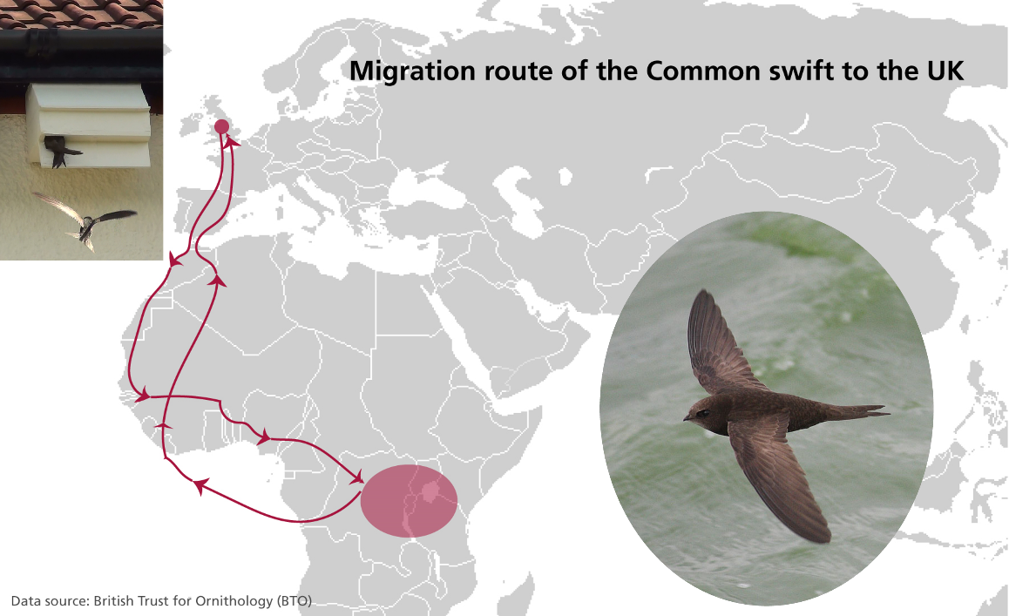
The swifts we see in our towns and villages have overwintered in Africa and come back each summer to nest and raise their chicks. Once the chick(s) leave the nest, they’re off - they will never return to the family nest again.
Sadly swifts are endangered and need swift boxes on buildings to nest. Find out more about how you can help them on either the Cherwell swift project website http://www.cherwell-swifts.org/
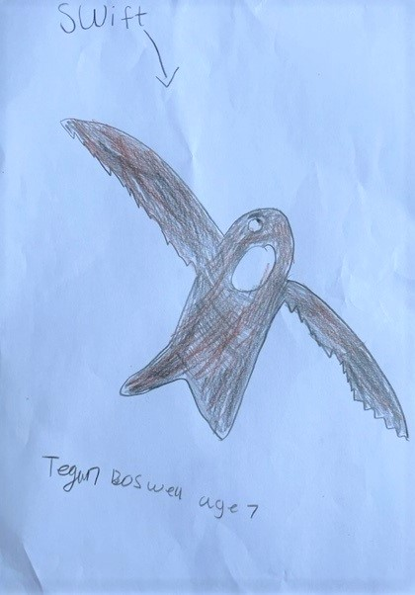

Tegan's Notes
"Hi I am Tegan Boswell, here are my facts about swifts:
- They are very fast!
- They come from Africa
- They can fly up to 69mph
I watched my Dad put up our swift box - it looked quite hard. He even let me climb a little bit up the ladder"

Gardening in July
Heading into the hottest months of the year, we need to be looking out for our local wildlife that could be harmed by the heat. Fortunately, there are lots of easy ways to lend a helping hand.

Even the most heat-loving species can suffer without enough to drink so consider providing a shallow bath of water in your garden. Add some stones around the dish so that bees and butterflies can climb out if they fall in.

It’s also important to provide some shade in your garden. A small pile of logs can be a great hiding place for insects from the sun.

Make sure you’re also helping your grass and flowers survive the heat as grass can reduce surface temperatures by 10℃ compared to concrete and flowers are a vital wildlife food source in the hot weather.

World Conservation Day – 28th July
Annual World Conservation Day is a great reason to join your local nature group and see how you could help create space for nature in your area. Check out our map to find the group closest to you https://www.wildoxfordshire.org.uk/guidance/community-groups
Thank you so much for all you have done for nature's recovery in the last year. Together we have brought people together, created more space for nature, and inspired more people to act for nature. Many people contribute to Wild Oxfordshire, and this support enables us to create a more natural, resilient, and biodiverse Oxfordshire for the benefit of all. If you would like to join in and are able to, we would greatly appreciate a contribution towards our work, either through a one-off contribution, or a monthly contribution. Check out our website to find out more about the many ways you can support us and our recent achievements.

Rhiannon Young – Wild Oxfordshire Nature Recovery Engagement Officer
https://www.wildoxfordshire.org.uk/

