November News – Winter Wildlife
Bees in Winter
Heading into the cold winter months, we need to be even more considerate to our local bees than usual. In winter, honeybee queens remain in their hives with the exception of particularly sunny days. Bumblebee queens may also emerge from hibernation if prompted to by mild weather. Solitary bees will leave their nests once ready to mate. When bees do emerge during winter, they need to have access to nectar, or they risk dying of starvation. In order to help these pollinators survive the winter, we recommend you plant winter bloomers in your garden. These include single flowered Hellebores (the open face gives great access to pollen and nectar!), Crocuses (make sure to plant them in an area with lots of light so they fully open), Snowdrops and Aconites. Ivy also works well as a late nectar source as well as shelter from any harsh conditions. If gardening isn’t your thing, you can make natural spaces bee friendly by creating twig and leaf piles (which can be as easy as not raking your garden when fallen leaves drop!) and caring for wayward queen bumblebees by either carefully relocating them to flowers or offering her a 1:1 sugar and water solution.

Tips for looking after our hedgehogs this winter
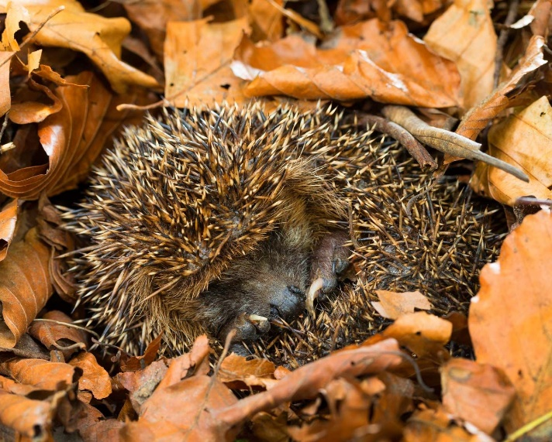
- Always move your burn piles before you light them as hedgehogs and frogs often use them to sleep in. This is, after-all, how hedgehogs were once upon a time cooked to be eaten! Thankfully it is now illegal to eat this endangered species.
- If you find a sick or injured hedgehog, or one that’s up and about during the middle of the day, call either Oxfordshire Wildlife Rescue centre on 07549322464 or Tiggywinkle’s wildlife hospital on 01844 292292.
- Leave some areas untouched! Messy log piles, long grass and fallen leaves are great for hibernating hedgehogs. Please leave a wild area in your garden so our hedgehogs can hibernate in peace - nice and cosy and safe.
- Put out a shallow dish of water or make sure your ponds are easy to get out of for hedgehogs, so they have water to drink. Sometimes hedgehogs come out of hibernation to eat and drink, especially in warmer weather, so even at this time of year, putting out water can help.
- Avoid using pesticides or herbicides as this will make hedgehogs very ill. Find out more at www.hedgehogrescue.org.uk
To find out more about Hedgehogs head over to the Wild Oxfordshire website at www.wildoxfordshire.org.uk and have a look in guidance for mammals.
Rhiannon Young – Wild Oxfordshire Nature Recovery Engagement Officer
https://www.wildoxfordshire.org.uk/

