Nature-Friendly Summer Activities for Kids

As summer kicks off, it’s the perfect time for all ages to get outdoors and help out your local wildlife (even on those not-so-sunny days).

1. Make a mammal footprint tunnel

Image credit: Gardener’s World
What you’ll need:
Sand or flour
Ruler
A small, shallow tray
Wet cat food (meat not fish)

1. Fill your tray Fill the tray with lots of flour or sand and use the ruler to smooth the surface

2. Check the trap
Lightly press your finger into the flour or sand – it should leave an indent. If it doesn’t, smooth over again.

3. Add bait – optional
Place a dish with pet food in the middle of the tray.

4. Place the tunnel outside Put the tunnel in a quiet, sheltered spot such as along a hedge or wall. Leave it out for up to a week, checking the tray daily for tracks.
5. Identify the footprints Take photos of the prints with a ruler for scale. Use ID guides to identify your guests.

2. Make seed bombs
Rewilding in the palm of your hand!
What you’ll need:
1 cup natural powdered clay
1 cup peat-free compost
1–2 packets of native wildflower seeds (pollinator-friendly is best)
Water (a little at a time)
‍Bowl for mixing
‍Tray or cardboard for drying

1. Mix the Dry Ingredients
In a bowl, mix:
1-part powdered clay
1-part compost
Seeds
2. Add Water Slowly
Add a little water at a time and mix with your hands until the mixture sticks together. It should not be too wet or crumbly.
3. Roll Into Balls
Roll the mix into small balls.
4. Dry Them Out
Place the seed bombs on a tray or cardboard and leave them to dry for 24–48 hours in a warm place.
5. Throw and grow!
Once dry, the seed bombs are ready to be tossed into bare soil areas in gardens or school grounds. Try and plant before rain is forecast or water them lightly and watch as pollinator habitats increases on your grounds.

3. Go Fungi spotting
Neither animal nor plant, fungi play a vital role in keeping our local habitats healthy. They help break down old leaves, wood, and other natural materials, turning them into rich soil that supports new life. Some species of fungi even form relationships with plant roots through the root-like mycelium. These ‘mycorrhizal networks’ help plants absorb water and nutrients while providing the fungi carbohydrate – a win-win!
You can find fungi almost anywhere: on logs, in soil, under trees, even on walls and woodchips!
Fungi are best found:
Nearby woodlands
Around fallen trees or logs
On leafy ground and tree stumps
In damp, shady spots after rain

What you’ll need:
A notebook or spotting sheet
Fungi ID app (like iNaturalist or Shroomify UK)
A magnifying glass (optional)
Gloves

The most common fungi in the UK this summer are:
Waxcaps – Known for their shiny caps, Waxcaps can be red, violet, yellow, green, or pink. They are commonly found in grasslands, meadows, and urban lawns and parks.
Parasol mushrooms – Tall fungi with a wide, round cap, a brown-to-black scaly top, white gills, and a white or off-white stem. Often found in woods, meadows, and fields.
Puffballs – Round fungi with a stem, no cap, and no gills. They release clouds of spores when touched. Puffballs are often found in open meadows, fields, and well fertilised lawns, as well as forest undergrowth. They never grow on logs or trees, only on the ground.
Chicken of the Woods – Easy to spot thanks to its bright sulphur-yellow colour. It forms thick, soft, fan shaped shelves and grows high up on the trunks of mature trees such as oak.
Elf Cups – Cup shaped and bright red, scarlet elf cups grow on decaying sticks and branches in damp spots and leaf litter.
Safety tips!
Never pick or eat mushrooms.
Take photos, not samples.
Wash your hands afterwards.
Stick to public footpaths and avoid damaging habitats.
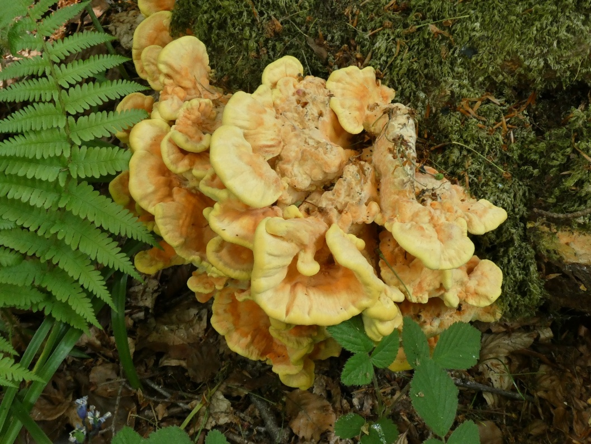

Laetiporus sulphureus, Chicken of the Woods, Ann Berkeley

Gardening tips for July
- Nectar is wildlife’s friend
You can help attract bees, butterflies, and other nectar-loving insects to your patch by planting nectar-rich plants.
Add climbers that may also produce berries and hips, such as Honeysuckle and Dog Rose. And go a step further and attract moths with night-scented plants like Evening Primrose and Night-Scented Stock.

- Cut back on the cutting back!
After a beautiful bloom, avoid deadheading roses this time of year. This way, some will develop hips (the fruit of the species of rose plant), which will feed birds and small mammals come winter.

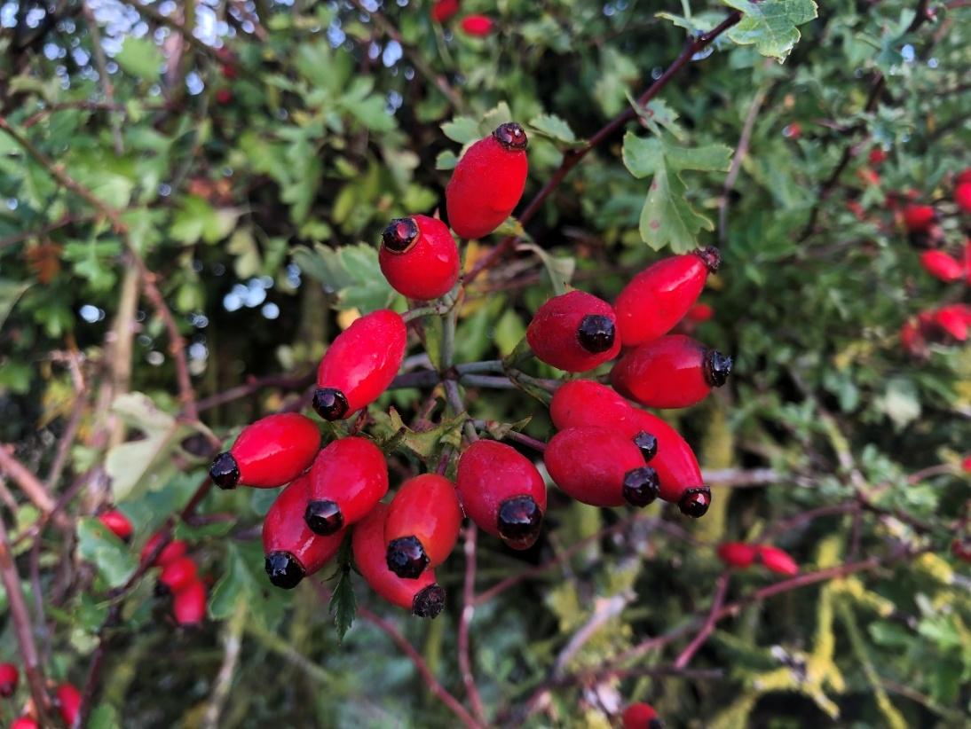

Rosehips, Rhiannon Young

- Big Butterfly Count
Here’s another one for your diary: July marks the Big Butterfly Count. Don’t just take part, give our fluttering friends a helping hand by leaving an area of grass to grow long until the end of summer. Species such as the Meadow Brown will use these patches to breed.

