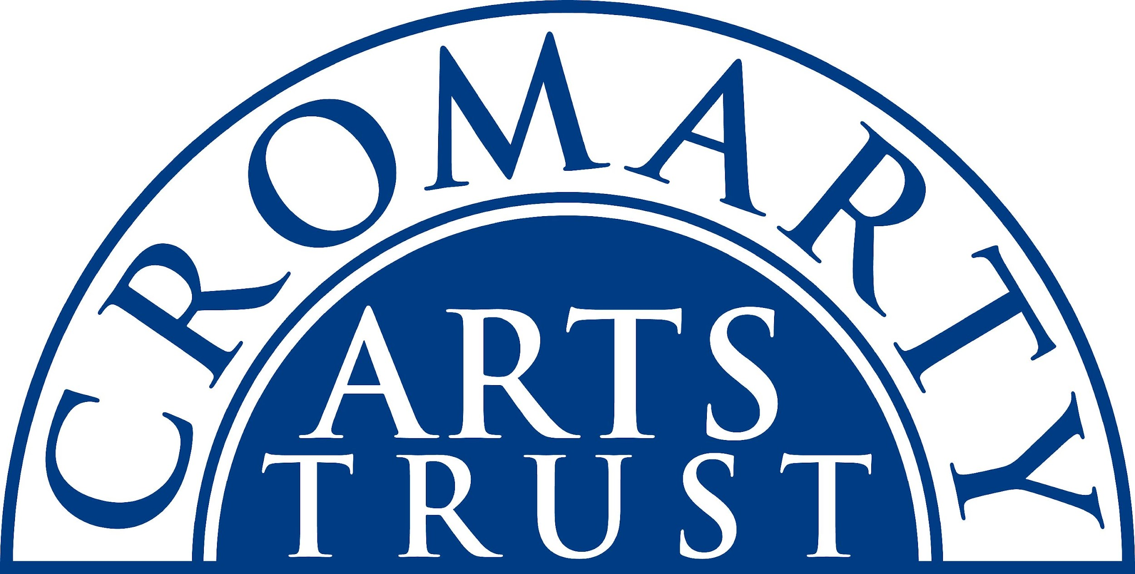

**Susan McCreevy Artist Weekend  
9 - 12 October 2025**

Name: ______________________________________________________________________________

Address: ____________________________________________________________________________

Tel/Mobile: ____________________________ Email: _______________________________________

Any allergies or dietary requirements, eg vegetarian/vegan and/or other issues it would be useful for us to know about:   
_____________________________________________________________________________________

The Susan McCreevy Artists weekend is a three-day residential weekend of creating art in the beautiful surroundings of the Old Brewery in the vibrant, coastal Highland town of Cromarty. There are workshops all day on Friday, Saturday and Sunday run by highland based artist Susan McCreevy.

Please tick the package you would like:

|  |  |  |
| --- | --- | --- |
| **Full Residential package**:  Old Brewery bed and breakfast three nights, arriving from 4pm on Thur 9 Oct departing Sunday 12 Oct by 5pm.  Dinners x 3; Thursday, Friday and Saturday nights  Lunches x 3; Friday, Saturday and Sunday  Susan’s workshops x 3 days; Friday, Saturday and Sunday. | £515  (Deposit £128.75) |  |
| **Non-Residential package**:  All of the above except bed and breakfast | £375  (Deposit £93.75) |  |
| **Workshops with lunches:**  Three days workshop with three lunches | £300  (Deposit £75) |  |

Please make sure you have ticked everything you want to attend and post or email this form to:   
**The Cromarty Arts Trust, Ardyne, 19 Bank Street, Cromarty, The Black Isle, IV11 8YE**

**Email: info@cromartyartstrust.org.uk Tel: 01381 600354**

I’m paying £…………… by BACS (ref SMA). Bank of Scotland, Acc No: 00911502 Sort Code: 80-06-83  
**If you are paying from a non-UK bank account, please email us for the best way to pay.**

**Payment & Cancellation Policy**

A 25% non-refundable deposit is payable on booking. The 75% balance is payable in full one month before the class. It is also possible to pay in instalments. You can cancel your class up to two weeks before and 75% is refunded. If you cancel within two weeks, we will do our very best to fill your place. If your place is filled, you’ll receive 75% refund. However, if we cannot fill your place, we are sorry there is no refund, unless under exceptional circumstances. We are a small, non-profit making arts charity and we appreciate your understanding in this matter.