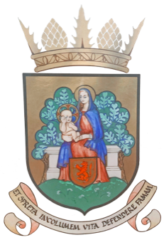
The Royal Burgh of Selkirk and District
Community Council

Chair Andy Murray 44 Hillside Terrace, Selkirk TD7 4ND 01750 21008
Vice-chair Ed Strang Steel 2 Priory Park, Selkirk, TD7 5DE 01750 21766
Secretary Alistair Pattullo 12 Victoria Crescent, Selkirk TD7 5DE 01750 721697
Treasurer Judith Thompson 12 Victoria Crescent, Selkirk TD7 5DE 01750 721697

A Meeting of the Council will be held on Monday, 14th April 2025 at 7.00pm
in the Cruickshank Room, Victoria Halls, Selkirk
AGENDA
- Attendance
- Chair’s introduction
- Apologies / Declarations of interest
- Minutes of the meeting of Selkirk Community Council held on Monday 10th March
2025
- Matters arising from the Minutes, and not covered elsewhere on the agenda
- Community Police Report
- Adopting Scott’s Place Telephone Box
- Borders Walking Festival 2026
- Planning Matters
- Tracker of Works
- OPEN FORUM
- SBC Councillors’ reports
- Treasurer’s Report
- Reports from Sub-Groups:
Selkirk Hill Management Group
Brighter Selkirk/Blooming Selkirk
Common Good Fund Working Group (CGFWG)
PR Committee
Victoria Park Action Group
- Reports from other community organisations and outside bodies:
Selkirk Resilience Team
Plattling Twinning Group
Selkirk & The Valleys
SBCCN/Eildon Area Partnership
A7 Action Group
- AOCB

The date of next scheduled meeting: 7.00pm Monday 12th May 2025
in the Cruickshank Room, Victoria Halls, Selkirk
www.selkirkcommunitycouncil.co.uk

