DRAFT
The Royal Burgh of Selkirk and District Community Council
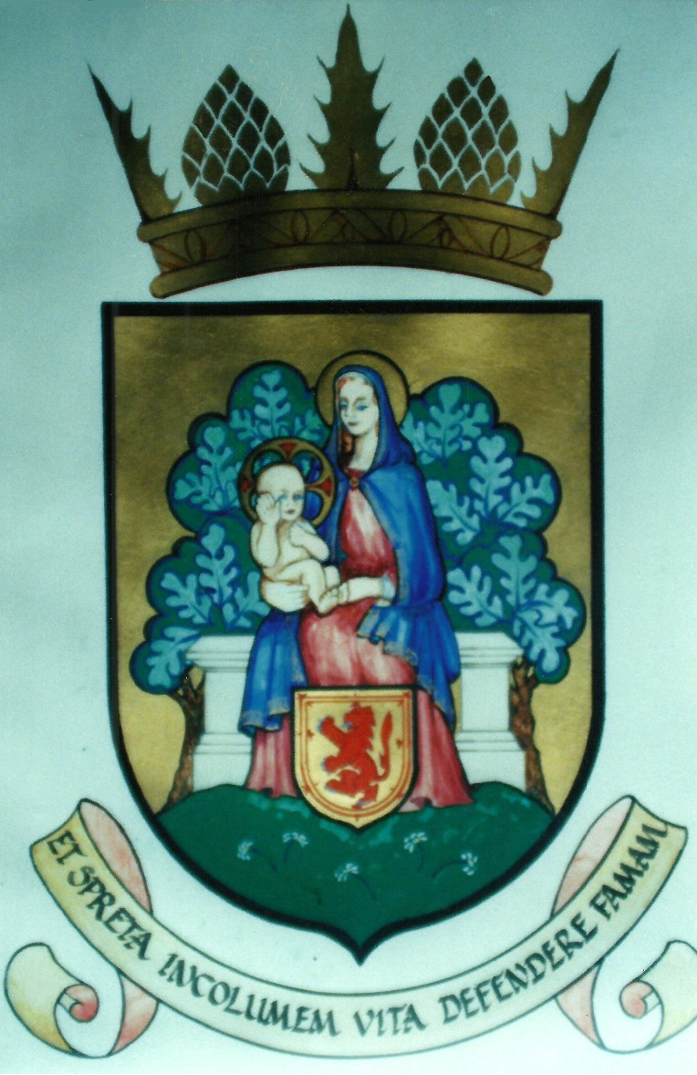
Chairman | Alistair Pattullo | 12, Victoria Crescent, Selkirk, TD7 5DE | 01750 721697
Vice-chairman | Ian King | 4 Russell Place, Selkirk TD7 4NF | 01750 722327
Minutes Secretary | Alisdaire Lockhart | Braeside House, Selkirk, TD7 4LF | 01750 22155
Treasurer | Tom Combe | 68 Back Row, Selkirk, TD7 4AG | 01750 720921

MINUTES OF THE MEETING OF THE SELKIRK COMMUNITY COUNCIL HELD IN THE COMMITTEE ROOM OF THE VICTORIA ROOMS, SELKIRK, ON MONDAY, 11TH JANUARY 2016.

At the start of the start of the meeting, the Chairman wished all present a happy New Year and reminded everyone that Dr Joh Gillies had been awarded an OBE in the Queen’s New Year Honours. It was agreed to write to Dr Gillies offering him the congratulations of the Council and the community for this significant and well-deserved award. ACTION; ANL.

- THOSE PRESENT:

Community Councillors Alistair Pattullo (Chairman), Alisdaire Lockhart (Minutes Secretary), Tom Combe (Treasurer) and Ian King.

SBC Councillors Michelle Ballantyne and Gordon Edgar.

Also in attendance: Scott Marr and Andrew Dinnet (Selkirk Flood Protection Scheme), 3 members of the public and one representative of the local press.

2. APOLOGIES FOR ABSENCE were received from Vice-Chairman Graham Easton, SBC Councillor Vicky Davidson, Kath Beaton and Kirsty Lovatt.

3. APPROVAL BY COUNCILLORS OF THE MINUTES OF THE MEETING HELD ON 14th DECEMBER, 2015:

Proposed by Gordon Edgar and Seconded by Ian King.

4. MATTERS ARISING FROM THE MINUTES NOT COVERED ELSEWHERE IN THE AGENDA

4.1 Concert in Selkirk by the Scottish Chamber Orchestra on 15th September next.

It was reported that the concert is part of the Touring Programme of the SCO and funded by them, however, it was agreed to hold a reception for the orchestra as hospitality provided by the SCC.

5. DECLARATIONS OF INTEREST – there were none.

6. REPORT OF THE COMMUNITY POLICE OFFICER – none received.

7. REPORT ON THE SELKIRK FLOOD PROTECTION SCHEME

Scott Marr reported on 3 separate flood events in Selkirk over the past month and he was thanked by the Chairman for the efficient and effective way that these incidents had been dealt with by both the Contractor and SBC.

An Information Sheet was tabled and it was agreed that this is a very helpful way of communicating progress on the Scheme.

It was noted by Ian King that the landscaping proposals are still to be forthcoming.

A full Report of the Scheme has subsequently been received and is appended to these Minutes for information.

8. COLLATION OF MINOR WORKS PROJECTS FOR SELKIRK.

A Paper listing all the projects received to date was tabled and had been pre-circulated to the members of SCC.

It was agreed to add “ACTION” lists of who on the SCC is responsible for each project and seek costings of each project, the list will then appear as a standard agenda item for each meeting with progress reported as appropriate. ACTION: ANL.

9. DEVELOPMENT PLAN FOR SELKIRK 2015 - 2025

SBC Councillor Davidson requested that this item be deferred until the next meeting when she can attend – agreed.

10. OPEN FORUM

10.1 Dougie Purves thanked SBC Councillors for the work on “ponding” adjacent to the Riverside Nursing Home.

10.2 Questions were asked about dog fouling in Selkirk and it was agreed that little further could be achieved until the Scottish Government adopted the same policy as in England and Wales – i.e. a fine of £1,000.00 for every incident.

11. PLANNING APPLICATIONS – none had been received in the past month.

12. REPORTS FROM SBC COUNCILLORS:

12.1 Michelle Ballantyne

The Scottish Government had reduced the budget to SBC by 3.5% and the consequences in this fall in funding was currently being evaluated by SBC Councillors and senior staff.

Each individual flood victim was entitled to compensation of £1,500.00 from central funds.

12.2 Gordon Edgar

There were questions about funding any repairs required for the Glen Hotel wall but the extent of any repair is still not finalised.

There was a lively debate about the “Tour of the Borders” as, one the one hand, this event brings into the Borders, mainly to Peebles, about £0.5 million of tourist income per annum, but the organisers treat the local community, particularly those in the Yarrow Valley with disregard to the extent that the Ettrick & Yarrow valley CC had submitted a formal complaint to the SBC.

It was explained that while the Scottish Borders Council determines policy on such issues, the formal approval application for this event is dealt with at SBC Officer level.

It was agreed that it was unlikely that SBC will change policy on this event, due to the substantial income to the area and the associated publicity, but it was agreed to write to the Chairman of Ettrick & Yarrow valley CC expressing the support of this CC in their endeavours. ACTION: ANL

13. SELKIRK COMMON GOOD FUND – no meeting so nothing to report.

14. BLOOMING SELKIRK – Michelle Ballantyne reported that the “Head Gardener” had resigned on health grounds and her replacement was being sort.

15. CORRESPONDENCE – none received.

16. TREASURER’S REPORT AND STUDY GROUPS

16.1 Treasurer’s Report

Tom Combe reported that there is £899.72 in the SCC bank account.

A grant of £150.00 to the A7 Action Group was approved.

A receipt is pending from the Chamber of Trade before the SBC annual grant will be forthcoming.

16.2 Evening Study Groups

Tom Combe re-iterated his problem of finding good tutors against strong demand for evening classes from the community.

17. REPORTS FROM SUB-COMMITTEES

17.1 Selkirk Hill Management Group – nothing reported.

17.2 Selkirk Chamber of Trade – ANL reported that he now received the Minutes of the Chamber of Trade’s meetings on a regular basis and it was agreed that these should be circulated to SCC Members for their information – ACTION: ANL

18. REPORTS FROM OTHER ORGANISATIONS AND OUTSIDE BODIES

18.1 The Scottish National Textiles Collection – previously the Scottish Centre of Textiles (SCOT)

ANL reported that considerable progress had been made with the project in 2015 such that the initial application to HLF Scotland for some £460k of initial funding was imminent, and if successful, would require a structured approach of community engagement and involvement about the proposed SNTC, which would be organised through the good offices of SBC and the relevant Community Councils.

19. ANY OTHER BUSINESS – there was none.

20. DATE OF THE NEXT MEETING:

The next meeting of the Selkirk Community Council will take place at 19.00 hrs in the Victoria Rooms, Selkirk, on Monday, 8th February 2016.

www.selkirkcommunitycouncil.co.uk

