draft for November - updated 30 October 2017 (numbering adjusted) | =  LATEST ADDITIONS

Project | Detail item |  | Description and Notes | Project  date initiated and promoter |  |  | Estimated cost/ finance source
The Haining | 1.05 |  | The re-location of a commemorative stone from Haining Park. | Jan 2016   Haining Trust responsibility. Cllr Ballantyne investigating.  CC support: general (public request) |  |  | Cost: ? unknown
The Victoria Halls | 2.01  railings / gate piers |  | The repair/ maintenance of the railings and restoration of entrance pillars  NOTE:  CARS Project Officer has now drafted a hybrid design to recreate original detail of gate piers which has been approved by HES who also support CARS funding being allocated. Common Good match funding now requested (via Cllr Edgar) to allow implementation in late Autumn 2017  From Minute of CG mtg - 21 june 2017  SBC Estates Strategy Surveyor has liaised with the Selkirk CARS project officer about the work required to replace the pillars at the Victoria Hall and that, if requested, a financial contribution of up to £10,000 be provided by Selkirk Common Good towards the cost of the work. | Jan 2016   CC support: Alistair Pattullo  See note:  CARS programme concluding and expenditure now committed –  urgent need to request and confirm financial contribution from Selkirk Common Good Fund |  |  | Detailed cost not available
 | 2.02  (new) notice board  (external) |  | June 16 update: Cllr Ballantyne to progress  Oct/Nov – February ‘17 update: design option offered and suitability of design now under consideration | Jan 2016   CC support: Alistair Pattullo  to investigate suitable options:  February 2017 – ongoing discussion  |  |  | Cost not yet known but  £600 RING FENCED by Cllr Ballantyne
NOTE: adjoining site at Scotts Place | Former BordersPrint site |  | Following demolition of buildings, vacant site left as a visual eyesore impacting on setting of Victoria Halls, especially during Common Riding and other public occasions | September 2017 – planning application submitted for erection of dwelling house -planning consideration ongoing and decision awaited |  |  | Privately owned site, now awaiting redevelopment
Wi-Fi for Selkirk | 3.01  Wi-Fi service |  | Agreed there is an accepted need for this service – but CC advised to await outcome of ‘wider’ discussions | Jan 2016   CC support: Alistair Pattullo |  |  | Cost: unknown
Community Information | 4.01  Information leaflets |  | - Re-issue of ‘Ring o’ the Town’ booklet  (Note: Selkirk Town Trail and the Paths Around Selkirk booklets currently produced by SBC – need to confirm need for update’ review texts and seek printing costs)  Consider developing together with Auld Kirk leaflet  - Sponsorship of Selkirk Hill guide | July 2016   CC support: Ian King  Follow up via SBC  - Cllr Edgar to check with SBC Rangers/ Countryside section and contact SBC grants officer  - Selkirk Hill guide being promoted by SHGroup |  |  | Cost? Uncosted  Dialogue with SBC Paths Officer
 | 4.02  Footpath signage |  | Longer term project to protect local heritage - involving Identification and ‘mapping’ of traditional local accesses - | July 2016   CC support: Ian King  Contact Erica Niven (SBC Paths Officer) to develop project form |  |  | Cost: ? uncosted
 | 4.03 |  | Community notice board : Market Place  - Existing unit requires repair or replacement | Jan 2017   CC support: Alistair Pattullo |  |  | Cost: ? unknown
7.
Central Area: public accesses and other issues

Market Place: 7.01 | - Enhancement of the Market Place forms part of the current Selkirk CARS initiative and major redevelopment ‘public realm’ work has commenced (in planned phases during period August 2017- Easter 2018).  - The Community Steering Group (working with the SBC engineering team overseeing the design proposals) despite a limited budget, plans to achieve best value for the town whilst maximising potential benefit and flexibility in the future use of the area.  - The redesign of the Market Place will include a comparatively limited palette of natural materials, well designed and co-ordinated street furniture - all supported by robust construction and well thought out infrastructure.  - Designs now finalised and phased on site development programme now started (late August 2017) – community liaison continuing. However, to cater for any unforeseen hard or soft landscape items or service needs which may be found beneficial to support future users of the Market Place – it has been agreed in principle that certain ‘small’ supplementary items or additional works (e.g. installation of ‘extra’ electricity points) will be sought through further grant aid. |  |  |  |  |  | April 2017   CC support: Ian King
 | 7.02  ‘public’ wayside seats | Refurbish public benches in town – clean – re-stain/ repaint all as required |  | Jan 2016   CC / Cllr Ballantyne support: |  |  | Costed and work  ORDERED - NOV 2016  WORK PROGRAMME STILL AWAITED
 | 7.03  Halliwell’s Close | Entrance from Mkt Place – repainting/ refreshing of walls – to complement refurbishment of Market Place |  | July 2016   CC support: Ian King |  |  | Cost? - private ownerships but potential SBC grant assistance
 | 7.04  steps to the Glebe Park from the Stey Brae | 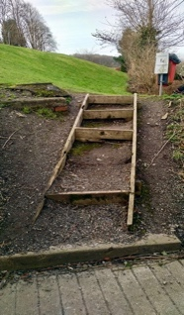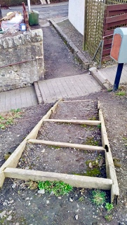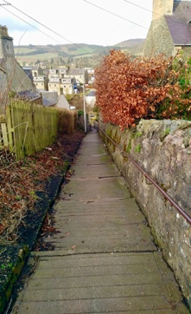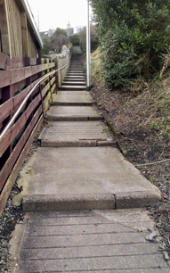  deterioration of ground surfaces, steps etc. and public safety prejudiced - needs thorough appraisal and repair programme |  | March 2017   CC support: Al Pattullo  Potential project for Community Payback  (formerly Community Offenders) scheme  - Cllr Ballantyne to make contact and pursue
 | 7.05 | Public entrance to Shawfield cemetary from Fairfield Drive: ponding and mud problems to be resolved - ground levels and ancillary repairs/ maintenance required  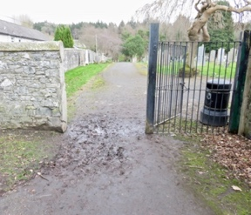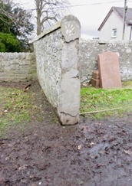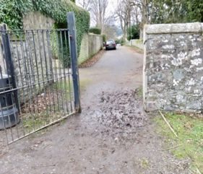 |  | March 2017   CC support: Ian King  Gravel laid and roiled by SBC (April) but problems for wheeled access still exist – suggest 2-3 paving slabs at gateway to assist  Cllr Edgar to arrange final completion to assist safe pedestrian access
8.  Auld Kirkyard (general area and individual projects) | 8.01   | Ongoing process of identifying means of safeguarding site and historic interpretation - via CARS - including production of informative leaflet, enactment etc.  VOLUNTEER GROUP formed – Kirk o’ the Forest Heritage Group (Selkirk) chaired by former SBC Cllr Vicky Davidson  –with support from CARS project officer.  TO BE EXPANDED FURTHER AS GROUP DEVELOPS REMIT  FURTHER MEETINGS OF GROUP: (to be advised) |  | July 2016   CC support: Ian King  Also from SBC/ CARS Project  Officer /Environment Scotland  Contact made with William Wallace Society  and Clan Wallace USA who are supportive in principle |  |  | Cost?  Individual works to be itemised/ prioritised and costed.
 | 8.02  public benches | Refurbishment of existing benches:  renew timber slats as required, prepare and re-stain timbers, prepare and repaint metalwork |  | July 2016   CC: Ian King / Cllr Ballantyne support:  ORDERED but still awaiting repairs etc.  - NOV 2016
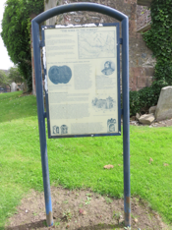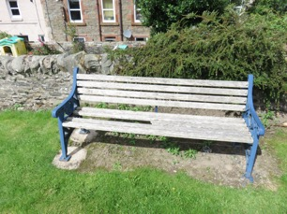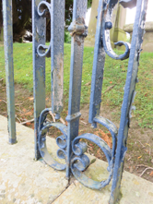
 | 8.03 Information boards: |  | clean down information panels and remove all algae etc. Prepare and re-paint metal work  Content updates required | July 2016   CC support: Ian King  initial cleaning undertaken  December/ January 2017 |  | c. £1,500 - potential for Community Grant funding to replace boards (only)
9.  High School site | 9.01  perimeter railings |  | Refurbishment/ repair/ painting of boundary railings to improve local environment  Work being phased viz.  A7 – High School Lane/ rear entrance – main entrance | Jan 2016   CC: Ian King / Cllr Ballantyne support:  A7 FRONTAGE COMPLETED – BUT AWAITING PROGRAMME FOR REMAINDER OF WORK |  | Now costed
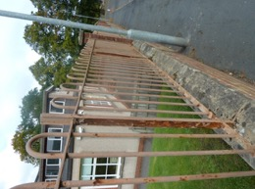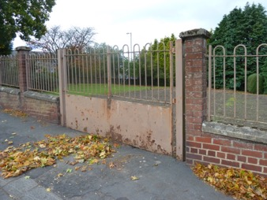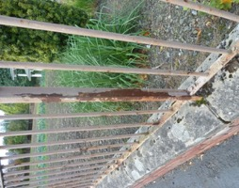
9.00  Other Projects | 9.01  Plaque at site of old dam (?) adj. Buccleuch Road |  | Public request for plaque to explain significance of stone wall feature  Text to be drafted for discussion/ approval and then quotes obtained for plaque and location agreed | July 2016   CC support: public request |  | Cost not yet known
 | 9.02  Cleaning of road signs – especially street names – throughout town |  | Distinguish between traffic signs and identifying street name signs – check whether there is any SBC policy for maintenance and refurbishment.  Noted current lack of SBC funding (august 2016)  What about other information signs? e.g. the finger post sign at Market Place – perhaps part of Market Place proposals?  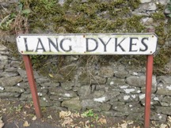 | July 2016   Suggest traffic signs (outwith A7 Trunk road) are full responsibility of SBC – and that street names could be cleaned / maintained on a regular neighbourhood basis and via Common Good.  SUGGESTED PHASED COMMUNITY PROJECT – SIMILAR TO LITTER PICK DAY
 | 9.03  Bannerfield:  Site opposite local shop (the ‘Camps’ area) |  | Surfacing improvement works to pathways in area | April 2017   CC support: public request |  | Cost?

(CC) May 2016 - SBC Councillor Gordon Edgar reminded Councillors present that there are a number of grants from SBC which are available for minor works, including the Common Good Fund for grants up to £5k, a Small Scheme Fund for grants up to £10k and the “Quality of Life” Fund for Selkirk of some £6.5k. These funds could help fund some of the Community Council’s Minor Works projects.

Updated 20 August 201

APPENDIX 1: COMPLETED PROJECTS/ WORK

The Haining | Gravel laid to the forecourt of main house to improve the appearance and approach. |  |  | COMPLETED MAY 2016 | Cost: £3,000.00
War Memorial | protective rail to protect wreaths laid at the War Memorial each year on Armistice Day. |  |  | INSTALLED - Nov 2016 | Cost:- SBC
Sir Walter Scott’s Courtroom | Repair of the courtroom windows in Sir Walter Scott’s Courthouse. |  |  | COMPLETED - May 2016 | Cost:- SBC
Central Area: public accesses | Scott’s Close: Timber (bracketed) handrail replacement – to assist public safety  (nb. bracketed, galvanised tubular handrail provided in lieu of timber) |  |  | INSTALLED -  November 2016 | Cost - SBC
Central Area: public accesses | Fleshmarket steps area: Improve landscape – clean up/ maintenance and replanting as required to improve local environment and important link to Market Place  Edges trimmed/ flower beds weeded – November 2016 |  |  | COMPLETED -  November 2016 | Cost – SBC and volunteers
Central Area: public accesses | foot of Back Row - replace conc. coping to low perimeter wall at flower bed/ tree area outside Council offices – opposite Sainsbury’s |  |  | COMPLETED - January 2017 | Cost - SBC
Auld Kirk/ churchyard | - Lang Dykes boundary railings replaced:  - Refurbishment/ repair/ painting of Lang Dykes boundary fencing and boundary hedging  - Rotted and missing metal palings/ preparation and painting of fence structure throughout  - Information boards washed down |  |  | COMPLETED - March 2017 | SBC ‘Small Schemes’ grant - £6k
Auld Kirk/ churchyard | DOORS Open Day: 17 September 2016 - guided walks + assistance with leaflets |  |  | COMPLETED SUCCESSFULLY | Volunteers
Auld Kirk/ churchyard | Boundary railings to Kirk Wynd: prepare metalwork and repaint |  |  | COMPLETED - May 2017 | Cost - SBC
High School perimeter railings | Frontage to A7 repainted – May/ June 2017 |  |  | COMPLETED - May - June 2017 | SBC
Speed bumps throughout town | Refurbishment of line markings on speed bumps throughout town – many now barely visible and representing a public safety issue |  |  | COMPLETED  - June/ July 2017 | SBC
The War Memorial  (St Mary’s Church site) | improve local environment/ setting for war memorial (especially visual appearance of former St Mary’s church site)  Privately owned site, but works carried out via community volunteers (ex-soldier’s association)  Programme of ‘fringe’ improvements – 2m edge strip cleared, tidied up and planted, + screen fencing and information panel |  |  | SUCCESSFULLY COMPLETED  February/ June 2017 | Volunteers  Notice board £2.5k with £500 donation from CC
A7 wall collapse,  100m north of High School | Stone wall at back of footpath showing structural distress - now collapsing in several places with collapsed section increasing in size  Repairs undertaken by member of Selkirk community – September 2017 |  |  | COMPLETED  September 2017 | Undertaken voluntarily by member of Selkirk Community

Appendix 2: PROJECTS IDENTIFIED BUT WHICH WE HOPE \WILL BE TAKEN FORWARD BY OTHERS

The Haining | 1.01  Selkirk Castle | Landscape and Management Plan: Community Archaeology Project | Jan 2016   Haining Trust responsibility.  CC support: Alisdaire Lockhart
 | 1.02 | The physical signs to support interpretation graphics for the castle archaeology project. SBC may supply the artwork as an in-kind contribution in line with an earlier offer. | Jan 2016   Haining Trust responsibility.  CC support: CARS Project officer in contact with Haining Trustees
 | 1.03 | Improvements to the paths and steps associated with the castle archaeology project. | Jan 2016   Haining Trust responsibility.  CC support: CARS Project officer in contact with Haining Trustees
 | 1.04 | General signage and way finding including a couple of ‘what's on’ notice boards.  It is understood that the current Trustee group has shown interest in an entrance notice board but no action yet taken. CC not involved. | Jan 2016   Haining Trust responsibility.  CC support
War Memorials | 2.01  memorial list of volunteers | Listing the volunteers from Selkirk in the 2nd Boer War who were killed on active service.  Passed to the Ex- Soldiers Association for action | Jan 2016   Ex- Soldiers Association CC support: Alisdaire Lockhart/ Graham Easton
 | 2.02  memorial list of the fallen | Listing those from Selkirk who have been killed on active service since 1946.  Passed to the Ex- Soldiers Association for action | Jan 2016   Ex- Soldiers Association  CC support: Alisdaire Lockhart/ Graham Easton

