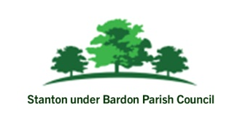

JOB VACANCY – Parish Clerk and Responsible Financial Officer
Stanton under Bardon Parish Council
26 hours per month
Stanton under Bardon Parish Council is seeking a motivated, professional and highly organised individual to undertake the role of Parish Clerk and Responsible Financial Officer.
The Parish Clerk is the Council’s principal officer and adviser and is responsible for ensuring the effective administration of the Council’s business and finances.
This is an exciting opportunity to support the local community and help deliver projects and services within the Parish.

Main Duties Include:
- Preparing agendas, minutes and supporting documents for Council meetings
- Advising the Council on legal, procedural and policy matters
- Managing the Council’s finances, budgets, accounts and audit processes
- Acting as the Responsible Financial Officer for the Council
- Managing correspondence, records and Council documentation
- Supporting delivery of community projects and initiatives
- Ensuring compliance with statutory and governance requirements
- Liaising with residents, contractors, local authorities and partner organisations
- Managing the Council’s website, notices and public communications
We Are Looking For Someone Who:
- Has excellent administration and organisational skills
- Has strong financial management and bookkeeping abilities
- Possesses good communication and interpersonal skills
- Can work independently and use initiative
- Has good IT skills, including Microsoft Office and email systems
- Has attention to detail and the ability to meet deadlines

Previous experience in local government, administration or finance is desirable, although training and support will be provided for the right candidate.
The successful applicant may be required to attend evening meetings.
Closing Date: Tuesday 30th June

For an application pack or further information, please contact:
www.stantonunderbardonparishcouncil.gov.uk
clerk@stantonunderbardonparishcouncil.gov.uk
01530 243987

