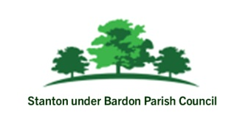

JOB VACANCY - Village Hall Manger - Stanton under Bardon Village Hall
15 hours per week
Stanton under Bardon Village Hall is looking for an enthusiastic, organised and community-focused individual to help manage and develop our busy Village Hall facility.
This varied role involves promoting and organising events, managing room hire bookings, supporting customers, overseeing the day-to-day operation of the building and ensuring the Hall remains safe, welcoming and well maintained.

Main Duties Include:
- Promoting and supporting events at the Village Hall
- Managing room hire enquiries and bookings
- Liaising with hirers, customers and contractors
- Ensuring the building meets Health & Safety and licensing requirements
- Supporting the smooth running of events and activities
- Managing records, invoices and stock control
- Updating notices, websites and publicity materials
- Responding to emergencies and customer enquiries

We Are Looking For Someone Who:
- Has excellent organisational and communication skills
- Is friendly, reliable and self-motivated
- Can work independently and manage competing priorities
- Has good IT and administration skills
- Has experience in customer service, events or facilities management

Experience within a community or local government setting would be an advantage.

Evening and occasional weekend working will be required.
For an application pack or further information, please contact:
For an application pack or further information, please contact:
www.stantonunderbardonparishcouncil.gov.uk
clerk@stantonunderbardonparishcouncil.gov.uk
01530 243987

Closing Date: Tuesday 30th June

