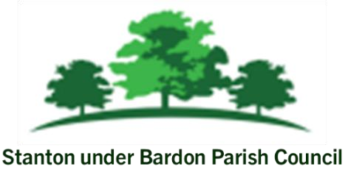

All Members of Stanton under Bardon Parish Council are hereby summoned to attend the Parish Council Meeting on Wednesday 5th March 2025 starting at 7:00pm at Stanton under Bardon Village Hall, 2 St John Cole Crescent, Stanton under Bardon, LE67 9AE for the purpose of transacting the business shown below:

PUBLIC PARTICIPATION
- Members of the public are welcomed to the meeting to make representations or ask questions in respect of any matters included on this agenda
- Updates from Borough Councillors Clare Harris and Chris Lambert
AGENDA
- APOLOGIES
  - To RECEIVE apologies for absence and to consider whether to approve the reasons given

- DECLARATIONS OF INTEREST PECUNIARY AND NON-PECUNIARY
  - To RECEIVE declarations of pecuniary and non-pecuniary interests and requests for dispensations in respect of items on the agenda

- PREVIOUS MINUTES
  - To CONSIDER the adoption of the draft minutes from the Parish Council Meeting held on 12th February 2025

- CLERKS REPORT
  - To RECEIVE updates from the Clerk relevant to the Parish Council activities during February 2025

- COUNCIL FINANCE
  - To REVIEW and APPROVE the financial statement for February 2025
  - To REVIEW and APPROVE bank statements and bank reconciliations for February 2025
  - To REVIEW and APPROVE the list of invoices scheduled for March 2025
  - To REVIEW and APPROVE the trade waste contract with Hinckley and Bosworth Borough Council for 2025 - 2026

- VEHICLE ACCESS AGREEMENT
  - To REVIEW and APPROVE the draft vehicle access agreement to allow tenants permissive access to the rear of properties off Main Street, Stanton under Bardon

- DRAFT MINUTES FROM VILLAGE HALL MANAGEMENT COMMITTEE
  - To NOTE the draft minutes from the Stanton under Bardon Village Hall Management Committee Meeting held on 24th February 2025

- STANTON UNDER BARDON COMMUNITY PROJECTS
  - To CONSIDER relocating the Queen’s Jubilee tree near to the Community Woodland
  - To CONSIDER quotation for benches at the Community Woodland at the Recreational Ground
  - To DISCUSS and CONSIDER a new footpath on Stanton under Bardon Recreation Ground
  - To DISCUSS and CONSIDER designs for the village sign

- COUNCIL ALLOTMENTS
  - To DISCUSS and CONSIDER overgrown allotment plots for potential tenants

- PLANNING
- To CONSIDER any planning applications submitted following the publication of this agenda

- PROPOSAL OF CLOSED SESSION
  - In accordance with the Public Bodies (Admission to Meetings) Act 1960 section 1 paragraph 2, to CONSIDER excluding the public and press for the following items for reasons that matters appertain to staff employment and staff appraisals that are of a confidential nature.

  - To CONSIDER the draft Job Description for the position of Village Hall Caretaker
  - To CONSIDER the draft Person Specification for the position of Village Hall Caretaker
  - To CONSIDER the draft Contract of Employment for the position of Village Hall Caretaker

Signed: 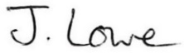 Dated: 28th February 2025

Stanton under Bardon Parish Clerk, Village Hall, 2 St John Cole Crescent, Stanton under Bardon, LE67 9AE

