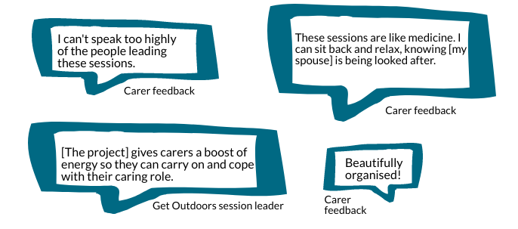
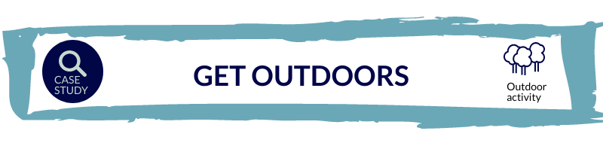
Evanton Community Wood planned to use the small grant to continue and develop their ‘Get Outdoors’ programme, which had been funded by an earlier grant from the Trust. The programme brings together people living with dementia and unpaid carers of those living with dementia in a series of creative outdoor activities, and these were to continue, run in a newly built woodland cabin.
Activities were moved online when COVID-19 restrictions were introduced. Although the online approach was inconsistent with the project’s ‘get outdoors’ aim, it maintained a woodland theme to bring ‘the outside in’. YouTube clips were also sent to care home residents who were unable to take part in the Messenger calls. The project commissioned local creative organisations to deliver the following activities:
Memory cushions
A story-teller session leader worked with participants to identify and develop a memory-based story. An image from this story was then added to a cushion, with the aim of helping people to hold onto their memories for longer. One pre-lockdown session was held in the woods, the rest on-line.
Music and song
A storyteller and two musicians delivered sessions of music and song. The aim was to learn songs that could be sung around the fire in the woods as and when restrictions allowed. The activity was perceived to be enjoyable for all and an additional five sessions were run. When restrictions were eased in the summer months, a socially distanced ceilidh took place in the woods and the songs that had been learnt online performed.
Wild painting
A second local creative organisation was commissioned to deliver these sessions, the first of which took place in the woods and then moved to Zoom. Materials were posted to participants ahead of each session.
Christmas craft and songs
Further activity was planned after the case study data collection. It was expected to focus on making Christmas decorations. Delivery via Zoom was being considered.
Successes
- Pre-lockdown activity helped facilitate the shift to an online project as participants were familiar with the session leader, and activities could be planned around the participants based on what they liked, and the skills they had. The session leader commented that, “it would have been harder if starting afresh with someone in an art form that they weren’t familiar with unless we’d had that face-to-face meeting opportunity first”.
- Despite the difficulties of learning online, those who took part did feel included. One carer noted that the organisers, “were managing to hand hold them through it and nobody was left out”. Participants were supported to access the online sessions by neighbours or the project team via telephone and socially distanced doorstep visits.
Challenges
- The inability to provide physical support created difficulties. Some participants struggled to follow instructions, others, ‘watched rather than took part.
- Participants acknowledged it was harder to get to know people through face-to-face delivery, noting, “it’s easier to get to know people when you’re together in a group rather than a small thumbnail on the sessions”.
- The move to online delivery was identified as a challenge by the project team and one of the session leaders identified a number of ‘hiccups’ in their report, including lost passwords and difficulty learning how to use new software.
- Participants were described in a report as having variable internet access, “some have quite a lot, some very little and some none at all”. Lack of access was identified as a particular issue for care home residents who were unable take part in memory cushion Messenger calls and were instead sent YouTube videos. In another of the project’s activities, poor connectivity experienced by one of the organisers was described in a report as adding ‘to the drama!’
It helped combat social isolation
Although only a small number of people had participated (two to three couples took part in each of the activities – eight people in total), the project was perceived to have provided an invaluable social function during a time of extreme isolation. The project team recognised the importance of maintaining activity throughout lockdown, with the weekly sessions being ‘sacrosanct’ to participants. The carer interviewees supported this view and described how the sessions had provided ‘something to do’ at a time when other contact and support had stopped.
It gave occupation and focus to people living with dementia
The mantra for all participants was, “keeping spirits up and being in contact, sharing and connecting with others”, (session leader interviewee). The project gave a focus and something to look forward to for participants.
It provided respite for carers
The project was perceived to be particularly beneficial for carers, giving them some respite and allowing them to regain some sense of themselves beyond a caring role. Supporting this, one of the carer interviewees described the sessions as ‘medicine’ because they were able to relax and enjoy the activity knowing that their spouse was being looked after. For the other carer interviewed, the sessions provided enjoyment and a boost during a difficult time.
The project hopes to run a second ceilidh in the woods when restrictions allow. Beyond the lifetime of the project, Evanton Community Wood would like to continue running weekly sessions and, should volunteer capacity allow, provide food and refreshments in the woodland. The focus of the sessions would depend on the organisation’s future funding decisions, with the continued involvement of creative session leaders requiring additional income. In its absence, focus could shift from creative to more woodland orientated activities as the project co-ordinator felt that their team had developed the skills needed to deliver these autonomously.
Online delivery had not previously been considered but the project experience has led the organisation to consider its potential use beyond COVID-19 as a means to complement other work.
The importance of the project to carers has been increasingly recognised; participants with dementia were described by the project co-ordinator as being able to take part in around 50% of the activities but carers in 100%.

Lizzie McDougall Art and Storytelling (2020). Out of the Woods and Onto the Inter…Web. Unpublished.
Lizzie McDougall Art and Storytelling (2020).
Creativity In Care CIC (2020). Evanton Community Wood Wild Painting Report. Unpublished.

