From: Joan Urquhart - Invergordon Academy
Sent: 31 March 2017
Subject: RE: School visit - ASN group Invergordon Academy
Simon,

That’s great and THANK YOU so much for a great day yesterday. Allan and I are so inspired by your work and enthusiasm. Our boys were exhausted but delighted with what they did and the fun they had in the woods.

I will be looking to incorporate what you have on offer for some of our pupils at Invergordon Academy in the near future. Will be in touch to meet up/discuss options with you.

Additional Comments
The pupils were able to experiment with ideas, actively learn, carry out presentation skills, increase their knowledge
of risk with the fire and carrying the length of branches etc. Develop their skills in co-operation, teamwork and listening.
It was great to see them being so physically active and motivated.
Toilet facility is amazing. It such a great safe place for kids. They just loved exploring the woods too.

Kind regards, Joan Urquhart

From: Ben Brittain-Dodd
Sent: 16 December 2016
To: Mark Jones-Tain Royal Academy
Subject: Monitoring visit
Hi Mark,
By a set of fortuitous reasons I ended up doing a spontaneous monitoring visit of Wednesday Mountain Bike session at Evanton Woods with Simon Harry as the provider. I’ve attached the report for reference as was keen to feedback how well I thought the activity was run and supported by your staff. Having spent a significant amount of time teaching ASN students in the outdoors it was refreshing to see such an engaging session that supported/focussed on the behavioural development as equally as the practical mountain biking.
I have been trying to take my 1st year pupils to Evanton Woods on a regular basis. We only have a short time, but I find that even just the experience of walking together helps the pupils mix socially with some pupils that they may not be in a friendship group with. They are taking exercise, which for some of them is not a normal feature of their day. They are amazed to climb trees and to run around, to explore. We discuss responsible risk taking and any limits/boundaries that are being set and they love the freedom to play within these.
…...............................................................................................................................................................
We do a lot of Arts based activities and this makes the pupils much more aware of colours and textures, as well as stretching their imagination.
We go out in all weathers and this encourages them to take responsibility for wearing appropriate clothing.
Kay Smith, Alness Academy, Jan 2017
…...............................................................................................................................................................
Evanton Wood Feedback February 2017 From Dingwall Academy
Dingwall Academy has been taking a group to Evanton Community Woodland since September 2013. We believe that outdoor learning is a valuable way of delivering Curriculum for Excellence offering engaging activities to a wide range of learners at every stage in their education. Such activities enable students to develop the four capacities in a natural environment. The woodland offers engagement which is not always present in the classroom situation for students with a range of special needs. They feel success as learners from physical and practical experiences and this promotes confidence and self -esteem. Certain students need encouragement to engage in physical fitness and the woodland provides the perfect environment to promote this area of wellbeing. Many of the individuals engaged in the project are fairly isolated in the school education environment. The woodland is invaluable in promoting teamwork, cooperation, communication skills and group problem solving. Certain projects that have involved the students have been for the general benefit of the community, such as the children’s play area,and this has promoted concepts of responsible citizenship and involvement in society. A constant emphasis in all activities is personal and group safety and this is a very valuable transferable skill into all other areas of life for individuals who are not always as aware of such issues as their peers.
The current group attends the woodland each Monday for three hours. This group consists of 11 individuals with very diverse needs. Several have a diagnosis of ASD, physical disability, learning issues, behaviour issues or are hearing impaired requiring signing . One student is not yet at the Academy but will require a long transition period and the woodland has been chosen as the perfect entry into this process. The sessions are staffed by a teacher, auxillaries one with signing skills, senior mentors from the Academy and a parent who enjoys seeing her relatively isolated teenager engaged with other children. The progress that all these children have made since becoming involved in the project is enormous. The activities developed by the staff at the woodland to meet the needs of the group have achieved spectacular results. Some of the children were very reluctant to engage with the project but all have gained enormously from it. The Academy tends to use the woodland as one of the primary projects to engage children in working with others and engaging with education. The activities planned by the staff at Evanton ,in conjunction with school staff, are carefully chosen to reflect the needs of the individuals within the group. Sometimes several activities run in parallel allowing children to work with different individuals, including different adults, and help each other to achieve the target. This increases the awareness of individuals to the complex needs of others and the value of team work in problem solving. All these skills are transferable into everyday life.
Two students stand out as examples of what can be achieved by this project. Student A is severely autistic and has been almost totally isolated in the school environment. He had little or no respect for the right of others, was severely affected by noise, was very afraid of any new experience and had a low level of physical fitness. Having established a relationship with the teacher leading the group it was decided to use the woodland project as the first attempt to widen his educational and social experience. He was obviously very anxious but with support from the staff at Evanton it was decided to slowly attempt to engage him in the project. Wearing different clothes for outdoor work and travelling with others, who might be noisy, in the minibus were severe challenges. For the first week he would not come out of the cabin and sat with his hood up in isolation. Over three months ,with sympathetic support and encouragement, he now is a fully integrated member of the group involved in team activities and happily socialising at break time. This has significantly affected the rest of his education and he is far more open to accepting challenge. He is now involved in the Saltire Award and The Duke of Edinburgh Award in conjunction with St. Clements school in Dingwall. The progress in such a short time is enormous and is enabling the school to think positively about his transition process at the end of his school education.
Student B also has ASD but also DCD and ADHD and this has impacted enormously on his educational provision. The Evanton Wood project was again selected as the first attempt at reengagement with education with massive support. This student has been attending now for about two years and it has not always been a smooth path but he really enjoys the provision, has received a sympathetic but firm approach to his needs and has become integrated into the group. Building on this success he has now been reintroduced into the school environment on a one to one basis and his new child’s plan targets are to introduce two more subjects by the end of this term.
This provision has been invaluable to the happiness and success of many children. The staff are massively committed to the students providing activities which are appropriate to gain engagement from young adults with extremely wide needs. The transferable skills they learn has had profound effects on their wider education and social skills.
…...............................................................................................................................................................“Evanton Woods is an invaluable resource for the pupils at St.Clements School, Dingwall. The facilities developed at the woods allow enormous learning opportunities for our pupils, through a variety of activities. While undertaking the volunteer component of the Duke of Edinburgh, Simon worked closely with our pupils enabling them to create resources for the play area. Through this partnership our pupils also gained skills for life and work, as they drew plans, discussed options, worked as a team and handled and used wood craft tools . Our pupils with complex needs have been able to participate in this award through the sensory experiences so readily available in the woods. Simon’s skilful direction allows our pupils to achieve the Scottish Curriculum for Excellences 4 capacities, enabling them to become Responsible Citizens, Successful Learners, Confident Individuals and Effective Contributors. Our pupils also gain SQA Personal Achievement Awards from our learning at the woods. Our connection with the Woods has also contributed to us gaining our 4th Green Flag, an achievement for a school of our size and range of pupils.
A variety of class groups also use the Woods for subject learning i.e social studies where the natural environment enhances classroom learning. A class of pupils with a complex need and high support level love attending the woods and experiencing the woods in all Seasons. The pupils benefit in developing their independence and well-being in a safe environment. The creation of pathways, self- contained areas to explore and areas to develop their mobility and agility have been beneficial. It also provides an interest for them to continue and build on after they leave school.
The facilities offered in the cabin give an added dimension to the trip to the woods , as the pupils sit and chat around the stove.
Simon engages very well with our pupils. He is very gifted at tailoring the learning to meet the diverse range of needs in our school. He has created very positive relationships with pupils and the staff. Our association with Evanton Woods has been very beneficial for our school and we value hugely our partnership with Simon and the Trust volunteers. Access to such suitable facilities enhance our pupils learning and offer opportunities not available to them elsewhere in their community. I can not thank Simon and the volunteers enough.”
Regards,
Margaret Berry, Principal Teacher
St.Clements School, Tulloch Street, Dingwall IV15 9JZ
…...............................................................................................................................................................
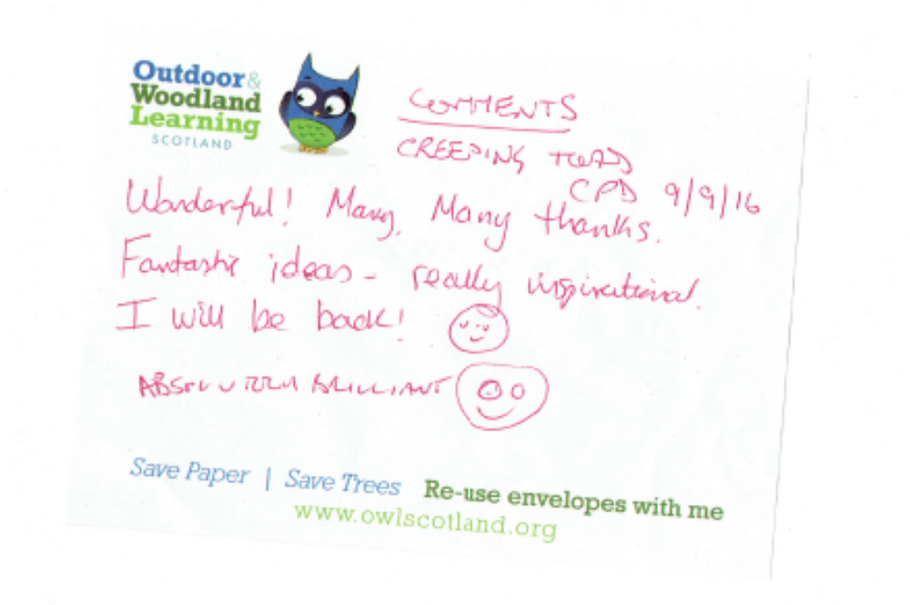

St Duthus School Evanton Community Woods 2015-16

Pupils at St Duthus Special School have benefited from a programme of health and wellbeing activities provided in Evanton Community Woods by Simon Harry and school staff. Our pupils have a range of additional support needs that make it difficult for many of them to access the outdoors freely.

Barriers to accessing outdoors:
- Many pupils rely heavily on technology for their leisure time at home and some refuse to go out
- Parents cannot take pupils out on their own for health and safety reasons
- Access to safe and appropriate environments is limited
Most pupils at St Duthus will not go on to work or supported work. They will require adult support for most activities and for everyday living post school. They will mainly engage in leisure style activities and staff at St Duthus feel it is essential that we prepare our young people for their adult lives. We feel that encouraging a healthy lifestyle including developing an appreciation of and engagement with our natural world is one of the greatest gifts we can pass on to our pupils. Using the outdoors as a vehicle to develop independence, self-reliance, fitness, curiosity, problem solving and to experience challenge and enjoyment is key to developing the health and well-being of our students. This is what we have tried to achieve.

Through the programme of activities provided at Evanton Woods our pupils have experienced a range of opportunities to explore the sights, sounds and smells of nature. These include:
Visiting the pond and river to listen to and observe the water and wildlife
Using stones to skim and build towers engaged our pupils and gave a sense of challenge, achievement and team work
Collecting natural items for a number of craft projects helped develop curiosity, practical and leisure skills and helped develop our pupils creativity, sense of achievement and self esteem
Lighting and using fires helped create a sense of adventure, excitement, satisfaction and helped build resilience
Sitting round the fire watching the flames, feeling the warmth, cooking and sharing helps us appreciate the feeling of being outdoors as part of a group and encouraged stillness and calmness
Walking through the woods at different times of the year gives many pupils the opportunity to move freely and to experience the seasons first hand. It allows pupils to make choices and decisions; to take responsibility for themselves and their safety
Walking in the snow, cracking ice, jumping in puddles, watching the shadows and the sun have all engaged pupils and helped them develop a sense of enjoyment and pleasure
Creating an accessible woodland play area that is free of tripping hazards and contains a range of natural equipment to encourage climbing, balancing, exploring… has provided our pupils with an invaluable opportunity to manage and take risks, build confidence, co-ordination and self esteem. We have been fortunate enough to have played a lead role in the design of the area to ensure the activities meet the needs of our children. The wood has been very accommodating supporting these needs.
Regular visits to the community woods helps our pupils to develop confidence in themselves and their abilities. It encourages physical and mental well-being and a sense of appreciation of the natural world and what it has to offer.
I hope that through maintaining these visits our pupils will develop skills that allow them to go on to access, enjoy and protect the natural world in their adult lives.

Clare Whiteford, Head Teacher St Duthus School
…...................................................................................................................................Tain Royal Academy and High Life Highland Youth Services
Evanton community woodland project

Starting 15th March 2016, a group of young people from Tain Royal Academy started attending the woodland project at Evanton.
The four young people were chosen and referred to the project by agreement via the school support for pupils meetings. They all have varying SEBN (Social, emotional, Behavioural, needs) and therefore all were finding it difficult to engage in a full timetable within mainstream school.
They were accompanied by HLH Youth Development Officer, Rob Parkes and a Pupil support assistant from the school. A full and varied range of activities was discussed and agreed, with the young people given full opportunity to shape the programme.
Activities include;
Conservation
Species identification
Woodland management
Shelter building
Fire safety and woodland fire making
Tool work
Basic map reading
Orienteering
Exploring water environments.
Attendance at the project was excellent, most have attended on all occasions, this would suggest that it had successfully engaged them in a positive activity. Learning was wide and varied, underpinned by using reflective questioning in normal conservation with individuals and as a group.
The group have learned and responded well, gaining skills in order to work collaboratively and reacting well to clear boundaries. Often, individuals have sought praise, when they feel it has been worthy of recognition, this is in addition to praise when appropriate normally. This suggests a pride in what they are doing.
Like most young people, the best conservations are had in an informal manner and on many occasions have willingly entered into chats where staff are able to speak about individual challenges and suggest or seek strategies to help them in school and in general.
The positives gained by them engaging in this environment are many. Retention of information has been better than expected and their ability to share knowledge has been great.
Initially it had been the four lads, but after the summer break it was decided to open the project to include four young people from a year above and have two senior pupils to take on a more lead role with the group. This older group were selected, chiefly to assist with their confidence and self esteem.
The original four, had the opportunity to “peer educate” their older peers, this happened on many occasions.
As the group dynamic changed it was hoped that being part of a group with a more pro social behaviour would have a positive effect on the younger ones, this is hard to evaluate over a short period, however the young people worked well together in the main and it was clear that the older ones had a clearer grasp of effective teamwork, making sure that tasks were equally shared.
Evanton woods is a unique project to the area and has been extremely valuable in the development of this group. In December, the group were asked to evaluate their time on the project, comments received:
“I liked working as a team”
“I enjoy all of it”
“I enjoy working there and learning new skills”
“I enjoyed knife skills and how to be safe”
“confidence and the Fyrish walk”
“ I didn’t like it when people misbehaved”
Staff and the school can report a positive change in most of the participants, from improved attendance, to behavioural changes which in turn leads to greater inclusion at school.
The participants report their inclusion has been a positive experience.
The two senior pupils will lead some sessions with groups from local primary schools as part of their learning journey and are confident in their own ability to do so. These will happen in March 2017.
Summary
A positive, active learning environment, where challenges are met, overcome, accepted and experienced. For individuals, the freedom of the outdoors and informal learning from experienced and passionate staff and volunteers from the project is so valuable.
The chance to adapt activities and respond to needs, flexibly is a massive asset to the success of the project, it keeps things fresh and allows the young people to feel they have a say.

Data (15-3-16 to 31-1-17)
Sessions = 32
Individual pupils engaged = 11
Average attendance = 6
Learning hours = approx. 120 per participant.
Average group learning hours per session = 720.

Rob Parkes, YDO, High Life Highland, Tain
…............................................................................................................................

Some feed-back in the daybook (June 2016):
Tain Beavers:
. Fabulous time! (£40 donation)

Tain Royal Academy:
. It was fun and interesting
. We found 15 adult palmate newts and 1 baby; whirliwig beetles, pond skaters, swimming mayfly nymphs, water boatmen ...

Park Primary:
. (Overheard) 'Best school trip I have been on'.

Resolis Primary:
. Fantastic morning. Staff were brilliant with the children and they loved the morning in the woods. We just ran out of time to continue the fun!! Lots of parents are planning to come back in the holidays.

Mulbuie Primary:
. (Overheard) 'Best school trip ever'

Marybank, Strathconon & Strathgarve Primaries:
. We have allhad an amazing time in these fantastic woods! Thank you so much, we are planning our return already.

'Wandern in Schottland'
. Impressed by the house, the work, the kindness. Thanks a lot
. Good idea for the kids ... Keep up the good work

Kiltearn Nursery:
. Childrens's comments: 'The men were very fun'; 'I really liked the pond dipping'; 'clay modelling was great'.
. Teachers: Fantastic day out. Great activities: pond dipping, shelter building, bread making, clay modelling. All levels joined in.
. Everything accessible, safe and engaging.

Culbokie Nursery:
. Thank you! *****
. The music was awesome (Craig [5]; Camden [3])
. Playing was so fun (Erin [5])
. We've all had an amazing time n- such fun. We are lucky to have this on our doorstep - thank you!
. Unique, hands-on amazing experience for children of all ages, a real treasure to have so local to us. Thank you for a wonderful time and your inspiring interaction with the children.
. Tasting marshmallows was a great treat.
. 'It's a wonderland' (Same [5])
. What a thoroughly unexpected wonderful day out. A huge thank you to the staff/volunteers for going that exttra mile and makimng a memorable day for us all. We'll be back!

From: Thelma Foster [mailto:Thelma.Foster@highland.gov.uk]
Sent: 30 June 2016 14:16
To: simon.harry@forest-education.co.uk
Subject: RESOLIS NURSERY

Hello Simon

I have a couple of thank you cards made by the children and a very small donation made by our parents that did not donate on the day, to give to you. I could drop them off on Friday 1st July 2016. if you are at the woods then? If not then next term! J
We had a wonderful morning pond dipping and generally enjoying the freedom of Mother Nature. We just ran out of time on the day.

Thank you very much for your help in making it such a special trip for us. We appreciate you giving your own time for this.

Thank you Simon and friends!!! J

Kind regards
Thelma Foster, Kathleen Macdonald, Tina Consterdine, Early Years Practitioners.

From: Kyria Yearsley - Bridgend Primary [mailto:Kyria.Yearsley@highland.gov.uk]
Sent: 23 June 2016 17:20
To: simon.harry@forest-education.co.uk
Subject: Evanton Woods - education feedback - schools 2016

Hi Simon

As usual, I’m rather behind on replying to my emails! Thanks again for our visit to the woods, it was a fantastic day out and the children and adults all thoroughly enjoyed it!
Any other comments
Thanks again for all the time and energy you have put in to making the woods a fantastic educational resource for the local schools. The extra attention to detail (e.g. for the kids who were cold or a wee bit out of their comfort zone etc.) made all the difference to their enjoyment and the success of the trip. It is definitely a site that is suitable for all . One particular success with a child who only a couple of weeks before the trip was scared of minibeasts and wouldn’t even look at a picture of one.
Cheers

Kyria

31.7.16
Have also had verbal feedback from the Head of Obsdale School about how valuable the children's experiences have been and how good Simon is with the children.

Penny
Sent from my iPhone

June 2016
Tarbat Primary
A fantastic experience both personally and for my whole class. Thank you very much.
Susan Munro
----Original message----
From : Donalda.Morrison@highland.gov.uk
Date : 14/06/2016 - 18:14 (GMTDT)
To : adrian.clark444@btinternet.com
Subject : Evanton Woods School Trip
Dear Adrian

Just a note to let you know that Primary 3, myself and parent helpers had a fantastic school trip to Evanton Woods.

Mr Harry, Simon and Kenny could not have been more helpful on the day. The children enjoyed all the events and learned so much from the staff about the outdoors. I have passed this onto my colleagues at school as well as our Head Teacher to organise the staff outing which I will be very much looking forward to as well as future school trips.

To all involved please keep up the good work as it is appreciated by us all.

Kind regards
Mrs Donalda Morrison
Head Teacher, Ben Wyvis Primary School
…......................................................................................................................................................
16.3.16
St Duthus School Evanton Community Woods 2015-16

Pupils at St Duthus Special School have benefited from a programme of health and wellbeing activities provided in Evanton Community Woods by Simon Harry and school staff. Our pupils have a range of additional support needs that make it difficult for many of them to access the outdoors freely.
Barriers to accessing outdoors:
- Many pupils rely heavily on technology for their leisure time at home and some refuse to go out
- Parents cannot take pupils out on their own for health and safety reasons
- Access to safe and appropriate environments is limited
Most pupils at St Duthus will not go on to work or supported work. They will require adult support for most activities and for everyday living post school. They will mainly engage in leisure style activities and staff at St Duthus feel it is essential that we prepare our young people for their adult lives. We feel that encouraging a healthy lifestyle including developing an appreciation of and engagement with our natural world is one of the greatest gifts we can pass on to our pupils. Using the outdoors as a vehicle to develop independence, self-reliance, fitness, curiosity, problem solving and to experience challenge and enjoyment is key to developing the health and well-being of our students. This is what we have tried to achieve.

Through the programme of activities provided at Evanton Woods our pupils have experienced a range of opportunities to explore the sights, sounds and smells of nature. These include:
Visiting the pond and river to listen to and observe the water and wildlife
Using stones to skim and build towers engaged our pupils and gave a sense of challenge, achievement and team work
Collecting natural items for a number of craft projects helped develop curiosity, practical and leisure skills and helped develop our pupils creativity, sense of achievement and self esteem
Lighting and using fires helped create a sense of adventure, excitement, satisfaction and helped build resilience
Sitting round the fire watching the flames, feeling the warmth, cooking and sharing helps us appreciate the feeling of being outdoors as part of a group and encouraged stillness and calmness
Walking through the woods at different times of the year gives many pupils the opportunity to move freely and to experience the seasons first hand. It allows pupils to make choices and decisions; to take responsibility for themselves and their safety
Walking in the snow, cracking ice, jumping in puddles, watching the shadows and the sun have all engaged pupils and helped them develop a sense of enjoyment and pleasure
Creating an accessible woodland play area that is free of tripping hazards and contains a range of natural equipment to encourage climbing, balancing, exploring… has provided our pupils with an invaluable opportunity to manage and take risks, build confidence, co-ordination and self esteem. We have been fortunate enough to have played a lead role in the design of the area to ensure the activities meet the needs of our children. The wood has been very accommodating supporting these needs.
Regular visits to the community woods helps our pupils to develop confidence in themselves and their abilities. It encourages physical and mental well-being and a sense of appreciation of the natural world and what it has to offer.
I hope that through maintaining these visits our pupils will develop skills that allow them to go on to access, enjoy and protect the natural world in their adult lives.

Clare Whiteford, Head Teacher St Duthus School
…......................................................................................................................................................
From: Rob Parkes [mailto:Rob.Parkes@highlifehighland.com]
Sent: 15 March 2016 15:30
To: simon harry <simon.harry@forest-education.co.uk>
Subject: RE: Activity RA - 15th march 2016

Thanks Simon,
They had a great start, I shouldn’t be, but I’m amazed when kids are let loose in the woods and allowed to be just that…kids! Running climbing, jumping splashing..
Really good start and all can’t wait til next week.
Cheers, Rob

From: Sarah Mackay - Obsdale Primary [mailto:sarah.mackay2@highland.gov.uk]
Sent: 09 September 2015 12:29
To: simon.harry@forest-education.co.uk
Subject: OWLS seats and maze

Hi Simon,

We are underway with our grounds group and making plans for the new session.
Would it be possible to continue the idea of making a maze in the area we discussed last time we met?
The children have also mentioned getting some log seats after our trip to the woods so I wondered if this would be possible and perhaps we could fundraise for some carving?
We have meetings planned for the next 3 Mondays 11-12 if you could come along on any of those days and help us get started marking the maze and planting that would be great.

We have just received your flyer about the OWLS meeting and I will attend this on 2nd October.

The 2 classes had a great day up at Evanton Woods yesterday, we are hoping for all classes to visit regularly this session.

Many thanks

Sarah Mackay

Schools Feed-back:
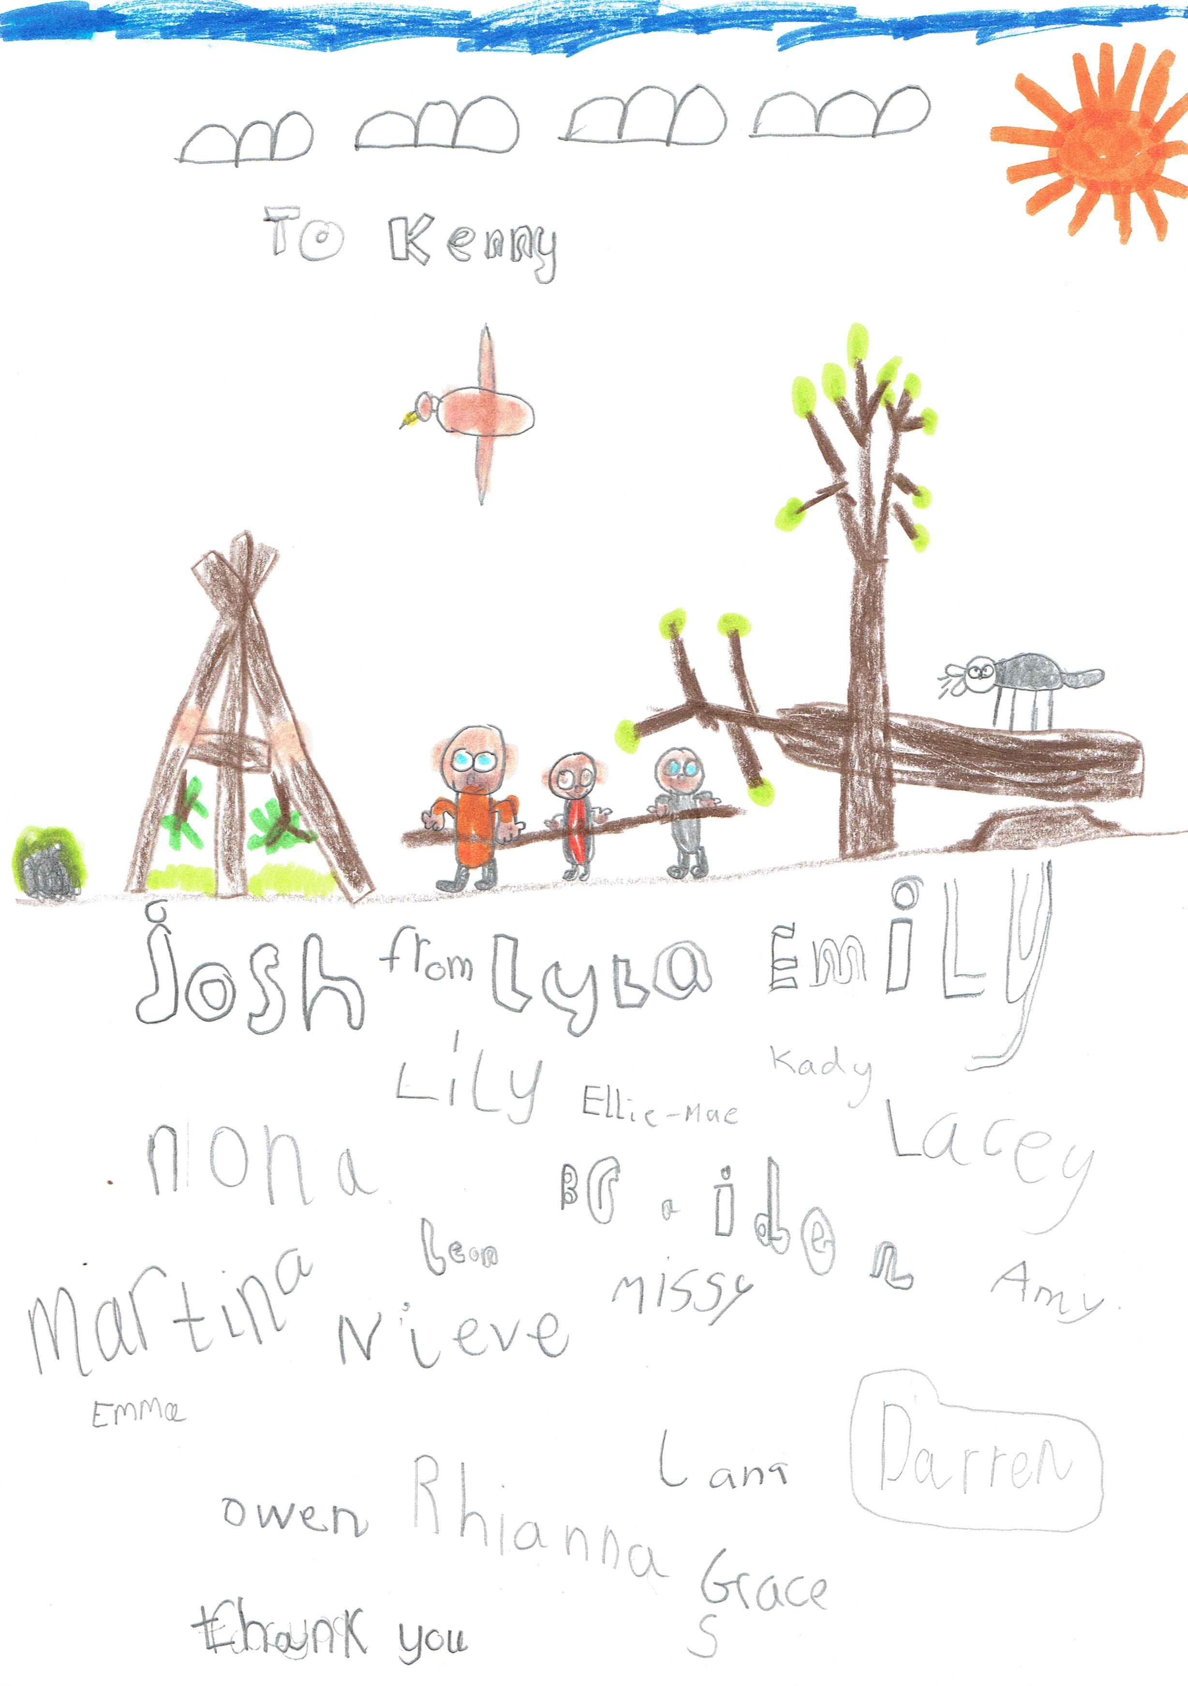
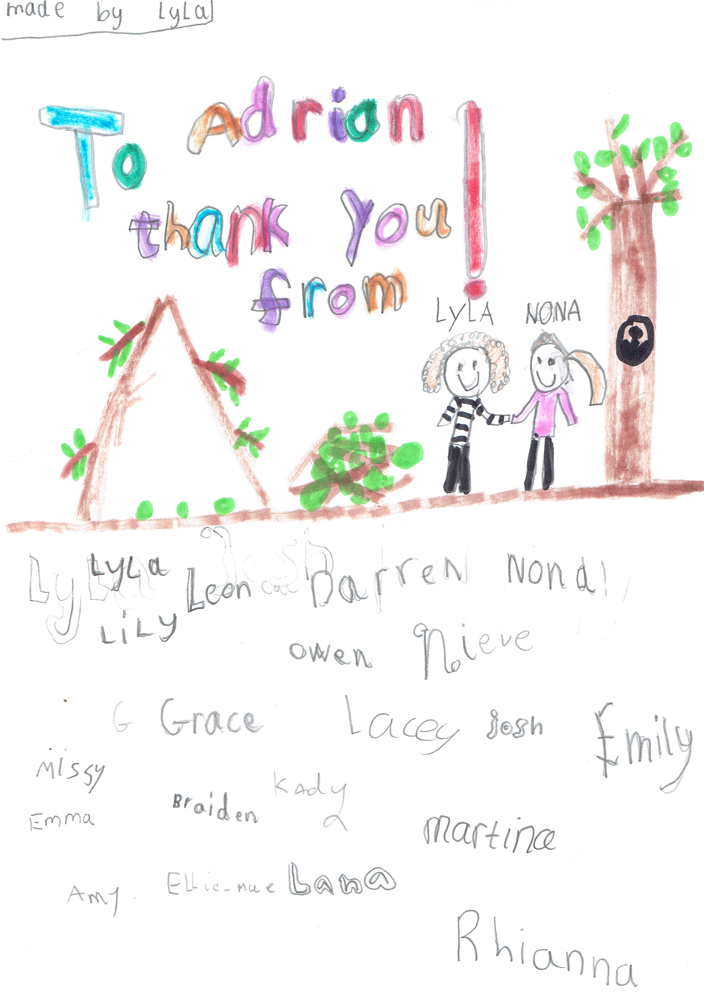
Park Primary School – 2 cards (June 2015)

19.6.15

Sounds like a great day. Thank you to everyone for their involvement in this project, we are delighted to have been given the opportunity to be part of it.

Does anyone have a good picture from Friday that we could put in the newsletter and on the Facebook page?

Thanks

Karen
(Karen Cormack, Rector Dingwall Academy)

From: simon harry [mailto:simon.harry@forest-education.co.uk]
Sent: 20 June 2015 07:51
To: Stephen Gaffney
Cc: Karen Cormack; DavidSmith; adrian.clark444@btinternet.com
Subject: awards ceremony

Hi Stephen,

Great to see you and the pupils yesterday, I’m sure you’ll agree is was a great ceremony especially as both parties gained recognition for their work done on the woodland cabin project.

As we didn’t have the opportunity to discuss the awards yesterday, may I suggest that Dingwall academy keep the plaque, trophy and certificate as these would make a welcome addition to the schools trophy cabinet to be enjoyed by all the school and Evanton wood keep and install the magpost outside the cabin. This would benefit not only Dingwall pupils visiting the wood but also other schools, some of whom also played a part in the cabin project.

Regarding the monetary prize, maybe we could sit down and discuss how best this would help further the partnership between Evanton Community Wood and the school, we could try for a date before the end of term?

I have contacted the Forestry Commission to get copies of the pictures taken by the photographer yesterday but in the meantime, would it be possible to have copies of the ones you took for our files and website.

Simon

From: Sarah Mackay - Obsdale Primary [mailto:sarah.mackay2@highland.gov.uk]
Sent: 11 June 2015 15:36
To: simon harry
Subject: RE: thanks and see you soon

Hi Simon,
We had a great day in the woods – many thanks to Jack and Ken for all the activities and patience !
I mentioned when you came to visit at school that I’d be interested in joining the OWLS committee so keep me in mind next session.
We will definitely try to get out more often next year.

Many thanks
Sarah
Obsdale

From: Roslyn Keyes - Park Primary [mailto:Roslyn.Keyes@highland.gov.uk]
Sent: 02 June 2015 15:50
To: simon harry
Subject: RE: school visit

Hi Simon
P2/3 were on a successful trip to Evanton Woods today. Thank you very much for organising this for us.
The comments were very positive on the bus trip home.
Mr. Adrian was taking photos throughout our trip which he promised to send to us – that would be wonderful.
But if they were to be used for any other purpose e.g. website, I’d have to ask the parents’ permission first.
We’d need to be specific about what they were to be used for.
Most are usually ok about this.
Thank you
Roslyn

8.6.15
Thank you for letting me come and help out with the primary 7's in Evanton woods last Friday. I was planning on coming and helping out every Friday but i don't think i will be able to continue volunteering with you. The school timetable at the academy changed this week and I've now realised how important it is to attend as many classes as possible. Especially since I'm doing my highers all my teachers have been emphasising the amount of work having to be put in and by potentially having to catch up on work from being out of class would add to all the work i already have to put in.
I am still interested in doing volunteering work at the weekends, so if you would like help at any events I would be happy to help if the time suited.

Thank you,
Megan Bell

From: Irene Cameron - Kiltearn Primary [mailto:irene.cameron@highland.gov.uk]
Sent: 28 May 2015 11:17
To: simon harry (simon.harry@forest-education.co.uk)
Subject: visit on Friday 29th May

Hi Simon,
The pupils have designed some great ideas for the seating area –I’ll bring them with me tomorrow. Also have ideas for the art work inside the cabin. Maybe the support assistant I have could take a small group-( 3-4 pupils max.) to start on this tomorrow if you wish? Do you have art materials in the cabin or would we need to bring paints etc with us. Looking forward to our visit tomorrow. The pupils are really enjoying themselves and so am I! Hope we can avoid the showers forecast!

From: Gavin Sked [mailto:Gavin.Sked@highland.gov.uk]
Sent: 19 February 2015 09:22
To: simon harry
Subject: RE: possible meeting

Hi Simon,
Thanks for taking the time to show me around last week. You have an excellent resource and project. I read your teachers pack, its well written and really helpful. Quite a few primaries I have visited have talked about the risk assessment process for outdoor visits being overly complex. I have organised a meeting with the folk responsible to try and find out why this is and if it can be simplified.
I would press on with your plans for a toilet though, I think it will make a difference to what groups and staff you will attract.
Cheers
Gavin

……
Sent: 03 December 2013 17:18
To: simon.harry@forest-education.co.uk
Subject: THANK YOU

Hi Simon,
The kids thoroughly enjoyed their trip to the woods on Friday, despite the weather they came back smiling, having loved their visit. I totally forgot to give the competition entries to Iain, will I post them to him?

Many thanks for the great day out on Friday from all of the children ☺

Isobel Sutherland
Acting DHT

Coulhill Primary School

6.6.13
Hi Simon
I was really disappointed that I was not able to join you on Tuesday but pressure of work, meetings etc meant it was just not possible. I have seen the photos and obviously missed a tremendous day. Many thanks for making this possible and I hope it is going to be the first of many visits.
Regards
Maureen
Maureen MacKenzie
Head Teacher
St Clement’s School

24.6.13
Simon

Hi. Thanks for the feedback. It is alway good to hear that a talk goes well. There were plenty of enthusiasts at the talk. Lots of questions at the end and during, which is always good.

Yes, Saturday was good a Water Cricket, a Horsehair worm, tadpoles of various ages lots of Large Red Damselfly larvae and the two boys Harry and ? found 2 adult large reds, one of which I caught and we all had a good look at. Adrian said he would be putting it on Facebook! The current pond is not ideal for dragonflies but the proposed new ponds will be and I am sure they will get colonised pretty quickly.

One thing that could be done for the existing pond is clearing back some of the trees say 2 or 3 metres from the edge of it in the Autumn time to allow more light into the pond area.

I'll pop back to the pond later in the summer to have another look. I'll get a full species list to you this week of what I found.

Regards

Jonathan
----- Ori
Subject: RE: Obsdale Primary

Hi Simon,

I hope you had a good Christmas and New Year. Here are some comments for you to use for the website if you wish (it only took be almost a month to get these to you...sorry!):

Sophie (8): "It was excellent...my favourite part was when I got to pet the horse."

Darren (8): "I've never seen wood carving that smooth before."

Mack (5): "We saw a little Christmas Tree. It was a great time".

Tomasz (8): "It was really great."

Martin Harkins (Teacher): "Thanks to all at Evanton Woods for a great day! The children had an amazing time and it was a very valuable opportunity for them to experience some of the work that goes on in a local forest and make some great links to other areas of the school curriculum."

Kind regards,

Martin

