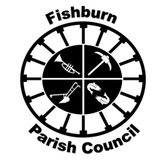 | FISHBURN PARISH COUNCIL  e-mail: fishburnparishcouncil@hotmail.com  Website: www.fishburnparishcouncil.org.uk  Chair: Cllr. Sandra Jean Dowson

NOTICE OF FISHBURN PARISH MEETING

I hereby give notice that the Annual Meeting of Fishburn Parish will be held in the meeting room in Fishburn Youth Community Centre, Butterwick Road, Fishburn, commencing at 6:30 p.m., on

Tuesday 6th May 2025

All members of the Parish Council are summoned to attend for the purpose of considering and resolving the business to be transacted at the meeting as set out hereunder.

The Council would welcome attendance from members of the public to ascertain your views.

J.Robinson

Mr. J.Robinson
Clerk to the Council
 | AGENDA
1. | Address of welcome from Chair of Fishburn Parish Council
2. | Apologies for absence
 | To receive member apologies for absence.
3. | Minutes of Annual Parish meeting 2024
4. | Annual Accounts 23/24
5. | Annual Parish Report by Chairman
6. | Questions from members of the public
7. | 2025 Durham County and Fishburn Parish Council election s  To note election of County and Parish Councillors
8. | Date of 2025 Annual Parish meeting.  John Robinson  Parish Clerk  10th April 2025.

