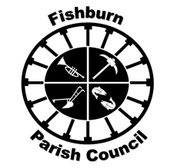 | FISHBURN PARISH COUNCIL  e-mail: fishburnparishcouncil@hotmail.com  Website: www.fishburnparishcouncil.org.uk  Chair: Cllr. Sandra Jean Dowson | 

NOTICE OF FISHBURN PARISH MEETING

I hereby give notice that the Annual Meeting of Fishburn Parish will be held in the glass meeting room in Fishburn Youth Club building, Butterwick Road, Fishburn, commencing at 6:30 p.m., on

Thursday 23rd May 2024

All members of the Parish Council are summoned to attend for the purpose of considering and resolving the business to be transacted at the meeting as set out hereunder.

The Council would welcome attendance from members of the public to ascertain your views.

J.Robinson

Mr. J.Robinson
Acting Clerk to the Council
 | AGENDA
1. | Address of welcome from Chair of Fishburn Parish Council
2. | Apologies for absence
 | To receive member apologies for absence.
3. | Minutes of Annual Parish meeting 2023
4. | Annual Accounts 22/23
5. | Annual Parish Report by Chairman
6. | Questions from members of the public
7. | DURHAM COUNTY COUNCIL  To receive an update on matters relating to Durham County Council.
8. | Date of 2025 Annual Parish meeting.

