THE ROYAL SCOTTISH COUNTRY DANCE SOCIETY  GLASGOW BRANCH  Charity No SC008002  Membership: Les Lambert  email: membership@rscdsglasgow.org | 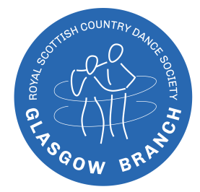  www.rscdsglasgow.org

Application Form for Joint Adult Membership 2023-2024 - two adults who live at the same address

1 Title | Surname | First Name
 |  | (Give preferred name i.e. the first name you use)
 | First Name if different from above
2 Title | Surname | First Name
 |  | (Give preferred name i.e. the first name you use)
 | First Name if different from above
Please state any official names if different from above
Address
Postcode |  | Telephone Number(s)

E-Mail Address Member 1
E-Mail Address Member 2

(We use email for subscriptions, renewals, notices and Newsletters. If you do not have an email address, please contact us)

We wish to join the Glasgow Branch as New Joint Annual Members [1/7/2023 – 30/6/2024]
and enclose our remittance of £56.00 of which a proportion goes to Headquarters.
We agree that the RSCDS and RSCDS Glasgow Branch may hold our Membership details on computer for the purposes of Branch and Headquarters’ business only.
RSCDS and RSCDS Glasgow Branch do not share Membership details with other third parties.
(Data Protection: GDPR)

We agree that RSCDS Glasgow Branch may send us important communications by email. | Yes |  | No

Signed |  | Date
Signed |  | Date
If this Form is being emailed from a personal email account it need not be “signed”. Just type your “signatures”.
(If this Form is being posted it MUST be signed.)

(If posting, please return the completed form along with appropriate remittance (or preferably use bank transfer),
to the Membership Secretary, or class teacher.
We prefer the form being emailed with payment made by bank transfer (or if necessary, by cheque).

Payment by internet banking: (REF: SUBS + your NAME).
RSCDS Glasgow Branch, sort code 80 54 01 a/c 00772964
(All cheques to be made payable to RSCDS Glasgow Branch.)

Please indicate below which class/classes you have attended or are about to attend:

The subscription year is from 1 July to 30 June.
As a member of the Branch you become a member of the Royal Scottish Country Dance Society. This means you will be welcome at any other RSCDS Branch in Scotland, in other parts of the UK and in the rest of the world.

