THE ROYAL SCOTTISH COUNTRY DANCE SOCIETY  GLASGOW BRANCH  Charity No SC008002  Membership Secretary Email: leslambert08@gmail.com | 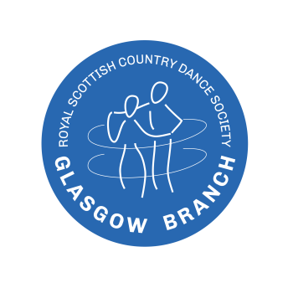  www.rscdsglasgow.org
MEMBERSHIP APPLICATION FORM
- PERSONAL DETAILS
Title |  |  | First name |  |  |  | Surname
If joint membership, name of second member
Address
Post code |  |  |  |  |  | Telephone No.
Email address

- MEMBERSHIP SUBSCRIPTION CATEGORIES (1st July - 30th June)
Category |  | Age Range | RSCDS | Branch | Total Payable | to select
 | Adult single | 25+ | £29 | £7 | £35
 | Adult joint for two people (both 25+) at the same address | 25+ | £46 | £14 | £59
 | Young Adult | 18-24 | £23 | £7 | £30
 | Youth | 12-17 | £15 | £7 | £22
 | Non-Subscribing Junior Membership | Under 12 | £0 | £0 | Free
 | Associate Membership for those who pay their Society membership through another Branch:  Other Branch Name: ______________________________ | Any | £0 | £7 | £7

Method of payment (please tick) | Cash |  | Cheque |  | BACS Transfer

Is this a renewal of your membership from last year? (please tick) | Yes |  | No

- ATTRIBUTES (Please tick all that apply)
Dancer | Teacher - RSCDS Fully certificated | Teacher - RSCDS Partly certificated | Teacher – not RSCDS certified | Musician | Adjudicator | Examiner

- DECLARATION
By signing below, I agree to my personal details being held on both the RSCDS Glasgow Branch and RSCDS Headquarters databases, and that my email address may be used to keep me informed of Scottish Dance related activities. I understand that my data will not be passed on to a third party.
Signature 1 |  | Date
Signature 2 (joint accounts only) |  | Date
Please complete and return this form with your payment (see over)

FOR INFORMATION ONLY
- You can return your form by:
- Branch Class - giving your application form and payment to the class representative.
- Post - mailing your printed application to - Mr Les Lambert, 16 Ewing Street, Kilbarchan, PA10 2JA
- Email – sending your application to leslambert08@gmail.com If you are unable to sign the form to email it,
just type your name in the ‘signature’ box instead.
- You can pay by:
- Branch class – give your payment with your application form (tick ‘Cash’ at method of payment on the form)
to the class representative.
- Post – include a cheque made payable to ‘RSCDS Glasgow Branch’ with your application form (tick ‘Cheque’
at method of payment on the form), and send to the above address
- BACS Transfer - this is the preferred method of payment. Send you application form to the email address
above (1c) and at method of payment in the application form tick ‘BACS Transfer’
Account name | RSCDS Glasgow Branch
Sort Code | 80-54-01
Account No | 00772964
Reference | SUBS (and your) NAME, for example, ‘SUBS JOE BLOGGS’

