Cyngor Cymuned Tregolwyn
Colwinston Community Council

Ffôn/Phone: 07930 956373
E-Bost/E-Mail: colwinstoncc@gmail.com

Minutes of an Ordinary Meeting of the Council Held in the Colwinston Village Hall Monday 18 December 2023 at 7.00pm

Present:  In Attendance: |  | Councillors: E Lewis (Chairman), G Jones, B Morris, C Nightingale,  Cllr C Cave (VOGC) &  Ms S Hookins (Clerk),
Item 1:  135/23 |  | Apologies for Absence:  Cllr C Hadley, Cllr H Thomas, Cllr R Cronin & PCSO A Stone
Item 2:  136/23 |  | Community Police Matters:  PCSO A Stone  Was unable to attend the meeting but updated council that there had been one incident of a mobile phone theft.
Item 3:  137/23 |  | Declarations of Members’ Interest:  None
Item 4:  138/23 |  | Public Session:  One member of the public attended and wished for clarification on the publishing of draft minutes.  The Clerk explained the new legislation (Schedule 4, Part 1 of the 2021 Act) which requires Councils to publish within 7 days, notice of who attended, any declarations of interest and decisions made. Therefore, the Clerk publishes the draft minutes.
Item 5:  139/23 |  | Vale of Glamorgan Matters  - December report-Noted  Cllr Cave also updated the Council on progress about the Landfill relocation at Llandow. A new site is still unknown however the road to access the current site has been improved.  Council reported to Cllr Cave that a block of street lighting is not working on Crack Hill and asked that this is reported to the relevant Vale officer.
Item 6:  140/23 |  | Approval of the minutes of the Meeting held on 20 November 2023.  Resolved: To confirm and sign the minutes of the meeting held on 20 November 2023 with two amendments, to include reference to the financial paper Cllr Jones distributed during the meeting to be discussed under financial matters at tonight’s meeting and to include reference to Cllr Jones proposal to change the financial regulations with regard when there is a requirement to get quotes. The Clerk informed council that this was not an agenda item and therefore had not been included in the resolutions (LGA 1972, Sch12, para10(2)(b)), but that this had not been made clear during the meeting, which in future it will be. The Chairman has requested that in future agendas an item for urgent business can be included, the Clerk will include this item on the understanding it is only used for urgent business.
Item 7:  141/23 |  | To consider any matters arising from the Meeting held on 20 November 2023 that are not on the agenda.  Village Defibrillators-Cllr Jones does not feel he is able to carry out the necessary checks on these and requests that due to how important their maintenance is that maybe there is a firm who will do this for communities like Colwinston and asked the Clerk to investigate this as an option.
Item 8:  142/23 |  | Reports of Council’s Representatives on Outside Bodies:  Cllr Ed updated Council that he was unable to attend the LDP webinar due to technical difficulties.
Item 9:  143/23 |  | Finance  - Bank Reconciliation up to date  Noted  - YTD Financial Report up to date  Cllr Jones discussed his report and hoped that it helped other councillors better understand the current financial situation. Council thanked Councillor Jones for the work on his report.  - Forecast to year end & Budget 2024/25  The Clerk discussed the YTD costs and Forecast to the end of the year. On the current projection the Council will have a deficit at year end, the forecast includes spending on 2 projects yet to be started.  Resolved: The budgeted money for the Little Hill Steps and a new Noticeboard will be held in reserves earmarked for these projects.
Item 10:  144/23 |  | Future Projects-Precept Setting  In January the Council will be setting the Precept for 2024/25. The Clerk asked members to think of projects they would like to do next year. Cllr Ed has distributed a list of potential projects for members to consider. The Clerk will collate these for the January meeting.  Resolved: Considering the current financial position and the work needed to be done particularly in the Old Ford area the council wish to start with a projection of 10% increase and asked the Clerk to construct a draft budget on this basis for the January meeting.
Item 11:  145/23 |  | Village Maintenance (including the Old Ford are)  Council wished to thank Cllr Hadley for his work on this and Cllr Lewis confirmed that Grant Smith has carried out some needed maintenance.  Resolved: To approach contractors for prices to maintain these areas under contract to compare with the current ad hoc maintenance.
Item 12:  146/23 |  | Standing Orders  The Council members are still reviewing these, deferred to January
Item 13:  147/23 |  | Section 106-Redrow Development (Land to the rear of St. David’s Primary School, Colwinston)  Council thanked Cllr Cave for forwarding the information on this so they can have an input into how the money is spent.  Resolved: The Council wish to propose 2 alternative options for consideration by the Vale of Glamorgan that they feel have more direct benefit to the Colwinston Community.  - An electronic speed sign on the school road but higher up by the large layby.  - A streetlight on the steps known locally as little hill.
Item 14:  148/23 |  | Financial Regulation Review  The Clerk has distributed a new version of the financial regulations based on the One Voice Wales model for 2019. There are very few differences between these and the current ones, but they’d include some legislation updates.  Resolved: The Council wish to set up a working group to review these and other financial matters and report back to the Council. The working group members will be Cllr G Jones, Cllr B Morris and Cllr C Nightingale.
Item 15:  149/23 |  | TWIG Grant Update  Cllr Lewis, Cllr Morris and the Clerk attended an informal visit to Brynagrarw Park who are currently benefiting from a grant. The tour highlighted some alternatives to woodland management and some key advice on applying for a grant. The two rangers would like to visit the Colwinston woodland and an invitation to attend in January has been made.  Resolved: The Colwinston Community Council wish to go ahead with applying a second time for the TWIG Grant and wish the Clerk to start working on the application.
Item 16:  150/23 |  | Vale of Glamorgan Council Replacement Local Development Consultation  The Clerk has distributed the dates of events organised by the Vale of Glamorgan for information on this.  Resolved: The Council wish to review their response to the first consultation and draft a response to this consultation on similar grounds to be brought to the January meeting for discussion.
Item 17:  151/23 |  | Councillor Roles  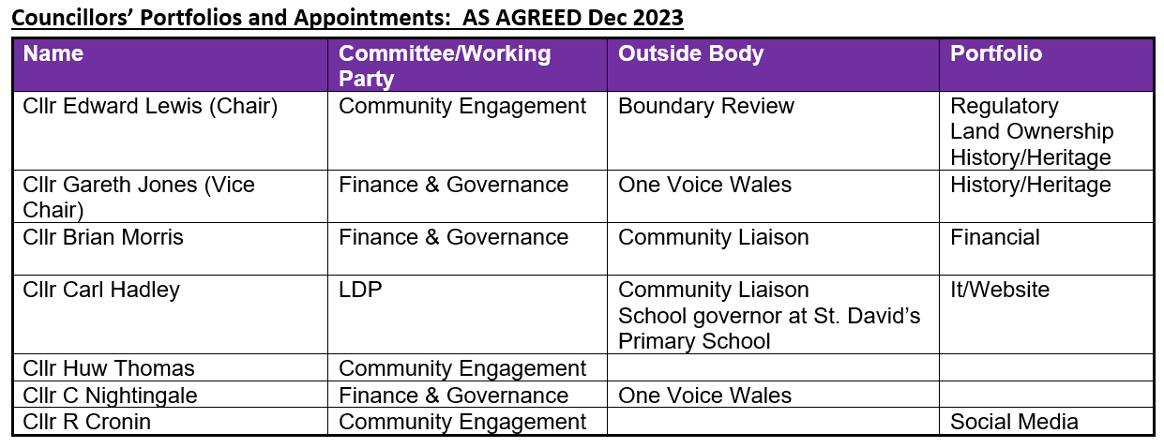
Item 18:  152/23 |  | Church Yard Maintenance  Local Government Act 1972 c. 70Part IX Miscellaneous functions Section 215  Resolution: Council agreed to donate £500 to help maintain the Church Yard for another year.
Item 19:  153/23 |  | Correspondence  - Survey/Consultation  - Vale of Glamorgan Council Consultation – Annual Delivery Plan 2024-25  - Independent Remuneration Panel for Wales Draft Annual Report - February 2024 - Extended closing date.  - Council Tax Reform  - Have Your Say on Gypsy, Traveller and Show people Sites  New consultation: Local Government Finance (Wales) Bill  Noted
Item 20:  154/23 |  | Planning matters
 | Application |  | Action
i | Planning Application No. 2021/01800/FUL  Location : 5, Maes Y Bryn, Colwinston  Proposal : Removal of existing single storey side and rear extensions and replacement with new two storey side extension and single storey rear extension. Addition of driveway to provide off street parking and reinstatement of original pathway to relocated front door |  | 10/02/2022-No Objection  16/10/2023-Update on plan, extension requested to comment  05/12/2023-Approved
ii | Planning Application No. 2023/00037/FUL  Location : 44, Heol Cae Pwll, Colwinston  Proposal : Take down existing boundary fencing and renew, increasing height as indicated to 1900mm |  | 20/02/2023- The Council had no objection to the Application to renew the fence but they do not agree to retrospective planning consent and the loss of the well-established hedge.
iii | Planning Application No. 2023/00873/FUL (ED)  Location : Pwll Y Wrach, Colwinston  Proposal : Replacement of an existing squash court building with a tennis court |  | 20/11/23-No Objection
iv | Planning Application No. 2023/01029/CAC (VI)  Location : Field access to the West of Village Farm House, Colwinston  Proposal : Repairing existing stone wall, reusing existing stone, and widening of field  access with new gate |  | 06/11/2023-Objection  05/12/2023-Refused
Item 21:  155/23 |  | Date & Time of next meeting  15th January 2024
iii |  | Planning Application No. 2023/00037/FUL  Location : 44, Heol Cae Pwll, Colwinston  Proposal : Take down existing boundary fencing and renew, increasing height as indicated to 1900mm |  |  | 20/02/2023- The Council had no objection to the Application to renew the fence but they do not agree to retrospective planning consent and the loss of the well-established hedge.  20/11/2023-resubmit the Council response.
v |  | Planning Application No. 2023/01029/CAC (VI)  Location : Field access to the West of Village Farm House, Colwinston  Proposal : Repairing existing stone wall, reusing existing stone, and widening of field  access with new gate |  |  | 06/11/2023-Response time extension requested  20/11/2023-Objection-Retrospective application, no mention of reinstating the stile a county treasure and query on the enforcement notice status in this.
 |  | Meeting ended at 8.48 pm

