Cyngor Cymuned Tregolwyn
Colwinston Community Council

Ffôn/Phone: 07706 252993
E-Bost/E-Mail: colwinstoncc@gmail.com

Minutes of the Annual General Meeting of the Colwinston Community Council Held in the Colwinston Village Hall on Monday 15 May 2023 at 7.00pm

 | Present:  In Attendance: |  | Councillors: E Lewis(Chairman), G Jones(Vice Chairman), B Morris, J Lloyd, C Hadley, H Thomas & T Wilson  Cllr C Cave (VOGC), & Ms S Hookins (Clerk)
 | Item 1:  19/23 |  | To Elect the Chairman of the Community Council for 2023/2024  Resolved: Cllr E Lewis was duly elected to be Chairman of the Council 2023/24
 | Item 2:  20/23 |  | To Elect the Vice Chairman of the Community Council for 2024/2024  Resolved: Cllr G Jones was duly elected to be Vice-Chairman of the Council 2023/24
 | Item 3:  21/23 |  | Apologies for Absence:  PCSO Angela Stone
 | Item 4:  22/23 |  | Community Police Matters:  Although PCSO Angela Stone was unable to attend the meeting she updated the clerk that there had been one incident of a theft from a garage in the Colwinston & Lampha area during the month.
 | Item 5:  23/23 |  | Declarations of Members’ Interest:  None
 | Item 6:  24/23 |  | St David’s Church in Wales Primary School  The Council would like to thank Mr M Sinnett Co headteacher of the school for joining the council at their meeting. The council led a discussion about various items that have been mentioned to the council including parking, bus usage, the water tank and an open day. Cllr Cave is going to speak to the Vale of Glamorgan to gauge the bus usage and Mr Sinnett will update the council on when an open day is to be organised and that the school will endeavour to remove the cones when not in use. The council would like to invite the school representatives to future meeting and that if there is anything the council can assist the school with they hope the school will contact members.
Public Session:
The meeting was attended by 2 members of the public with 3 issues
The Hedge at Pantiles although an attempt has been made to cut back is still causing an issue for taller vehicles driving down the road. Cllr Cave will contact the Vale of Glamorgan regarding this as the community council had previously reported it.
During May the Community Council was contacted by Mr Austin about the road surface, where a particular area is now forcing cyclists to the opposite carriageway due its state of repair. The Council will look into this and contact the Vale of Glamorgan about it.
Dog Fouling again is becoming a problem in the village. Cllr Cave will contact Colin Smith in the Vale of Glamorgan and this shall be brought back to the June meeting.
 | Item 7:  25/23 |  | To appoint Committees and working parties--See Table Below  - Personnel Committee  - Community Engagement Working Party
 | Item 8:  26/23 |  | To Appoint Representatives –-See Table Below  - Community Liaison  - One Voice Wales-2 Vacancies  - Village Community Association  - Youth Club  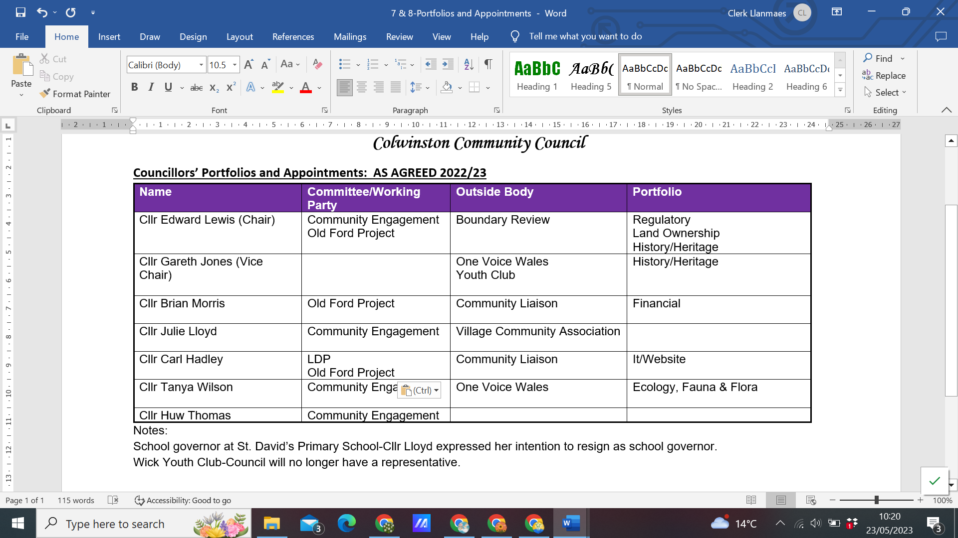
 | Item 9:  27/23 |  | Annual Accounts and Audit 2022/2023  - Clerk’s Report on Financial Accounts 2022/2023  - Annual Return 2022/2023  Resolved: The Clerk presented a draft Annual Return and will confirm with Council the date for the Internal Audit. The Internal Audit Report and completed Annual Return will be presented to Council in the June Meeting.  - Confirm Appointment of Internal Auditor 2022/23  Resolved: To confirm the appointment of Mr A Davies as the internal auditor.
 | Item 10:  28/23 |  | To Review the Council remuneration for 2023/24  The Clerk informed Council that the Councillor Working from Home allowance for members is now £156 per year.  Resolved: Clerk will provide members with a form for them to complete about whether they wish to receive the allowance this year or not. No optional allowance payments were adopted.
 | Item 11:  29/23 |  | To Review the Council Risk Assessment Register  Resolved: The Council Adopted the Risk Assessment Register
 | Item 12:  30/23 |  | To agree the proposed meeting dates 2023/24  Resolved: The Council agreed to meet on the 3rd Monday of each month at 7pm, with one amendment in December to an earlier week.
 | Item 13:  31/22 |  | To appoint an internal auditor for 2023/23  Resolved: The Clerk will approach the current and other auditor’s and bring to the council for review.
 | Item 14:  32/23 |  | Approval of the minutes of the AGM held on 16 May 2022  Resolved: To confirm and sign the minutes of the meeting held on 16 January 2023.
 | Item 15:  33/23 |  | To consider any matters arising from the AGM held on 16 May 2022 that are not on the agenda  None
 | Item 16:  34/23 |  | Approval of the minutes of the Meeting held on 17 April 2023  Resolved: To confirm and sign the minutes of the meeting held on 16 January 2023.
 | Item 17:  35/23 |  | To consider any matters arising from the Meeting held on 17 April 2023 that are not on the agenda  None
 | Item 18:  36/23 |  | Council Insurance Renewal:  Resolved: The Clerk will confirm that the Zurich Quote includes the area known as the Old Ford Project and if so to accept the Zurich Renewal Quote.
 | Item 19:  37/23 |  | Community Matters  - Community Areas  - Tree Survey-The Clerk has contacted the contractors again about a tree survey and will update the council when further quotes have been received.  - Community Engagement-Cllr Lloyd updated the council on the successful village Kings Coronation events, the council were also showed the wild seed packet that the Bridgend Council distributed and suggested that Colwinston might wish to consider a similar idea.  Resolved: Cllr Lloyd will investigate costs and numbers and update council.
 | Item 20:  38/23 |  | National Lottery Grant  The Chairman was pleased to announce that Colwinston have been successful in the first application level for a woodland grant.  Resolved: The deadline for the second tier is 4th July. This includes quotes and several areas of work. The Chairman has contacted Mr Hewitt for further advice and with a working group of Cllr Lewis Cllr Morris & Cllr Hadley will work on completing the application.
 | Item 21:  39/23 |  | Colwinston Logo  The Colwinston Community Council do not have a logo as a council and are considering adopting the poppy logo they have used on their Old Ford Project sign.  Resolved: The Clerk will investigate if the poppy picture would encroach on the RBL poppy copyright.
 | Item 22:  40/23 |  | Bio-Diversity Draft  Resolved: The Council wish to adopt and publish the bio-diversity draft report.
 | Item 23:  41/23 |  | Website  The current website will lose its support in the future and an upgrade to the latest version has been offered.  Resolved: The Council wish to accept the new price and the upgrade of the website.
Planning matters
- LDP-No Update
- Update on current planning applications
 |  | Application |  | Action
i |  | Planning Application No. 2021/01800/FUL  Location : 5, Maes Y Bryn, Colwinston  Proposal : Removal of existing single storey side and rear extensions and replacement with new two storey side extension and single storey rear extension. Addition of driveway to provide off street parking and reinstatement of original pathway to relocated front door |  | 10/02/2022-No Objection
ii |  | Planning Application No. 2023/00037/FUL  Location : 44, Heol Cae Pwll, Colwinston  Proposal : Take down existing boundary fencing and renew, increasing height as indicated to 1900mm |  | 20/02/2023- The Council had no objection to the Application to renew the fence but they do not agree to retrospective planning consent and the loss of the well-established hedge.
iii |  | Planning Application No. 2023/00297/FUL (VI)  Location : Sycamore Tree Inn, Coed Masarnen, Colwinston  Proposal : The erection of a small decking area out the front of the pub, which will have  tables for people to eat and drink on
 |  |  | Meeting ended at 8.48 pm

