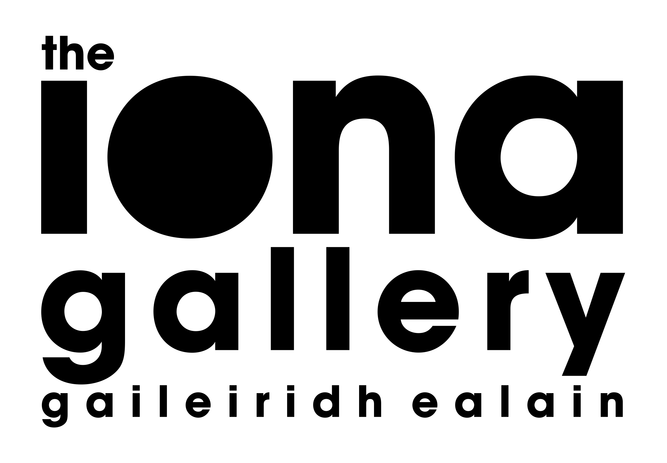

**SOCIETY OF BADENOCH & STRATHSPEY ARTISTS**

**SC046852**

**MEMBERSHIP FOR 2025**

| Name |  |
| --- | --- |
| Address |  |
|  |  |
|  |  |
| Telephone |  |
| Email |  |

| Annual Subscription |  | £20-00 |
| --- | --- | --- |
| **Donation** |  | £ |
| **By direct bank payment to Bank of Scotland**  Sort Code 80-22-60 Account 17487268 | |  |
| **By cheque payable to SBSA** | |  |

**(Please tick your method of payment)**

**NOTES**

Please complete this form and send to the Treasurer.

Roy Alexander, Lochnagar, Main Street, Newtonmore PH20 1DR

Email address: roya@a9partnership.co.uk

*\*It is essential for communication purposes that you do this, even if you are paying directly to the bank.*

**DATA PROTECTION:** In providing this information, you are giving us consent to hold this information securely for internal membership purposes only.