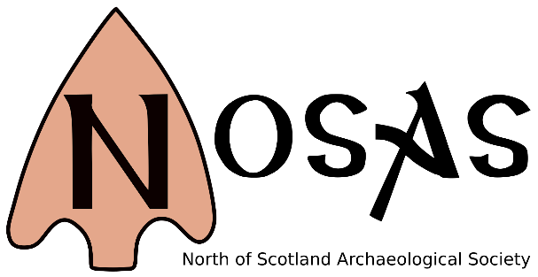**BOOKING FORM**

**NOSAS 20 YEARS CONFERENCE WEEKEND**

**23rd-25th March 2018 Inverness**

|  |  |  |  |  |  |
| --- | --- | --- | --- | --- | --- |
|  | **1st Person** | **2nd Person** | | | |
| **Name?** |  |  | | | |
| **Address?** |  |  | | | |
| **Telephone Numbers:** | **Mobile:**  **Home:** | **Mobile:**  **Home:** | | | |
| **e-mail address:** |  |  | | | |
| **Please indicate any**  **dietary requirements:** |  |  | | | |
| **Any disability that is likely to need our consideration?** |  |  | | | |
|  | | | | | |
| *Please select* | | | **Cost per person** | **How Many People?** | **Enter**  **Total Sum** |
| **Friday afternoon walk along the Caledonian Canal** | | | **Free** |  |  |
| **Friday evening lecture presentation:**  **Fraser Hunter – Romans & the Highlands** | | | **Free** |  |  |
| **Friday Buffet Dinner before Fraser Hunter’s lecture** | | | **£10** |  |  |
| **Saturday Conference**  **This includes coffee and tea at breaks, but no lunch** | | | **£16** |  |  |
| **Soup & Sandwich lunch at Saturday Conference** | | | **£7** |  |  |
| **Saturday Evening Dinner at Hotel Mercure, Inverness** | | | **£30** |  |  |
| **Sunday Field Trip near the Slochd - Sluggan Bridge & Inverlaidnan** | | | **Free** |  |  |
| **Total Cost** | | | | |  |

|  |  |
| --- | --- |
| **Methods of payment:** | Please tick the appropriate box |
| * **By cheque:** made payable to North of Scotland Archaeological Society |  |
| * **By BACS transfer:** Royal Bank of Scotland 83-23-10 12685931   Please reference your BACS transfer with the words*:* ***20 Years*** |  |

Please return this completed application form, with your enclosed cheque, to NOSAS at:

By post: **Anne MacInnes**

**24 Ellis Park, Conon Bridge, Dingwall IV7 8HW**

Or email**: nosas20years@gmail.com**