***How to….* Guide, for using the JS Bone Spreadsheet**

The spreadsheet can be found here: <https://1drv.ms/x/s!AghLXhpbwJvn1gcA3dUsEMusyAkH?e=SXCpl4>

***What do you now want to do?***

* *Understand this spreadsheet?*
* *Or, skip understanding, and go straight to searching, (see the next page)?*

You’ll see a spreadsheet with 12 columns across the page/screen. There are 6148 rows from the top to the bottom of the sheet, representing 6147 separate photos.

This is a guide to the columns:

* **Format?** The images were originally in a variety of formats:
  + **Digital** images garnered from Jim Bone’s computer, taken with a digital camera
  + **HC** (Highland Council) **Slides** borrowed from the Historic Environment Team
  + **Negatives** in strips
  + **Prints** in envelopes or plastic sheets
  + **Slides** in boxes or plastic sheets
* **NOSAS Unique Identifier** – each image started by being given a NOSAS number. This is unlikely to help you now, unless you want to contact us, because you can’t find the NOSAS number on the Canmore website.
* **HES Scan Number** – Historic Environment Scotland’s Canmore archive scanned all the prints, slides and negatives we lent them. And so gave the digital images a HES scan number too.
* **Image Title - t**he digital images, in particular, had file titles, recorded here, given to them by the camera.
* **Image Year or Date** – the digital images had dates in their metadata representing the date the image was taken. It’s recorded here in a reverse sortable form, ie starting with year. The negatives, prints and slides sometimes have dates attached to them representing the date the film was processed, not necessarily the date of the image.
* **Canmore URL** – clicking on the hyperlinks in this column takes you directly to the image on the Canmore website where you can see information about what this image shows.
* **Google Satellite View** - clicking on the hyperlinks in this column takes you directly to the geographical location of the centre of the photo image on Google Maps. You might need to zoom in or out a bit to make sense of where you are.
* **Centre of Photo Grid Reference** – for each of the 6147 images we have recorded a 10-figure grid reference from (roughly) the centre of the photo image.
* **Canmore ID’s** – if there’s any interesting archaeology visible in the image, this number will take you to the site(s) on Canmore where you can find out more information. Sometimes the image is packed with archaeology, eg in a town, in which case just a selection of archaeology is listed here. A Canmore search engine is [here](https://canmore.org.uk/collection/1767881/details/), putting the ID number into the Search box at top R takes you to the relevant information.
* **HC HER ID’s** – These numbers are the relevant Highland Council equivalent to the Canmore numbers. Note that sometimes an archaeological feature is in one database and not another. [This link](https://her.highland.gov.uk/search) takes you to the HER Search page, putting the MHG number in here takes you to the information.
* **Title** – a short description of what the image shows
* **Scope & Content** – a more detailed description of what the image shows, often with some background information about the archaeological features.

**Search the Spreadsheet for a place or site**

1. 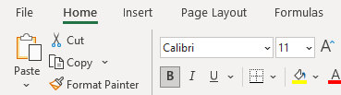Ensure you are working from the Home tab, top left. It should be underlined:
2. To search for a place or site, probably best to start with the ***Scope & Content*** column. Click on the letter, **Q**, above the column heading. This will highlight the entire column of 5149 rows.

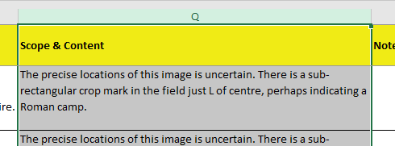

1. Diagram

   Description automatically generatedYou could alternatively search the **Title** column, as that will probably give you fewer images to search through. In that case, click on the letter, **P**, above the **Title** cell.
2. 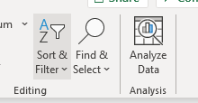Click on the Sort & Filter tab, top R. This will produce a drop-down list, select the fourth option down, Filter.
3. 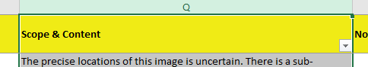The drop-down list will disappear, and you will notice a down arrow in the column heading.

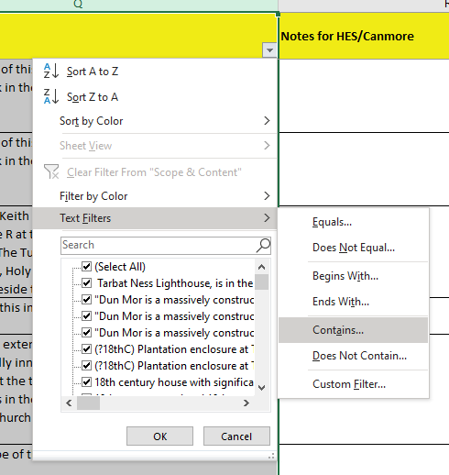

1. Click on it, a drop-down list appears, hover over **Text Filter,** then click **Contains…** in the sub-list that opens up (usually to the right).
2. 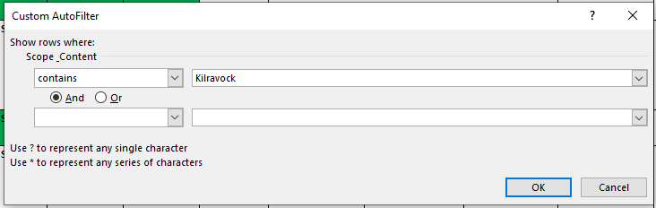A search dialogue box opens up. Enter the place or site in the first search row. So, say you are looking for images of Kilravock Castle just outside Inverness. Put Kilravock into the search box, then click OK. The spreadsheet will then remove all the rows that don’t contain Kilravock, leaving you with the five rows that do. Use the information in the other columns to explore further. Often the **Canmore URL** link is the easiest place to start.
3. To search for another place or site, repeat Stages 5 & 6 putting the new search term into the text box.
4. At the end, when you’ve finished, clear the search by clicking the arrow from the column heading (see stage 4) and click **Clear Filter from Scope & Content.**