The big news this month is that our application to the National Lottery “Awards for All” scheme has been successful, we have been awarded the grant of £3540. The fund will go towards more survey and recording equipment, including a digital camera and equipment for producing reports. Also on the shopping list is some basic excavation equipment.

A small team attended the day at Coille Leitir Fearna above Loch Oich in the Great Glen. Recessed platforms, often with well constructed and stone faced revetments, appear in several locations in Lochaber and the West coast, extending down to Kintyre. Evidence from excavation has revealed that huts were sited on the platforms and that they date from the 11th century, although some have been used for charcoal burning since. What is peculiar is that they are often on steep slopes and in remote locations. Our site is no exception to this. It is previously unrecorded and is the most northerly identified so far. Eight platforms were photographed and recorded and at least 4 others identified before worsening weather pushed us down the hill.

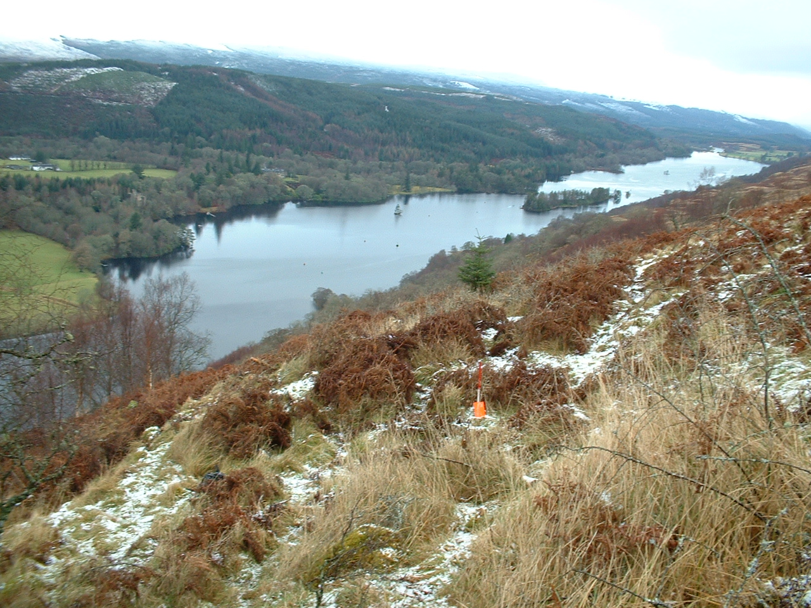

Meryl Marshall, 10 Riverford Crescent, Conon Bridge, Ross-shire, IV7 8HL, tel 01349 861824 or email [Meryl.Marshall@tesco.net](mailto:Meryl.Marshall@tesco.net)

**Recording and Plane Tabling at Rogart o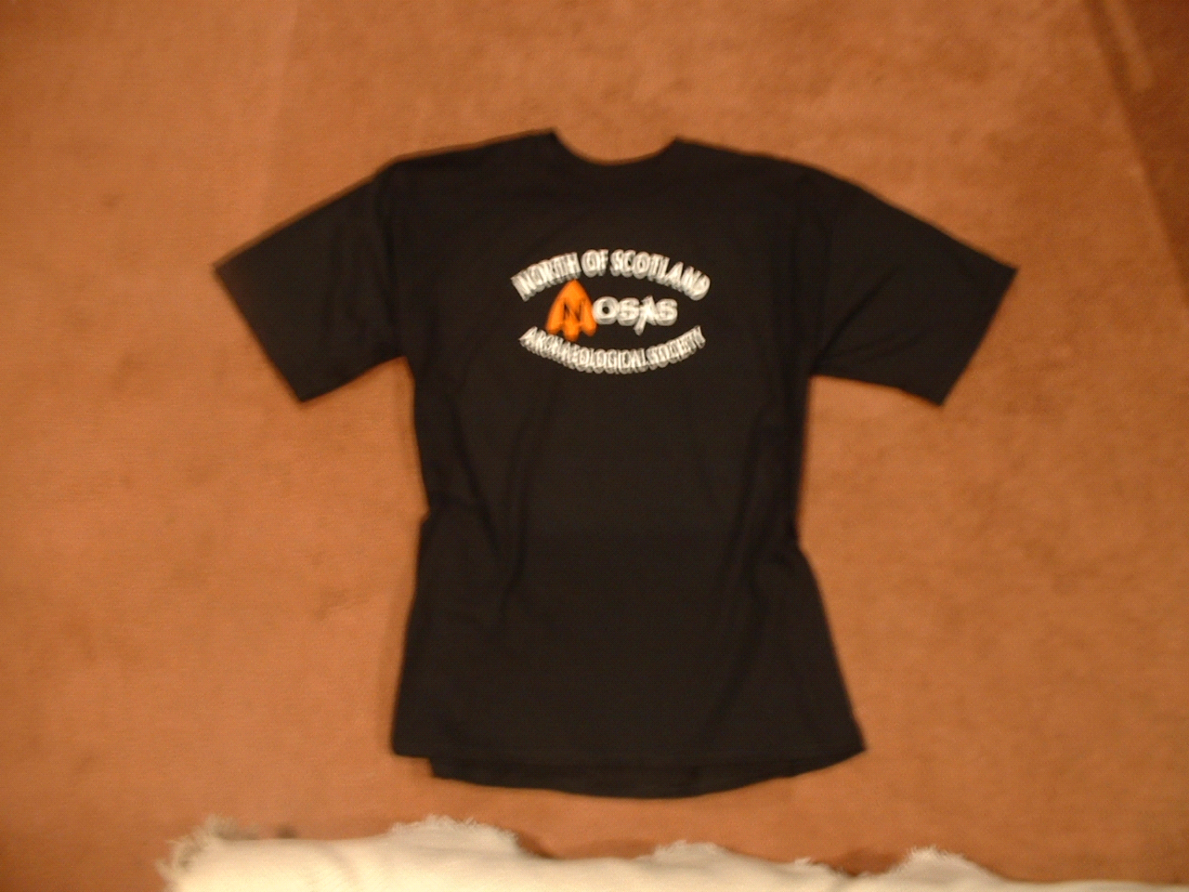n Saturday 28th February.**

Anne C is heading up this day at Blarich, GR NC 6933 04057 - 4km NW of Rogart Station, where several previously unrecorded hut circles have been identified. Meet at 10.00am, bring a picnic and wear appropriate clothing and footwear for the time of year!! Directions - from the A9 at “The Fleet” take the A839, on the right just beyond the entrance to Blarich there is a gate into the field where we can park off the road “so long as it hasn’t rained too much (land owners words). Contact Anne Coombs if interested in coming phone 01862 810431 or email - hscoombs@bigfoot.com

**NOSAS T-shirts and sweatshirts**

Have you got the T-shirt? The committee thought it would enhance our corporate identity if we had a T-shirt and Kate S has kindly agreed to look after this. Here are the results of her research:-

**T shirts -** choice of black with white lettering or white with black lettering - price £8. **Sweatshirts** black with white lettering - prices £11. P&P additional £1.50 (in padded envelope)

Sizes: Small 36-38”, Medium 40”, Large 42”, XLarge 44, XXL also available (all sizes look on the ample side)

Email Kate Sanderson with requirements and send cheque payable to NOSAS with cost of p&p if appropriate - [KDSanderson@4u2give.com](mailto:KDSanderson@4u2give.com)

**KINLOCH HOURN 2004**

Following the successful week of recording in Spring 2002, a further week is to take place from the 17th to the 25th April this year.

We will be surveying and recording the archaeological remains on the south shore of Loch Hourn. It is anticipated that these may well be more to do with MOLRS settlement than fishing, although some sites connected with the fishing have already been identified. Part of the aim is to try to determine if there are any differences between the south and the north shore and if it that is the case, why is it so? There will also be some additional research to be done on the north shore of the loch and some prospecting and recording at Barrisdale.

A good level of fitness is needed as there will be some clambering up and down slopes and in and out of boats to be done, and of course, the weather can throw anything at us, as those who were there last time will testify. But the rewards are considerable and the location fantastic. John Wombell has pulled out the stops again, arranging for us to stay at the Lodge and also secured a grant from Historic Scotland.

This time we will build on lessons learned from the last time!! Digital cameras will be used, and we are looking for a volunteer who would be willing to stay at “base”, to organise and collate the information gathered each day. This would suit someone who is not quite so agile.

The cost will be as last time, £4 per night. Contact John if interested in coming for all of the week or just part of it or for more information.

John’s phone - 01997 423273 and email - [johnandtrina@onetel.net.uk](mailto:johnandtrina@onetel.net.uk)

**Lectures**

At Millburn Academy, Inverness:

**Weds 11th February,** 7.15pm - “Farming in Scotland 5000 years ago” - Donald Paterson, (Aberdeen University Key Learning)

**Weds 18th February,** 8.00pm - “The Greenland Whale Fishery: Scotland’s First Oil Industry” - Dr Martin Gorman, (Inverness Field Club)

**Welcome to new member** John Smith, 62 Balnakyle Road, Inverness IV2 4BS Tel - 01463 231595 Email - [josandy@hotmail.com](mailto:josandy@hotmail.com)

**New email address** for Emma Sanderson:

[emma.sanderson@thurso.uhi.ac.uk](mailto:emma.sanderson@thurso.uhi.ac.uk)

**Awards for All Grant -** Progress report:-

A small sub-committee of John, George, Allan and Meryl has already met to discuss the “shopping list” and how we go about making the purchases. John is looking after the surveying stuff and the report binder, George the excavation tools, Meryl the tent, the photocopier and the digital camera and Allan the weather tight hut. Hopefully we will have all that we need for Kinloch Hourn in April and for the small excavation we are hoping to organise in the Summer (more information at a later date)

I received a letter from MP David Stewart yesterday asking me to convey his sincere congratulations to NOSAS on the successful outcome of the application. MM