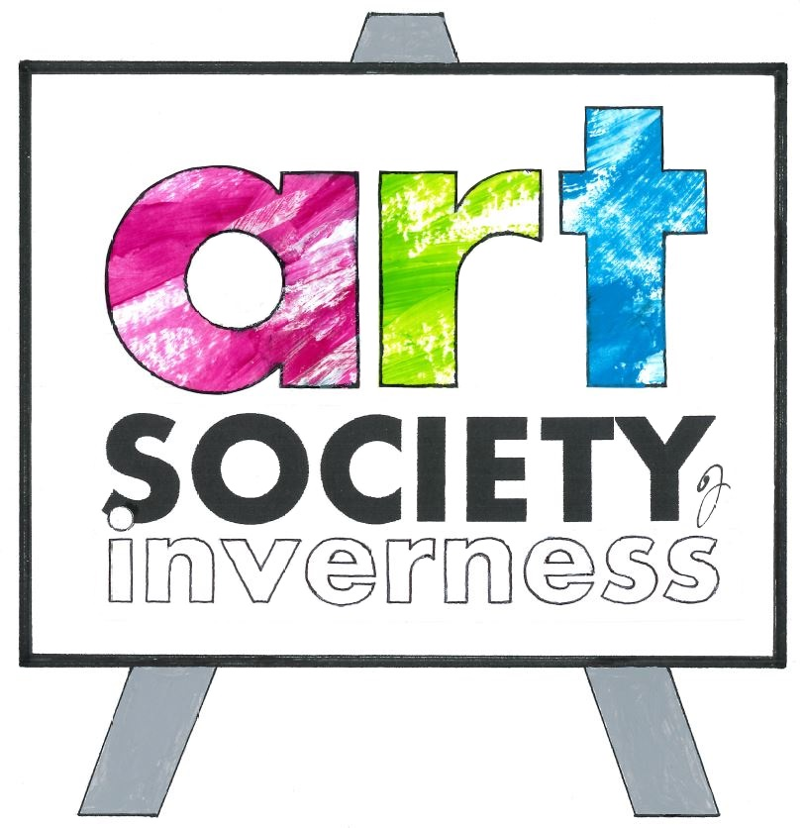

CONSTITUTION OF THE ART SOCIETY OF INVERNESS
adopted at the Annual General Meeting 25 November 2006 and updated at the Annual General Meeting 29 November 2008. Subsequently updated at the Annual General Meetings on 3 November 2012 and 25 October 2014.

- NAME AND OBJECTS

The name of the Society shall be The Art Society of Inverness.

The objects of the Society shall be to promote interest in and knowledge of the visual arts, and in furtherance thereof:

  - to provide classes, workshops and advancement opportunities for artists;
  - to organise exhibitions, lectures, demonstrations, workshops, courses, visits, publications, research and other activities involving or relating to the visual arts;
  - to do all things necessary or conducive to the furtherance of the foregoing objects.

- MEMBERSHIP

  - Membership shall be open to persons wherever resident who support the objects of the Society.
  - There shall be the following classes of membership: Ordinary Members, Honorary Members and Life Members.
  - Honorary membership may be conferred on any individual who is considered to have made a significant contribution to the visual arts. Honorary Members shall not be liable for any annual subscriptions, shall not be entitled to vote at meetings and shall not be eligible to be members of the Committee.
  - Life membership may be conferred on any member of the Society in recognition of his or her outstanding work on behalf of the Society. Life Members shall not be liable for any annual subscriptions, but shall be entitled to all the rights of and be bound by the same rules as Ordinary Members.
  - Applications for Ordinary Membership shall be dealt with as determined by the Committee. Honorary and Life Membership shall be conferred only by the Society in general meeting.

- MEMBERSHIP SUBSCRIPTIONS

The amounts of the annual subscriptions shall be determined each year at the Annual General Meeting and shall become payable on 1 January following for the ensuing calendar year. Any member who fails to pay his or her annual subscription by 30 April shall be deemed to have resigned and shall cease to be a member. It shall be in the power of the Annual General Meeting to determine different levels of subscription for different groups.

- COMMITTEE

  - The business of the Committee shall be conducted by not more than 12 members and not fewer than 8 members elected at the Annual General Meeting and any co-opted members as aftermentioned.
  - The Committee shall have the power to co-opt additional members to fill any vacancies. Co-opted members shall hold office only until the next Annual General Meeting.
  - The Committee shall elect from its own number a President, Vice-President, Secretary and Treasurer.
  - Elected members of the Committee shall hold office for a period of 2 years and thereafter shall be eligible for re-election.
  - The Committee shall have the power to appoint subcommittees, from its own membership or otherwise, which shall be responsible to the Committee and shall act on such terms as the Committee shall prescribe.
  - The quorum for a Committee meeting shall be five. The President shall have a casting vote as well as a deliberative vote.

- FINANCE

  - The Treasurer shall be responsible for maintaining accurate records of transactions with the funds of the Society, and shall produce such records to the Committee on request.
  - The Society shall hold such bank accounts in its name as the Committee shall decide. All cheques and withdrawals shall be signed by two of the following: the President, Secretary and Treasurer.
  - The Treasurer shall prepare the Annual Accounts of the Society for the year to 30 September, for presentation to the Annual General Meeting following. The Committee shall appoint a suitably qualified independent person or persons to examine and report on the Annual Accounts prior to such presentation.

- APPLICATION OF FUNDS

  - The income of the Society shall be applied to meet the liabilities of the Society and to further the objects of the Society.
  - The Society shall be entitled to make payment to members of professional fees for services provided to the Society.
  - The Society shall be entitled to make such payments to charities or for charitable purposes as the Committee or the Members in General Meeting shall decide.

- GENERAL MEETINGS

  - The Committee shall convene an Annual General Meeting to be held within 3 months after 30 September in each year for the conduct of the following business:

To receive a Report from the President on the year’s activities
To consider the Annual Accounts
To determine the amount of the Annual Subscriptions
To elect members of the Committee
To make proposals to the Committee for future activities
To consider any competent motions

  - A Special General Meeting may be called at any time by the Committee, or by the written request of at least 10 Members entitled to vote, which request shall be lodged with the Secretary at least 21 days before the date of the meeting and shall set out the reasons for calling the meeting.
  - Any motion for consideration at a General Meeting shall be notified in writing to the Secretary at least 21 days before the date of the meeting.
  - The Secretary shall give to the Members at least 14 days’ notice of a General Meeting and of any motions to be considered at such a meeting.
  - The quorum at a General Meeting shall be 10 per cent of the membership. The President shall have a casting as well as a deliberative vote.

- ALTERATION OF THE CONSTITUTION

The Constitution may be altered only with the approval of at least two thirds of the Members present and voting at a General Meeting, and only if a motion for the alteration has been notified to the Secretary and intimated to the Members under Clause 7 hereof.

9. DISSOLUTION

The Society may be dissolved only by decision of two thirds of Members present and voting at a General Meeting, and only if a motion for the dissolution has been notified to the Secretary and intimated to the Members in terms of Clause 7 hereof. In the event of dissolution any assets of the Society remaining after satisfaction of the liabilities of the Society shall not be distributed to the Members, but shall be made over to a charitable body or bodies with objects related to those of the Society or applied for such charitable purposes as the Members shall decide.

