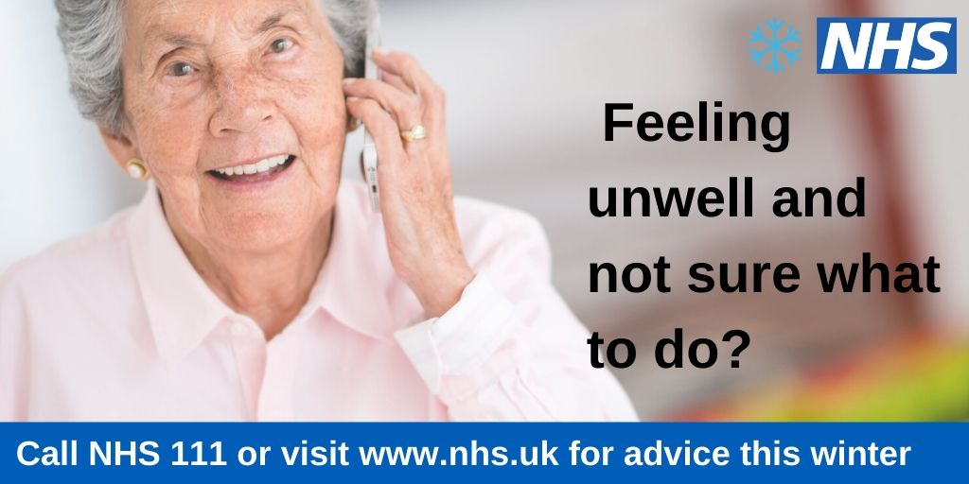

**Choose well this winter**

If you or a family member feels ill this winter and it is not an emergency, remember that NHS111 is available 24 hours a day, 365 days a year. Calls from landlines and mobile phones are free.

NHS111 makes it easier for patients to access local health services, when they have an injury or illness which may not be an emergency. It is free to use and helps direct you to the right care, first time.

You can get medical help or advice from NHS111 online using your smartphone, laptop or other digital device. You can also use the NHS111 online service to ask questions about your symptoms, find out where to get the right healthcare in your area, get advice on self care, get further advice from a nurse or doctor on the phone or during a consultation

If you need help at a time when your GP surgery or pharmacy is closed, call NHS 111 or visit [www.nhs.uk](http://www.nhs.uk)