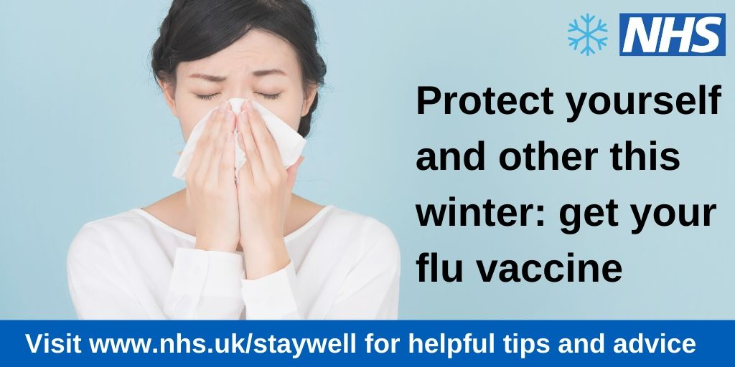

We are encouraging people in Somerset to get their flu jab this year. Getting the jab is the best way to protect you and your loved ones from the dangers of flu. Getting the flu jab is particularly important for people living with long term conditions and those over the age of 65.

Dr Helen Thomas, Clinical Lead for Urgent Care at Somerset Clinical Commissioning Group, said “The flu vaccine is free for those most at risk. People most at risk of catching flu are: Over 65s, pregnant women, those living in long-stay care facilities and people living with long-term conditions (such as respiratory disorders). However, it’s not just these individuals who need to be vaccinated – their carers should be vaccinated too. If you receive a carer's allowance, or you're the main carer for an elderly or disabled person whose welfare may be at risk if you fall ill, you will also be eligible for a free jab.

“Flu is an unpleasant illness for anyone to experience, but most healthy people should make a full recovery within 1-2 weeks. However, flu can cause severe illness and potentially death for those most at risk. Having your vaccine is the best way to keep you and your loved ones safe. Children are at higher risk of both spreading and catching the disease as they generally do not use tissues properly or wash their hands, meaning flu  is a very common infection for them which can also be very unpleasant; so it’s important that you give consent for your children to be vaccinated at school.”

Some common myths about the flu vaccine:

1. The vaccine can give you flu – False. The vaccine does not contain the live virus and therefore cannot infect you with the flu
2. Antibiotics can treat flu – False. As influenza is a virus and not a type of bacteria, antibiotics cannot help with flu. You may however be prescribed antivirals, which can reduce your infectiousness and reduce the length of your illness
3. The flu vaccine lasts for more than one year – False. You need the vaccine every year in order to stay protected, as the virus changes and adapts to the vaccine each year
4. You shouldn’t get vaccinated if you are late into your pregnancy – False. It is highly recommended that pregnant women get vaccinated, no matter what stage of pregnancy they are at
5. Children can’t have the vaccine – False. The nasal spray flu vaccine is recommended on the NHS for all healthy 2- and 3-year-olds, plus children in primary school
6. If you have already had flu this season, you won’t need the vaccine – False. As flu is caused by several viruses, the immunity you naturally developed will only protect you against one of them, so you could go on to catch another strain
7. It’s too late to have the flu vaccine by November – False. The best time to have the vaccine is from the beginning of October until the end of November
8. Vitamin C helps prevent flu – False. There is no evidence to support that vitamin C helps with flu.