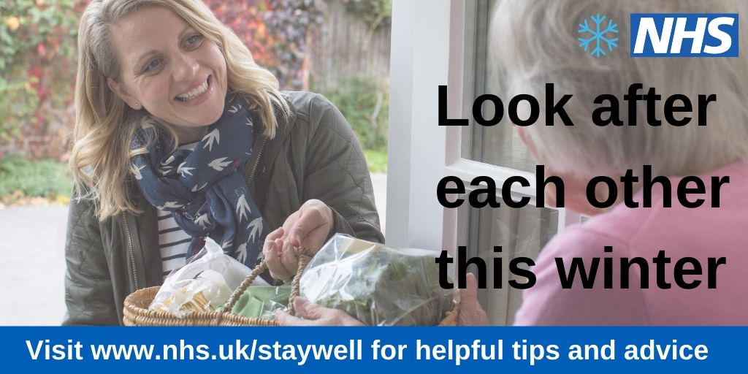

**Look after each other this winter**

Winter can be an especially difficult time for people, especially for those living with long term conditions, the elderly and people living with disabilities. It is therefore important that those who are able to help those who are less capable do so.

There are some simple things we can all do to help everyone stay well this winter. For example, make sure that your elderly or vulnerable friends and relatives are keeping their home warm (at least 18 degrees), have enough food in the house and are wearing appropriate clothing for the weather.

For those living alone, the risk is higher still. If you have an elderly neighbour who lives alone, please check in on them every now and then to make sure they are OK – just a quick chat is all that’s needed.

At the first sign of a winter illness, whether it be a cough, cold or a sore throat, don’t suffer in silence – make sure you go to your local pharmacist for advice. Your local pharmacist is clinically trained and can offer you expert advice and recommend a range of over the counter treatments and remedies. And if they think you need to see a nurse or doctor, they’ll tell you.