|  |
| --- |
| **WALKS** |

Visitors are welcome to join our walks for a £2 donation

towards the Mendip Society Heritage Fund.

Please wear suitable clothing and boots, and also ensure that the walk grade is suitable for your fitness level.

All walkers must take personal responsibility for their own safety (and that of any accompanying children), informing the leader of any personal health matter which might affect them on that walk. Unless stated otherwise well behaved dogs on leads are welcome on walks.

*Assistance Dogs are welcome on all of our walks*

|  |
| --- |
| **NOVEMBER 2019** |

**Sat 2nd – Dolebury Warren and Woods**

**Meet at 1.30pm** at Pear Tree Works, Bath Road, Upper Langford, (BS40 5DJ).

A 4 mile walk, limestone grassland and wooded slopes. *Moderate*

Contact: Gill 01934 742508                                      **ST 463 597**

**Sat 9th – Uphill**

**Meet at 1.30pm** by The Dolphin, Uphill Way, Uphill,

Weston-super-Mare (BS23 4TN).

A scenic walk of about 4.5 miles  *Moderate*

Contact: Rose 07796 910123  **ST 316 584**

***Wednesday 13th* – Around Shipham**

**Meet at 1.30pm** at Shipham Village Hall, New Road (BS25 1SG).

A walk of about 4 miles with hills and fine views. *Moderate*

Contact: Mary 01934 843789 **ST 444 579**

**Sat 16th – Around Bleadon**

**Meet at 1.30pm** at the Village Hall, Coronation Rd (BS24 0PG).

A 5 to 6 mile walk with steep hill at the start but rewarded with fabulous views.  *Moderate*

Contact: John 01934 842868   **ST 340 569**

**Sat 23rd – Kilmersdon**

**Meet at 1.30pm** in the village hall main road car park (BA3 5TD).

A 4 mile walk past Jack and Jill Hill to the chapel of Babington House. *Moderate*

Contact: Terry or Gill 01749 679128 **ST 735 458**

**Sat 30th – Clevedon**

**Meet at 1.30pm** in Ladye Bay, Clevedon (BS21 7BU).

A 5 mile walk along sea front at Clevedon to include Poet’s walk and the newly developed coastal path. Views of Sand Point and Weston Bay as well as South Wales. *Moderate*

Contact: John 01934 842868 **ST 409 730**

|  |
| --- |
| **DECEMBER 2019** |

***Thursday* 5th – North from Wells**

**Meet at 1.30pm** outside Wells Cathedral west door (BA5 2UG).

A 4.5 mile hilly walk past Walcombe and Milton Hill**.** *Moderate* Contact: Peter 01761 221995 **ST 550 458**

**Sat 7th – Chew Lake to Blagdon Lake Circular**

**Meet at 1.30 pm** in the Heron's Green lay-by on the west side of Chew Valley Lake on the B3114 (BS40 8XD).

A walk of about 5 miles with a small hill & all on quiet lanes. *Easy*

Contact: Clive 01275 848052 **ST 554 593**

**Sat 14th – No walk planned, but please check on the website.**

**Sat 21st – No walk planned, but please check on the website.**

**Sat 28th – Cheddar Gorge**

***Meet at 10.30am*** by the Gardeners Arms, Silver St (BS27 3LE).

A 4 mile walk followed by lunch at the Gardeners Arms. *Hard*

Contact: Gill 01934 742508 **ST 458 539**

|  |
| --- |
| **JANUARY 2020** |

**Sat 4th – No walk planned, but please check on the website.**

**Sat 11th – From Wookey over Yarley Hill**

**Meet at 1.30pm** on Castle Lane, Worth (BA5 1NL).

A 4 mile walk of lanes & hills with views over the Levels. *Moderate*

Contact: Terry or Gill 01749 679128 **ST 513 453**

**Sat 18th – Cadbury Hill and Kings Wood**

**Meet at 1.30pm** in from the car park off Gooseham Mead, Congresbury (BS49 5BX).

A 5 mile walk taking in a Hill Fort and woodland with some climbing *Moderate*

Contact: Richard 01275 852786.           **ST 438 639**

**Sat 25th – Around Cranmore**

***Meet at 1:00pm*** at Cranmore Railway Station (BS4 4QP).

A 5 mile walk passing Cranmore Tower, the highest point on the Mendip Way. *Moderate*

Contact: Shirley & Phil 07733 539018 / 07866 869241 **ST 663 430**

|  |
| --- |
| **FEBRUARY 2020** |

**Sat 1st – Walk around Winford**

**Meet at 1.30pm** at Winford Church (BS40 8AY).

Please park carefully in Church Road & Chapel Lane.

A 4 to 5 mile walk with extensive rural views.   *Moderate*

Contact: Richard & Denise 01275 472797 **ST 543 650**

**Sat 8th – Avon Wildlife Trust at Folly Farm**

**Meet at 1:30 pm**in themain car park, Stowey (BS39 4DW).

A walk of 5.5 miles. *Moderate* Contact: Tim 01761 452017  **ST 606 604**

**Sat 15th – Coleford to Edford wood**

**Meet 1.30pm** by the King's Head, The Green, Coleford (BA3 5LU).

A 5 mile walk along the route of the Dorset and Somerset canal.

Bridges, an aqueduct and maybe snowdrops*. Easy*

Contact: Gill 01934 742508                                    **ST 688 486**

***Sunday* 23rd – Timsbury**

**Meet at 1.30pm** in Conygre Hall car park North Road (BA2 OJQ).

A 4.5 walk to Priston, “not fast" and no major hills. *Moderate*

Contact: Beryl 07800 630004 or 01761 412045 **ST 668 589**

**Sat 29th – Around Wrington**

**Meet at 1.30 pm** by the Golden Lion, Broad Street (BS40 5LA).

A 4 to 5 mile walk with some hills and views. Some parking in Broad St. (look out for restrictions!) or park nearby.  *Moderate*

Contact: John 01934 842868   **ST 469 629**

|  |
| --- |
| **MARCH 2020** |

**Sat 7th – Coastal Walk east of Clevedon**

**Meet at 1.30pm** at The Avenue, Clevedon (opposite the golf course) parking on the road.

A walk of about 4.5 miles over the golf course and Walton Common, & back via the coast path. Views of South Wales. *Easy*

Contact: Clive 01275 848052 **ST 413 727**

***Wednesday* 11th – Around Cranmore**

**Meet at 1.30pm** at Cranmore Railway Station (BA4 4QH)

A 5 mile walk up to and past Cranmore Tower. *Moderate*

Contact: Peter 01761 221995 **ST 667 430**

***Sunday*15th – Around Winscombe**

**Meet at 1.30pm** inthe CP behind Woodborough Inn (BS25 1HD).

A 4 to 5 mile walk with fine views and hopefully some wildflowers. . *Moderate*

Contact: Mary 01934 843789                    **ST 421 576**

**Sat 21st – Sand Point**

**Meet at 1.30pm** in the Sand Point National Trust car park, Beach Road, Kewstoke, Weston-super-Mare (BS22 9UD).

A 4 mile coastal walk around Sand Point and Middle Hope with fabulous views across the Bristol Channel on a clear day.

Steep and slippery in some places so bring poles if needed. *Hard*

Contact: Pauline 01934 820745 **ST 330 659**

**Sat 28th – Another Wellow Wander**

***Meet at 1.15pm*** in the car park, Station Road, Wellow (BA2 8QB). A 6 mile walk towards Hinton Charterhouse. *Moderate*

Contact: Martin 01249 720809 **ST 738 581**

|  |
| --- |
| **TALKS** |

Visitors are very welcome, and it is not necessary to book.

£3.50 (Members £2.00) with free refreshments.

Contact: Richard Frost 01275 472797

|  |
| --- |
| **WELLS** |

These will be held at the Wells Museum, Cathedral Green,

Wells BA5 2UE and will commence at 2.30pm

**--------------------------------------------------**

**Tuesday 10th December 2019 at 2.30pm**

**‘The Inventor of National Parks - Who was John Muir?’**

**An illustrated talk by Terry Gifford**

Known as the father of the American Conservation Movement, John Muir never lost his Scottish accent.

His idea for a series of National Parks is said to be America’s gift to the world, so why the opposition to them in Scotland

by The John Muir Trust?

How is Muir’s ecological philosophy from the 19th century relevant to landscape issues in 21st century?

What can now be seen as John Muir’s errors from our modern perspective?

Terry Gifford is editor of the complete works of John Muir and more recently of eight famous books (and ebooks) by Muir published by Vertebrate Publishing.

Terry is a world authority on the Scot who became known as America’s wilderness sage.

**Tuesday 14th January 2020 at 2.30pm**

**‘The World of Rock Climbing Photography’ by Ian Smith**

**with an introduction by Terry Gifford**

Ian Smith is a rock climbing photographer, and an editor of guide books for the Southwest & North Wales. In this illustrated talk he gives us an insight into the subject, its challenges, rewards, issues & rivalries. Ian as an editor will reveal behind the scenes ethical debates and the publishing competition. Great photos of Fairy Cave, Lands End and others.

So this promises to be an opportunity for you to learn the secrets of the climbing world.

|  |
| --- |
| ***Please check on our website for any***  ***changes to the walks or events.*** |

**Tuesday 25th February 2020 at 2.30pm**

**‘Caving and Cave Rescue’ by Martin Grass**

**of Mendip Cave Rescue**

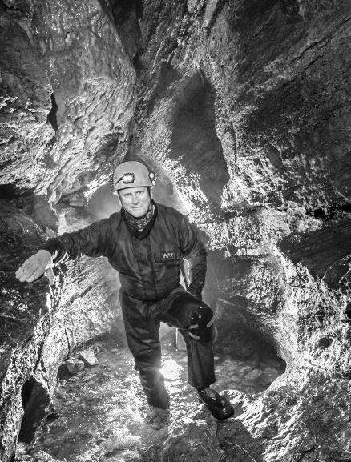Mendip is synonymous with caving, and cave rescue is vital to activities in our area.  Martin will give us an insiders' knowledge of this valuable, highly trained group of volunteers, touching upon the history of caving and exciting recent discoveries in this area.  Martin played a vital co-ordinating role in the search & rescue of the group of the young Thai footballers which gripped the nation last year. (I’ll let you into a secret – how vital a role is to be seen from the fact that Martin was one of the 15 people, with partners, that had a private meeting with Prince William at Buck House!) Not to be missed!

|  |
| --- |
| **WINSCOMBE** |

These will be held at St. James’s Church Hall, Woodborough Road, Winscombe BS25 1BA, and will commence at 2.30pm

**--------------------------------------------------**

**Thursday 28th November 2019 at 2.30pm**

**‘A History of Knitting Patterns’**

**An illustrated talk by Sarah Harris**

**of the Spinning Weal, Clevedon**.

This is more fun than it sounds, social history expressed through the earliest patterns to the current revival of the craft; a nostalgic journey for those who once suffered the indignities of the knitted swimsuit! A ‘laugh out loud journey’.

|  |
| --- |
| **EVENTS** |

**Saturday 11th January – The Mendip Society Wassail”**

**at Fry’s Lane Orchard, Burrington**

We have booked the Burrington Village Hall this year so

meet there at 6.00pm and please park respectfully in the square. The Master of Ceremonies will again be our President Les Davies. We welcome the Barley Rye Choir for the Wassail singing, and dancing with the Ladies Somerset Morris.

Come prepared for an evening of joining in and there is usually a charity collection by both groups.

Joining the Wassailing is free, and everyone is welcome.

Warm clothing, good shoes/boots and a torch are all advisable.

*The ceremony requires a lot of noise to drive away the bad goblins so bring something noisy to bang.*

A very nice seasonal curry, fragrant rice and flat breads will be available afterwards in the hall for £5pp payable on the night, but must be booked by emailing [orders@thevegetablediva.com](mailto:orders@thevegetablediva.com) by January 7th at the latest so we know how many to cater for.

For information contact Les on 01458 445233 or at LesDavies@westcountryman.co.uk or Richard on 01275 472797 or at chairman@themendipsociety.org.uk.

**Fridays 14th and 21st February 2020**

**‘Hedge Laying Days’ with Tina Bath and Chris Claxton**

Tania’s Wood, Woodbridge Farm, Bickfield Lane,

Ubley BS40 6PX

As before tuition days are open to members and non-members, both beginners and those with some experience, and for one or both days.

Shelter, parking and toilet facilities are on site.

This year we are able to provide this expert training at no cost to the participants and it is hoped that non-members will be able to make a donation to our Heritage Grant fund.

We would also hope that participants would be able to help on at least one workday in Tania’s wood after the training (it consolidates what you have learnt as well as helping the society).

We will provide a hot soup, rolls, etc lunch and drinks

all day for £5.

There is a max of 8 places each day which must be booked, and directions, times and other details will be sent on booking by contacting Judith on 01275 874284 or at: judith.tranter1@btinternet.com.

Please note – places fill up very quickly, so don’t delay.

If booking in January please contact Richard on 01275 472797 or at: chairman@themendipsociety.org.uk instead.

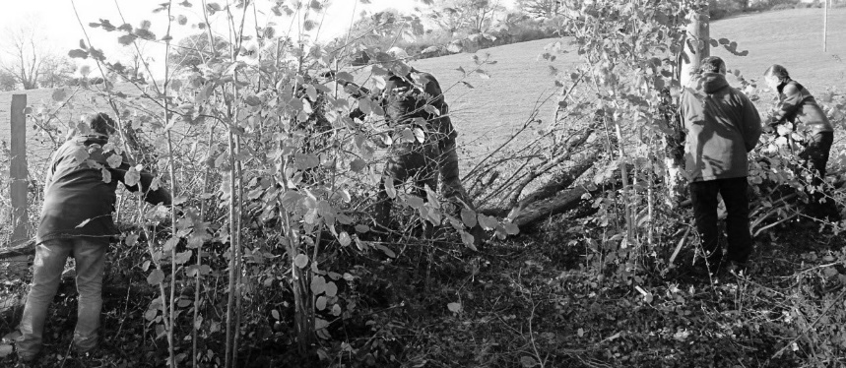

|  |
| --- |
| ***Annual General Meeting***  **The 2019 AGM will be held on Friday 27th March 2020 at 7.30pm**  **in Priddy Village Hall BA5 3BE.**  Come and hear the future plans of your Society and have your say.  Our Guest Speaker is Julie Merrett, Reserves Wetlands Manager for Natural England,  who will be telling us all about the historic and future ideas now being implemented on that site and the Mendips. |

|  |
| --- |
| **The Mendip Society may put on extra walks and events, and these will all be publicised on our new website** **www. themendipsociety.org.uk**  ***Important:*** Our old website www.mendipsociety.org.uk is now obsolete ***and*** ***should not be used.*** |

|  |
| --- |
| ***Please check on our website for any***  ***changes to the walks or events.*** |

**Chairman: Richard Frost**

2 Chapel Close, Winford BS40 8EE

Tel: 01275 472797

Email: chairman@themendipsociety.org.uk

**Hon. Secretary: Judith Tranter**

2 Walton Lodge, 27 Castle Road, Clevedon BS21 7DA

Tel: 01275 874284

Email: secretary@themendipsociety.org.uk

**Membership Secretary: Peter Janes**

The Cottage, Harptree Hill, West Harptree BS40 6EJ

Tel: 01761 221995

Email: membership@themendipsociety.org.uk

***Please visit our website www. themendipsociety.org.uk***



**Programme**

***November 2019 – March 2020***

**www.themendipsociety.org.uk**

**08454 092951**

**Registered Charity No. 262867**