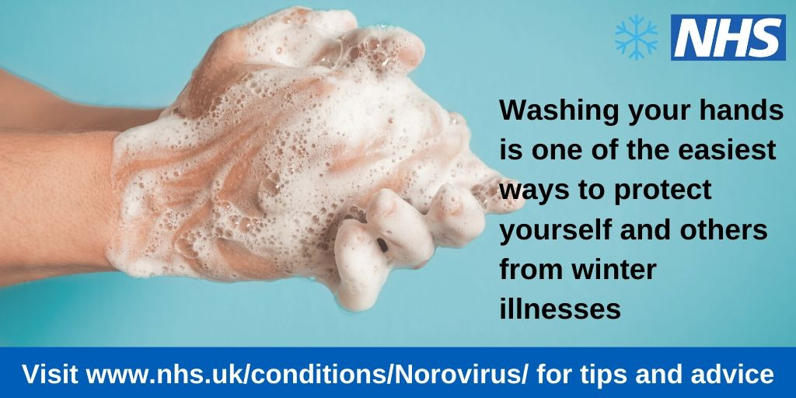

**Stay well this winter**

Norovirus, sometimes known as the ‘winter vomiting bug’ is the most common stomach bug in the UK, affecting people of all ages. It is highly contagious and is transmitted by contact with contaminated surfaces, an infected person, or consumption of contaminated food or water.

The symptoms of norovirus are very distinctive – people often report a sudden onset of nausea followed by projectile vomiting and watery diarrhoea.

The easiest way to protect yourself from norovirus is to wash your hands thoroughly using soap and water and dry them after using the toilet, before preparing food and before eating. Don’t rely on hand gels as they don’t kill the virus.

Did you know that the World Health Organisation recommends washing your hands for as long as it takes for you to sing ‘Happy Birthday’ to yourself twice!

If you are unlucky enough to get norovirus this winter, don’t worry, you should make a full recovery within 1-2 days. Make sure you drink plenty of water (this is particularly important for young children and the elderly).

Stay away from work (or school) for 24 hours after your symptoms stop to reduce the spread of this nasty illness.

Please don’t visit a hospital A&E or GP practice with symptoms as this may spread the virus to others!

Further information and advice is available from NHS 111 or the NHS online A to Z condition and treatment checker at <https://www.nhs.uk/conditions/Norovirus/>