Hedges of the Mendip Hills
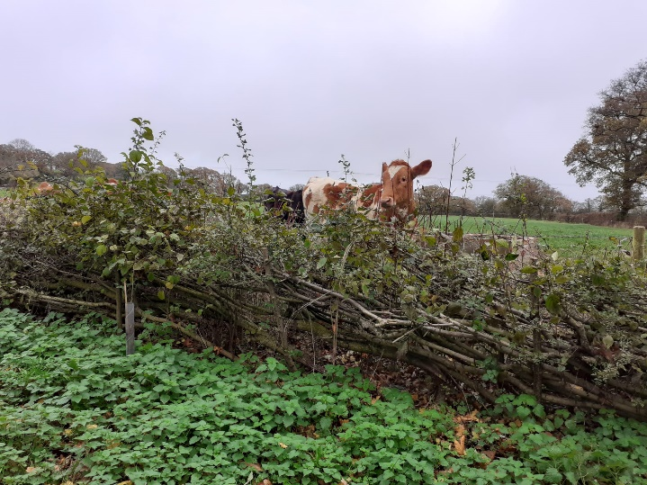
The Mendip Hills AONB Service are looking to help farmers and land managers to increase the length of native hedgerows across the area. Since this time last year, the Farming in Protected Landscapes programme has funded 2400 metres of hedgerow planting, and hundreds more metres have been funded for management like hedge-laying. In total nine farms in Cheddar, Hutton, West Harptree, Blagdon, and Priddy have already benefited from support with hedgerows through the Farming in Protected Landscapes programme, with more projects in the pipeline.
The patterns hedges weave in the countryside are a link to the past, as generations of farmers create and maintain boundaries to suit their land. Some hedges might be as old as the Romans, others overlay banks built as boundary markers in the Bronze Age, and some are older still, carved out of the Wildwood in Man’s early years. Some of these ancient hedgerows can still be found across the AONB, while some exist only as ghostly ridges on the ground, or infield trees that were too big to remove with the rest of the hedge when the field was enlarged. Many of the more regular perpendicular hedges in the Mendip Hills date back to the 1700s and the series of enclosure acts – as do many of the hundreds of miles of drystone walls.
Well-managed hedges can be a tremendous natural capital asset to a farm. They reduce windspeed, lessening coil erosion and crop damage, and provide a shelter for livestock against extreme weather. They stabilise soil with deep roots which hold the soil together and encourage the slow absorption of rainwater. Roots also play a vital role in storing carbon dioxide. Hedgerow plants absorb and lock away carbon in their growing leaves and branches, but they also send some of the carbon into their roots, and combined with the autumnal leaf drop, soils under hedges can contain up to 57% more carbon that soils in the middle of the same field.
For wildlife, the importance of hedgerows in the landscape is unparalleled. They are vital corridors in the landscape, which species can use to navigate and seek shelter in. They are also often rich in wildflowers, cow parsley, red campion, and hedge mustard are common species to find creeping out from the bottom of a hedgerow. The variety in plants found in a hedgerow allows them to support a huge density and diversity of invertebrate life. For bird life, hedgerows provide excellent opportunities for shelter, nesting, and feeding. Sixteen of the nineteen bird species in the Farmland Bird Index are associated with hedgerows, ten of which use hedges as their primary habitat. The number of bird species, as well as the number of individual birds, tends to increase with the size of the hedge and the number of woody species of plant that the hedgerow is made from. Having a variety of hedgerow plants that flower and fruit at different times of the year means there is a longer period of abundant food – hawthorn and dog rose are particularly valuable food sources that can last throughout winter. Come Springtime, when birds are beginning to pair up for breeding, trees and taller plants in the hedgerow are important as song posts, from which males attract mates or defend their territory.
If you farm or manage land within the AONB and are looking to increase the hedgerows on your land, or manage them to increase their value for wildlife – get in touch with Megan from the Mendip Hills AONB Service, by email via mendip@mendiphillsaonb.org.uk or phone 01761 462338 to request a free, impartial advice visit to your holding. The Mendip Hills AONB Service are also working in Partnership with FWAG SouthWest, the National Farmers Union, Somerset Wildlife Trust, and Mendip District Council to run a programme of free sustainable land management workshops across the area – the programme can be found online here (www.somersetwildlife.org/slm-workshops) or request a physical copy by ringing our office. We are working with the NFU to run an event on the 12th October, providing information on Farm Carbon Auditing and Natural Capital Management. Somerset Wildlife Trust and Mendip DC are running an event on the 23rd September looking at green financing, and there are many more to come!

