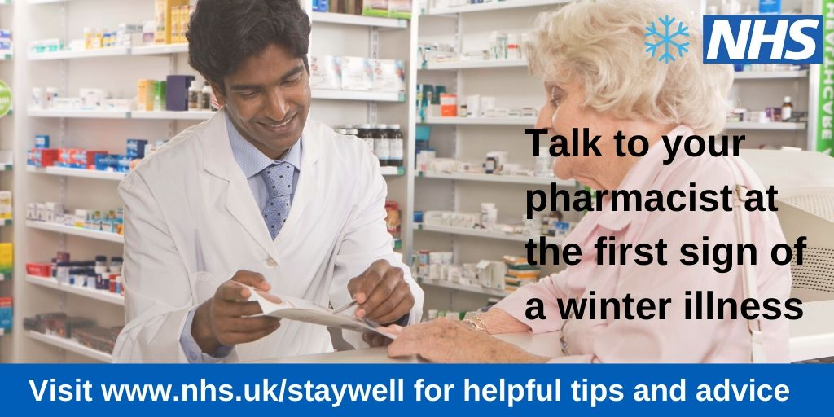

**Don’t suffer in silence this winter – talk to your pharmacist at the first sign of a winter illness**

Your local pharmacist is an expert in medicines. They train for five years and can give you medical advice on how best to treat your condition. Quite often you can treat common illnesses at home with the right medications and some rest, but if they think you need to see your GP, they will advise you to make an appointment.

Your local pharmacy is stocked with a wide range of medicines to help you recover from minor illnesses and ailments such as coughs, colds, vomiting and diarrhoea. You might be surprised by what they stock, so if you are in any doubt about what to take, go and talk to them and they will help find the right medication for you.

There is always a local pharmacy near you, and quite often they will have extended opening hours on selected evenings and weekends, meaning you don’t have to take time off work to come and see them. They also have private consultation rooms available, so you don’t have to worry about your conversation being overheard.

Your pharmacist can also give you your flu vaccine, which might even be free if you are eligible. Over 65s, children and those living with long term conditions are most at risk, so if you or one of your family members is in one of those groups, please make sure they are protected by having the vaccine. Children will be offered a nasal spray instead of an injection (this can also be provided to adults with severe needle phobias).

This winter, help us help you by using the right service at the right time, and remember, if you are in doubt about which service to use, call NHS 111 or go online: <https://111.nhs.uk/>.