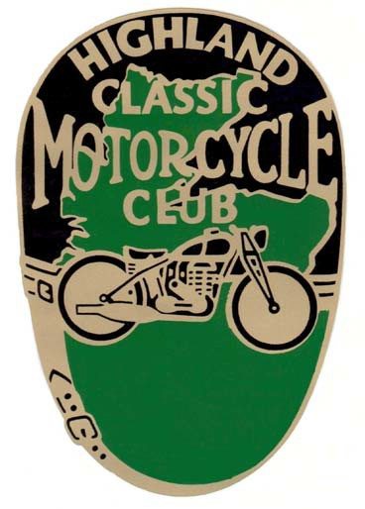
The Highland
Classic Motorcycle Club 41st
Loch Ness Rally
Sunday, 9th June, 2024. Fairways Leisure Centre, Inverness.
Starts at 10 am.
Classic Bikes & Trikes over 20yrs.
Contact Rally Co-ord: John Williams (01667) 258228 for further details and a Rally Entry Form.

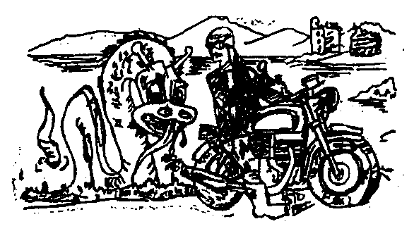
www.hcmc.org.uk
Raffle Road Run
Prizes & Trophies
A Monster Rally!!

