**Monmouthshire NORTH MONTHLY REPORT**

**March 2025**

**Crime figures for Abergavenny**

|  |  |  |  |  |
| --- | --- | --- | --- | --- |
|  | Llantilio Pertholey | Llanelly Hill | Abergavenny Town | Llanfoist Fawr |
| Criminal damage | 3 | 2 | 12 | 2 |
| Shoplifting | 1 |  | 12 | 1 |
| Public order offences | 5 | 2 | 17 | 0 |
| Violence without injury | 12 | 2 | 30 | 6 |
| Violence with injury | 7 | 2 | 9 | 1 |
| Misc Crimes Against Society | 1 | 2 | 3 | 2 |
| Residential Burglary | 1 | 0 | 3 | 3 |
| Other theft | 3 | 2 | 6 | 3 |
| Vehicle Crime | 2 | 0 | 1 | 3 |
| Commercial Burglary | 0 | 0 | 2 | 0 |
| Possession of Weapons | 0 | 0 | 0 | 0 |
| Drug Offences | 2 | 0 | 3 | 0 |

**Good work / Anti-Social Behaviour**

We have continued to actively tackle Anti-Social behaviour throughout Abergavenny by increasing mobile patrols, foot patrols and engagement events in the area. We are continuing to show a high visibility presence between the hours of 5pm and 8pm around the Town centre of Abergavenny this has shown a decrease in ASB within the area.

Starting from the end of March we have funding for an operation called Op Lockwood, where we will have two extra officers in the area that are dedicated to preventing ASB.

With lighter evenings approaching we are encouraging more youths to be outdoors, on the 29th of March we arranged a football match between neighbourhood police and the youths of Abergavenny, the youths thoroughly enjoyed the afternoon, and we will look to make this a monthly occurrence.

Throughout the months of March, the neighbourhood officers have completed several plain clothes operations around Monmouthshire and getting several positive stops searches and preventing further ASB.

**Police Surgeries/ events for March:**

PCSO Leah Murphy and PCSO Josh Carey attended Llanfoist primary school and engaged with the reception class, showing the children the marked police vehicles and explaining the role of a police officer. The children were so excited and had the opportunity to try on uniform and ask questions.

PCSO Tia Bonnici and PC Aled Thompson visited Tiny Tots’ nursery in Llanfoist showing the children around the vehicle and trying on uniform. The children were very excited and enjoyed their visit.

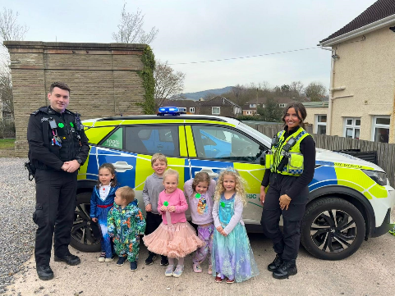

Neighbourhood arranged a football match with the youths of Abergavenny, several youths made an appearance and thoroughly enjoyed the afternoon. This prevented the youths causing ASB around the area for the evening.

**Business Crime**

We have seen a reduction in shoplifting offences within Abergavenny Town Centre. Officers still regularly patrol the town and engage with staff encouraging them to remain vigilant.

**Where can you meet with us?**

* **One Stop Shop Abergavenny – 9-4pm Mon- Fri**
* **Morrisons Abergavenny between 6pm-8pm most evenings**
* **If you have any additional enquiries or wish to address any issues.**

**Please feel free to email or contact:**

**Abergavenny Ward Manager:** [**Aled.Thompson@gwent.police.uk**](mailto:Aled.Thompson@gwent.police.uk)

**Town PCSO: Tia Bonnici** [Tia.Bonnici@gwent.police.uk](mailto:Tia.Bonnici@gwent.police.uk)

**Monmouthshire NORTH Neighbourhood POLICING TEAM**



@gwent.pnn.police.uk