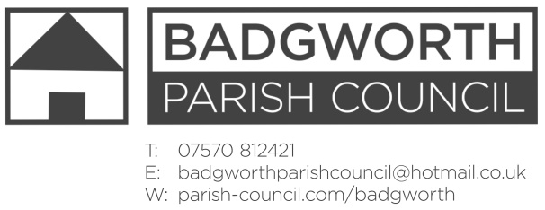

NOTICE OF MEETING OF THE PARISH COUNCIL

**A meeting of the Parish Council is to be held on Monday January 20th 2020 at 7pm in BADGWORTH AND BIDDISHAM PARISH HALL, BIDDISHAM. Members of the Public are entitled to attend an open question time at the beginning of the meeting should there be any issues or concerns on the agenda. Any relevant comments will be most welcome. The Public may also stay throughout the meeting as observers.**

**AGENDA**

**Open Forum**

1. **Apologies for absence** and any resolution to approve the reason
2. **Declarations of Interest**
3. **Dispensations**
4. **Minutes** of the Parish Council Meeting 18th November 2019
5. **Matters for Discussion**
6. **County Councillor report**
7. **District Councillor report**
8. **Community Matters** to include: emergency plan; parish online software; annual Litter pick; website regulations, accessibility statement.
9. **Highways** to include: To consider requesting signage for Biddisham Lane, south of Coombes Way, to indicate that there is ‘no turning for lorries beyond this point’.
10. **Jubilee Field and Memorial Field** to include Safety Inspection reports;
11. **Crime report** and policing update
12. **Cluster meeting** update
13. **Planning:** Report attached
14. **Correspondence:** List attached
15. **Finance to include:**
16. Request for support from Contact magazine
17. Financial statement - attached
18. To consider a direct Debit Payment to the District Council for the Clerks Salary;
19. Payments schedule authorisation:

Clerks expenses £19.80

West Country Groundcare Ltd Grass cutting £1080

Badgworth and Biddisham Parish Hall Management Committee Room Hire £90

Badgworth Schoolroom Management Committee Room Hire £95

1. **Member’s Points of Information**
2. **Items for the Parish Magazine/Social Media**
3. **Date of next Meeting:** 24th February 2020 Badgworth and Biddisham Parish Hall.

H Marshall Notice dated Wednesday 15th January 2020