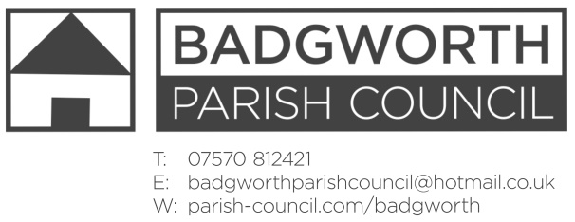

NOTICE OF MEETING OF THE PARISH COUNCIL

**A meeting of the Parish Council is to be held on Monday September 16th 2019 at 7pm in BADGWORTH SCHOOLROOMS. Members of the Public are entitled to attend an open question time at the beginning of the meeting should there be any issues or concerns on the agenda. Any relevant comments will be most welcome. The Public may also stay throughout the meeting as observers.**

**AGENDA**

**Presentation by Ben Stevens – Gigaclear**

1. **Apologies for absence** and any resolution to approve the reason
2. **Declarations of Interest**
3. **Dispensations**
4. **Minutes** of the Parish Council Meeting 22nd July 2019
5. **Matters for Discussion**
6. County Councillor report
7. District Councillor report
8. Community Matters to include recent Airspace Change workshop; Route 60+ event; Grant application; footpath AX2-15 update; Parish plan
9. PAT testing
10. Highways to include the extent of temporary speed limits; Gigaclear road closures; National Grid haul roads drainage and update; overgrown hedges;
11. Jubilee Field and Memorial Field to include Safety Inspection reports; Jubilee Field fence update.
12. Crime report and policing update
13. Cluster meeting 8th October
14. **Planning:** Report attached
15. **Correspondence:** List attached
16. **Finance to include:** Financial statement; RLT 2 & 3 funds; to consider items for inclusion in the budget; Payments schedule authorisation:

Chq 799 Clerks Expenses September

DD Information Commissioners Office £35

1. **Member’s Points of Information**
2. **Items for the Parish Magazine/Social Media**
3. **Dates of next Meetings:** Parish Council Meeting 21st October Badgworth and Biddisham Parish Hall, 18th November 2019

H Marshall Notice dated Wednesday 11th September 2019