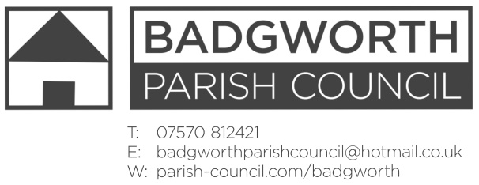

NOTICE OF MEETING OF THE PARISH COUNCIL

**A meeting of the Parish Council is to be held on Monday November 18th 2019 at 7pm in BADGWORTH AND BIDDISHAM PARISH HALL, BIDDISHAM. Members of the Public are entitled to attend an open question time at the beginning of the meeting should there be any issues or concerns on the agenda. Any relevant comments will be most welcome. The Public may also stay throughout the meeting as observers.**

**AGENDA**

**Open Forum**

1. **Apologies for absence** and any resolution to approve the reason
2. **Declarations of Interest**
3. **Dispensations**
4. **Minutes** of the Parish Council Meeting 21st October 2019
5. **Matters for Discussion**
6. County Councillor report
7. District Councillor report
8. Community Matters to include: emergency plan; Route 60+ event; Contact; Hinkley Connection Project request to attend meeting in 2020.
9. Highways update to include: extent of temporary Speed restriction on A38; Biddisham Lane Small Improvement Scheme improved signage proposal.
10. Jubilee Field and Memorial Field to include Safety Inspection reports;
11. Crime report and policing update
12. Cluster meeting: to agree representative for Wednesday 20th November in Shipham
13. **Planning**
14. **Correspondence:** List attached
15. **Finance to include:** Financial statement - attached; Confirmation of budget and precept 2020/21; Payments schedule authorisation: Clerks expenses £19.80
16. **Member’s Points of Information**
17. **Items for the Parish Magazine/Social Media**
18. **Date of next Meeting:** 20th January 2020 Badgworth and Biddisham Parish Hall.

H Marshall Notice dated Wednesday 13th November 2019