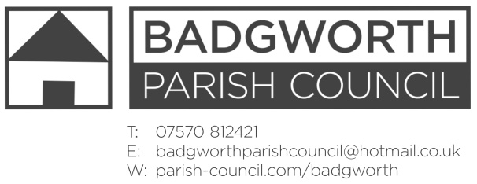

NOTICE OF MEETING OF THE PARISH COUNCIL

**A meeting of the Parish Council is to be held on Monday June 24th 2019 at 7pm in BADGWORTH SCHOOLROOMS. Members of the Public are entitled to attend an open question time at the beginning of the meeting should there be any issues or concerns on the agenda. Any relevant comments will be most welcome. The Public may also stay throughout the meeting as observers.**

**AGENDA**

1. **Apologies for absence** and any resolution to approve the reason
2. **Declarations of Interest,** approval of registered interest table and Code of Conduct training 10th September, 6pm.
3. **Dispensations**
4. **Minutes** of the Annual Parish Council Meeting 13th May 2019
5. **Matters for Discussion**
6. To consider co-option to fill the vacancy for a Parish Councillors
7. County Councillor report
8. District Councillor report
9. To consider application 03/19/00018 (see planning report)
10. Community Matters to include: National Grid including Tarnock Compound; Badgworth Defibrillator cabinet, repair or replacement; VE day 8th May 2020; website; Annual Civic service invitation; Gigaclear update
11. Footpaths in the Parish to include gate at Biddisham layby.
12. Highways to include temporary speed limits
13. Drainage to include Church Lane
14. Jubilee Field and Memorial Field to include BBQ; Safety Inspection reports; Jubilee Field fence.
15. Crime report and policing update
16. Cluster meeting
17. **Planning:** To includePlanning Seminars andReport attached
18. **Correspondence:** List attached
19. **Finance to include:** to consider setting up a direct debit payment for the Axe Brue Drainage Board annual payment; financial statement; request for grant from Citizens Advice; payments schedule authorisation:

Chq 792 Somerset Association of Local Councils Councillor training £25

Chq 793 Axe Brue IDB Drainage Rates £3.44

Chq 794 Sedgemoor District Council uncontested election fee £100

Chq 795 CPRE membership fee £36

1. **Member’s Points of Information**
2. **Items for the Parish Magazine/Social Media**
3. **Dates of next Meetings:** Parish Council Meeting 22nd July 2019 at Badgworth Schoolrooms

16th September, 21st October, 18th November 2019

H Marshall Notice dated Wednesday 19th June 2019