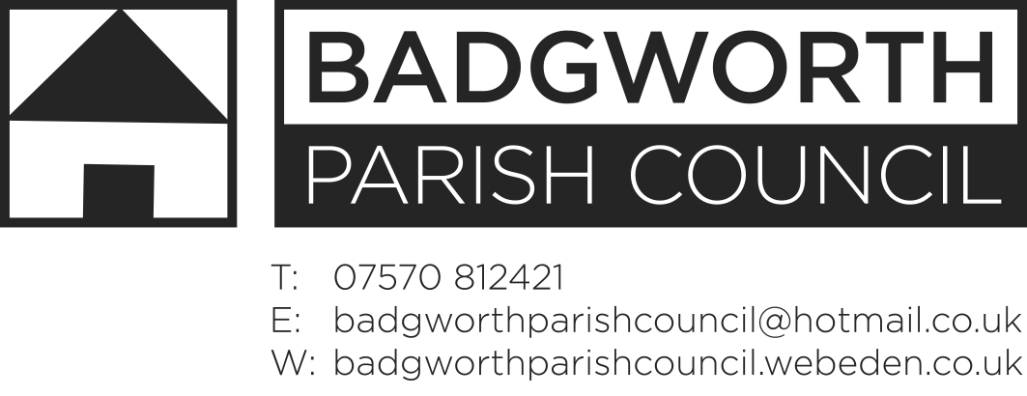**Minutes**

Minutes of the Planning Committee Meeting, held on Wednesday 27th February 2019 at 3pm at the location stated below.

**Present**

Cllrs Body (Chairman), Hipwell and Stiddard

Also in attendance Mrs H Marshall (Clerk), 1 members of the public were present.

Open Forum topics discussed were: Same signage, increase in overall lighting but Halo lighting, Ford require signage moved as the service area now moved, Pole sign moved back in accordance with Highways requirement. Will be lit from dusk to midnight with halo illumination, comparison to existing sign.

009/19P Apologies for absence: None

010/19P Declarations of Interest: None

011/19P Dispensations None

012/19P The council discussed the application:

Planning application:03/19/00005

Proposal: Display of 3 internally illuminated fascia signs and 1 internally illuminated freestanding pole sign

Location: Tarnock Garage, Bristol Road, Tarnock, Axbridge BS26 2SL

Applicant: Peter Brace Limited

Topics discussed were: pollution impacts and residential amenity, light impact on neighbouring property, impact on road.

## Consultee responses: Environmental Health – must only directly illuminate the application site and be fully adjustable to safeguard residents from obtrusive light.

**RESOLUTION: Support**

**BASIS: Low level light impact and compliance with Highways advice.**

Signed F Body Chairman

Date 27th February 2019