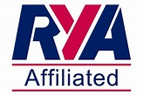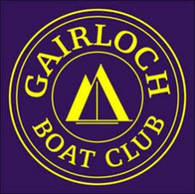**GG 3**

**GBC**

Adult Level 2 Dinghy Course

Weekend of 18-19 May 2024

Places are limited to six participants

Cost: Members £80

For further information and to book your place please send a message using the Contact Us page.

Janet MacLean

*Training Lead*