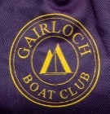 Gairloch Boat Club 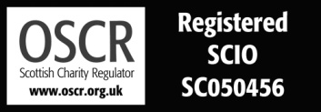

Charity Trustee Induction Programme
September 2024
As a new Trustee, there are certain duties that you must undertake. Use the following links to OSCR, the Scottish Charity Regulator, and our own website to get further information
https://www.oscr.org.uk/managing-a-charity/trustee-duties/
The Constitution (also known as our Governing Document) of Gairloch Boat Club is published on our website: https://web-cdn.org/s/1431/file/2023/gbc-scio-constitution-rev-3.pdf
Aims : Our aims are published in our annual report to OSCR
https://web-cdn.org/s/1431/file/2024/Trustees-Report-to-OSCR-2023-2024-Web.pdf

Values:
We value our community, and strive to make a positive impact on all its members
We are welcoming to all members, visitors, volunteers and neighbours
We promote and encourage the volunteering culture, as this is what our club depends on
We support our members and strive to provide the facilities which enable them to develop their boating skills
We run our activities safely and efficiently
We make good decisions to ensure the club will carry on in the future

Current Activities
See above for our annual report.

Further guidance:
https://www.oscr.org.uk/guidance-and-forms/guidance-and-good-practice-for-charity-trustees/introduction/

