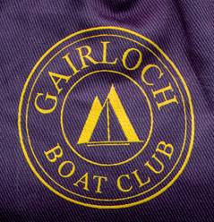

# Gairloch Boat Club

# Contact numbers

Coastguard Emergency : 999 or 112 or VHF Ch 16

Stornoway Coastguard : 01851 702013

Harbourmaster Gairloch : 01445 712140 or 07919 690929

Highland Council Harbours : 01349 781611

Highland Council Harbours manager : 01349 781615 or 07785 341188

Gairloch Health Centre (&NHS24 out of hours): 01445 712229 (NHS24 also on 111)

GBC Secretary 01445 712094

Scottish Environmental Protection Agency (SEPA) 03000 99 66 99

Pollution hotline 0800 80 70 60