**Cromarty Boat Club Minimum Mooring Specification**

**Minimum required for craft up to 32ft (9.7m)**

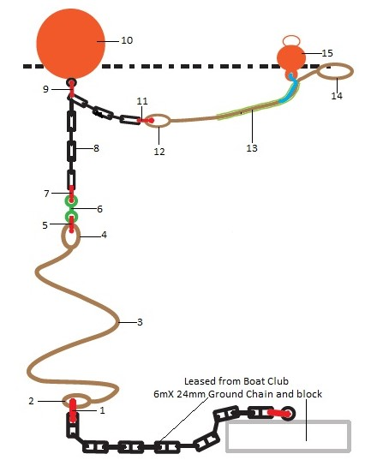**Refer to accompanying table for description of each constituent part**

**CROMARTY BOAT CLUB**

**Minimum Specification for a mooring riser/strop**

**Table describing constituent parts**

**To be read in conjunction with the Minimum Mooring Specification diagram**

|  |  |  |
| --- | --- | --- |
| Diagram Item No | Part | Further information |
| 1 | Bottom shackle - connects the ground chain to the hard eye at the bottom of the riser | 25mm dia Bow Shackle - self coloured (28mm dia pin). Working Load Limit (WLL) 5 tonnes |
| 2 | Spliced hard eye at bottom of riser | 28mm tube thimble with gusset & angled ends. Note that a 28mm thimble allows for protecting the riser with (for example) lay flat hose. |
| 3 | Riser | 24mm dia 8-strand polysteel or equivalent - minimum breaking load 10 tonnes. Finished length after splicing 8m (10m length needed to allow for splices) |
| 4 | Spliced hard eye at top of riser | As Item 2 |
| 5 | Shackle connecting hard eye at top of riser to swivel | 22mm dia Bow Shackle - self coloured (25mm dia pin). WLL 4 tonnes |
| 6 | Swivel | 22mm dia forged blue painted sweep swivel. WLL 5.3 tonnes |
| 7 | Shackle connecting swivel to intermediate chain | 19mm dia Green Pin Bow Shackle WLL 4.75 tonnes with screw collar pin |
| 8 | Intermediate chain | 13mm Long Link self coloured chain. Length 3m |
| 9 | Shackle connecting intermediate chain to flotation buoy at mid point of chain | 19mm Bow Shackle - self coloured (22mm dia pin). WLL 3 tonnes |
| 10 | Flotation buoy | 60 inch circumference Polyform net buoy |
| 11A | First of 2 shackles connecting end of intermediate chain to hard eye at bottom end of strop | Both 11A & 11B required  19mm Green Pin Bow Shackle WLL 4.75 tonnes with safety type pin - ie pin with securing nut & split pin or bolt |
| 11B | Second of 2 shackles connecting end of intermediate chain to hard eye at bottom end of strop | Both 11A & 11B required  As item 5 |
| 12 | Spliced hard eye at bottom end of strop | As Item 2 |
| 13 | Strop | 24mm 8-strand polysteel or equivalent with PVC tube or similar to prevent chaffing at the boat’s bow roller. Finished strop length 3m but minor variation allowed to fit the layout of the deck cleats of the boat (5m length required to allow for splices) |
| 14 | Spliced soft eye at top end of strop | Size to suit cleating arrangement of the boat |
| 15 | Pick up float connected to the strop by a light line with gill net floats | Combination of 200mm dia trawl float with side hole & yellow gill net floats |

NOTES:

1. Boat name to be on both flotation buoy & pick-up buoy
2. Shackle pins to be treated with Loctite & moused where possible

JC/Updated-24Jan2025