Reporting on Section 6
Community and Town Councils
Environment (Wales) Act 2016 Part 1 – Section 6
The Biodiversity and Resilience of Ecosystems Duty Report 2025

Name of Town or Community Council: Goetre Fawr Community Council (Group 2)

Introduction and Context
Goetre Fawr is a small Community Council (CC) in Monmouthshire in South Wales, with a precept of £49,000 (financial year 2025/26). There are just over 1800 residents on the electoral roll in the villages of Penperlleni and Llanover, and hamlets of Mamhilad and Nantyderry. Goetre Fawr currently has 8 councillors and employs a part-time Clerk and two cleaners for the public conveniences.

Much of the Community Council’s influence on biodiversity is through decisions taken at Council and Planning meetings, to ensure the promotion and protection of the eco-system within the Community. However, over the last 18 months in particular the CC has worked closely with the Green Infrastructure Project Officer at Monmouthshire County Council (MCC) to identify biodiversity opportunities on public and community spaces through the Green Corridor Project. The potential for a partnership with the Canal & Riverside Trust (C&RT) was not taken forward. However, this remains a future opportunity as the Brecon and Monmouthshire Canal runs through the ward and is a major wildlife asset. The issues with water supply (or potential lack of), for the canal have been a key focus for the C&RT and one of our Community Councillors has been extremely active in raising this issue and the likely impact it would have on the environment. Through local campaigning, she successfully called for a debate in the Senedd to ensure a long-term solution. Her work, together with our MS will continue until a mutually agreeable resolution for all parties concerned can be found.

In addition, the CC owns a small paddock (Ton Land - c1 acre), on which horses have traditionally been grazed and which is land-managed in accordance with best practices. This is now utilised by a local famer with sheep. Previous requests from residents to consider the use of this land as allotments were reviewed by the Community Council, but were not considered viable. The use as a community farm has also been considered, although at only 1 acre, the plot was considered too small by the charity involved. GFCC also owns the Llanover churchyard and the Olde Pounde Shop, currently run as a fish and chip shop.

Action Report 2023-2025

NRAP Action carried out to:  Objective |  | Monitored by:
1a) Embed biodiversity  into decision making  & procurement | The impact on biodiversity is now routinely considered as part of all Planning Committee meetings, and council meetings and in particular the awarding of GFCC contracts.  To ensure our continued focus on Biodiversity the Community Council has again appointed a Councillor with specific responsibilities for overseeing the CC’s Biodiversity actions and plans. This councillor has undertaken an OVW training module on Biodiversity and is part of two biodiversity groups, in MCC and OVW.  Initial contact was made about obtaining Bee Friendly accreditation through MCC. However, this was placed on hold this year while GFCC undertook a major biodiversity planting exercise in conjunction with Monmouthshire CC (Green Corridor Project). Bee Friendly status was obtained for the local Community Garden, as our appointed Councillor is the Chair. | Clerk, Full Council / Planning Committee  Biodiversity  Rep/MCC/  OVW  Biodiversity  Rep/MCC/  Comm. Garden
1b) Raise awareness  of biodiversity &  its importance | Work with influential groups to promote biodiversity / ecological sustainability continued via links with the Community Garden and the major garden nursery in the area. A second councillor has also liaised closely with the local primary school as part of the Green Corridor Project, to enhance a local green space and learn firsthand about the importance of wildflowers for pollinators and the health of our ecosystem. We hope this will help inspire the next generation of environmental stewards.  A large-scale consultation took place for the Green Corridor Project in summer 2024 with engagement events in the village halls and an online survey supported by regular promotion and updates on the villages and GFCC Facebook pages. | Full Council / Biodiversity rep./school/  MCC  MCC/GFCC
2) Safeguard principal  species and habitats | Through our Planning Committee meetings, we ensured that principal species and habitats were protected. This included hedgerows being protected with restoration of any hedges/trees removed or damaged during construction.  It is primarily the responsibility of MCC to ensure hedgerows are managed in the winter months when the woody growth is dormant and to avoid work during the nesting season (March to August). The Community Council has supported this via Facebook updates, particularly when ‘Nature isn’t Neat’ draws adverse comment although more needs to be done.  Habitat piles, dead wood and piles of leaves which are good for a range of species, have been created in the Community Garden and Llanover churchyard. Areas of long grass have been left in areas of Goytre Park and in the Community Garden.  A Bug Hotel is being erected in Llanover Churchyard and bird and bat boxes have also been established in the Community Garden. We are looking to undertake similar work in Goytre Park.  Liaison with the Canal & Riverside Trust to explore opportunities – the canal is a haven for wildlife– is work that is still to be undertaken. Hopefully a solution will be found regarding the provision of a sustainable water supply to maintain the canal and enable us to focus on other areas. As mentioned earlier a GFCC councillor was very active in bringing this issue to attention of Welsh Government. | Planning Committee/  Full Council/  MCC/GFCC  MCC/Comm.  Garden, contractor for churchyard  MCC/Comm Garden  GFCC &  C&RT
3) Restore & create  habitats and resilient  ecological networks | GFCC continued to manage the Goytre Wildflower area and orchard / bee friendly trees. This is an area specifically created in Goytre park to enhance local biodiversity. The Green Corridor project was consulted on and the planting undertaken in Spring 2025. This significantly enhanced the biodiversity of Goytre Park with wildflower areas, native hedging and trees. It has also added similar spaces in Llanover village (including the churchyard), as well as other public spaces around the ward.  Bulb planting as part of the Green Corridor project is being undertaken this Autumn (2025).  GFCC supported different mowing regimes with MCC (no mow May), to allow low growing species like daisies, clover and selfheal to flower and increase the number of flower-visiting insects, helping pollinators. A ‘Nature isn’t Neat’ policy replaced ‘No Mow May’ due to the logistical problems of ‘catching up’ with the mowing regime from June onwards. However, certain areas of grass are being left to grow longer than previously to achieve this objective.  Areas of grassland in Goytre Park and the Community Garden have been allowed to grow longer.  We continued with the messaging that ‘tidiness is not a priority’ for biodiversity projects (Nature isn’t Neat), and that sometimes just leaving a small area (in the park or Community Garden) to go wild can be beneficial. This is understood by some residents (although not always appreciated). We think this is one area where more ‘educational’ work needs to be done. | Full Council /  Biodiversity rep. /MCC  MCC  GFCC/MCC  MCC/Comm Garden  GFCC
4) Tackle negative factors:  e.g.reduce pollution, use  nature based solutions,  address invasive species | Both the CC and MCC continue to have a non-pesticide policy as does the Community Garden.  Councillors have identified invasive species such as Japanese Knotweed and alerted MCC.  The CC does not directly use composts, and the Community Garden has already adopted this practice, as has, we believe, MCC. GFCC will encourage peat free composts in work done by MCC and on council owned land.  There are groups of residents that regularly litter pick around the Goytre area. The councillor for Llanover organised a litter pick in Llanover and is due to join a county wide Litter Picking Forum. | Full Council  (liaise with MCC as necessary)  Councillors/  MCC  GFCC/MCC  GFCC/ liaison with litter pickers needed in Goytre
5) Use improve and  Share evidence | The engagement events which GFCC held in the Village Halls with MCC biodiversity staff provided the CC with an excellent opportunity to talk to residents about biodiversity and share best practice.  As already mentioned, the local primary school has undertaken planting in one of our local villages. The Biodiversity lead has been into Goytre Primary school to talk about wildlife in the area. | Full Council/  Biodiversity rep./MCC staff  School/  Councillors/  Biodiversity rep.
6) Support capacity  and/or other  organisations | Goytre Park has been significantly enhanced over the past 12 months and will remain a focus of our attention. In addition, new wildflower areas and planting such as hedgerows and trees have been established throughout the ward. A garden has recently been established in a separate initiative at Goytre Community Centre, funded by Keep Wales Tidy.  GFCC supported MCC in their management of areas of biodiversity across the ward and actively manage biodiversity on GFCC owned or managed land.  Requests were supported from local organisations for bulb planting (e.g., Seed Bombs requested by Llanover Village Hall). A major bulb planting exercise is being undertake in the Autumn of 2025.  The Olde Pounde Shop (OPS) trough has been planted up with pollinator friendly flowers / shrubs.  MCC & Community Garden adopts good practice such as avoiding hedge cutting during the nesting season, using bio-friendly mowing regimes and allowing grass to grow longer, but we think there is still more to be done. | Full Council /  Biodiversity rep./MCC staff/Goytre CC  GFCC/MCC  GFCC/MCC  GFCC/OPS  GFCC/MCC/  Com.Garden

Biodiversity photos
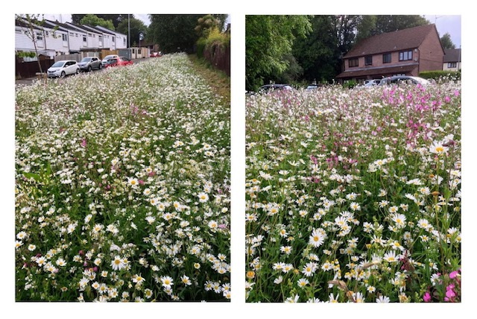
Verges planted in Highfield

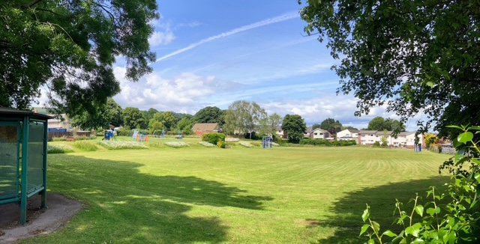
Goytre Recreation Park with wildflower planting on the far bank

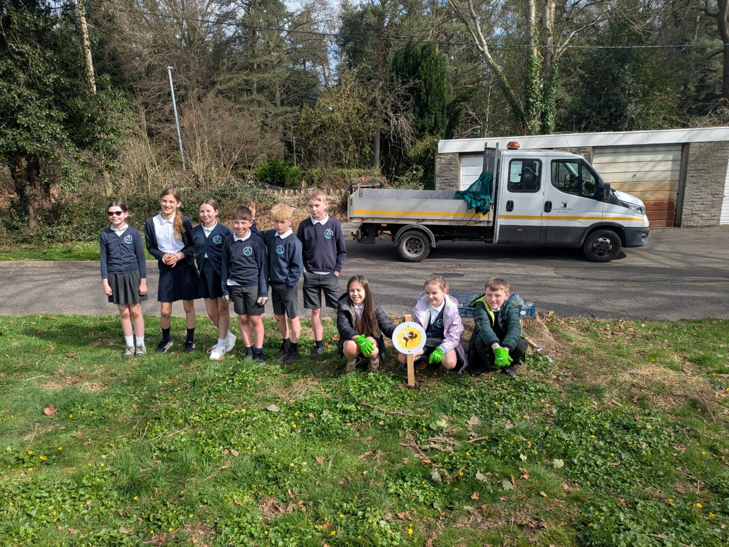
Pupils from Goytre Fawr Primary School gardening club, learning first-hand about the importance of wildflowers for pollinators and the overall health of our ecosystem.
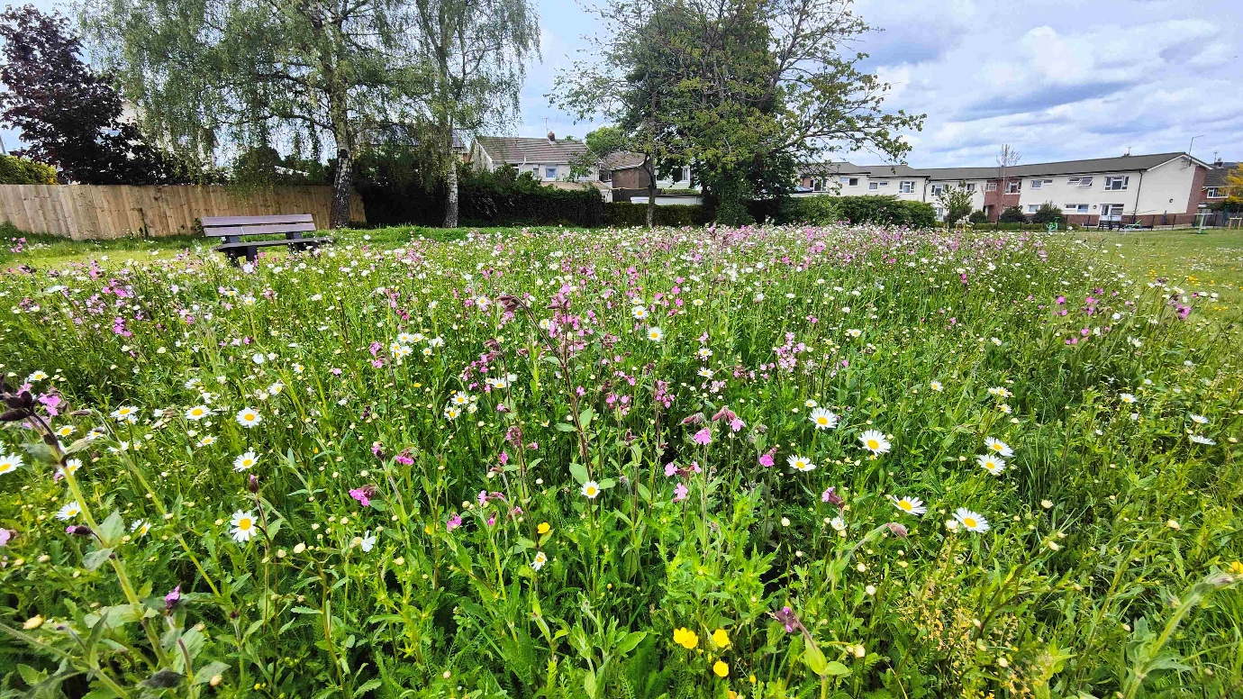
Flowers in Goytre Park

Review of s6 duty

What worked well? What have the barriers been? What will you change?

What worked well?
- In the last three years, The Clerk and Biodiversity Representative have continued to work
with MCC, and the whole Community Council has taken part in a major nature project,
the Green Corridor project, which has significantly enhanced the size and number of
biodiversity activities across the ward. This project has allowed GFCC to engage with
residents through face to face and online engagement on the changes they would like to see
and given excellent opportunities to discuss the impact of biodiversity. A recent separate
initiative has seen a wildflower, area, fruit trees and a vegetable garden attached to Goytre
Community Centre. In addition, Goytre Community Garden was successful in gaining the
Green Flag Community Award (which recognises good practice) for the 10th year in
succession. All of these initiatives have resulted in significantly enhanced biodiversity
practices throughout the ward, given opportunities to discuss biodiversity and greatly
enhanced the attractiveness of our green spaces.

- GFCC has a dedicated Planning Committee and typically, the committee will examine the impact on any proposals on:
  - The prevention of the removal of hedgerows and trees (with any unavoidable damage caused by construction equipment etc made good).
  - The impact on local drainage / watercourses.
  - Enhancement of bio-diversity as part of any application.
Biodiversity is now considered by the Planning Committee in all planning proposals as a
matter of course.

- ‘No mow May’ has now been replaced by ‘Nature isn’t Neat’ which is practised on all
council -owned and managed land as well as in the local community garden.

What have the barriers been?
- The reduction in Councillors from 12 to 8 at the May 2022 election has meant a 33% reduction in the Council’s resources – meaning that Councillors have less time to allocate on a wide range of Council priorities. A significant amount of time was needed to put the Green Corridor Project into place which meant that not all of the other actions could be followed up on e.g. Bee Friendly scheme

- The formation of a partnership with the Canal & Riverside Trust, to explore biodiversity opportunities along the Brecon and Monmouthshire Canal did not happen in part because of the issues around the canal. This is to be revisited.

What will you change?
- Because of the reduction in the number of councillor’s we need to ensure the next plan is achievable with the resources that are available. Our previous plan was quite ambitious in stating that we will engage with landowners re mowing and biodiversity practices. It may be better to engage with one or two, for example, Llanover estate which is known to have good practice.

- Whilst the Biodiversity rep has been monitoring the Biodiversity plan and it has been raised in CC meetings it needs to be more formally reviewed and minuted on an annual basis with full council.

- Councillors could be encouraged to attend training courses on biodiversity so that all councillors knowledge of biodiversity is increased.

- We could look into whether our banking is environmentally friendly as well as any other organisations that we engage with.
- We need to ensure that all GFCC managed land adheres to environmentally friendly practice. This could include the church yard in Llanover as well as Ton land.

How and when will the s6 duty be monitored and the s6 plan?
We are in the S6 reporting year of 2025. A new Biodiversity Action Plan will be written in 2026, to be reviewed annually.

