CYNGOR CYMUNED GOETRE FAWR COMMUNITY COUNCIL FINANCE COMMITTEE

MINUTES OF THE MEETING HELD BY TELE-CONFERENCE ON TUESDAY 4th OCTOBER 2022 @ 18.30

Present: Community Councillors Peter Daniel, Janet Robins, Morgan Chandler & Jonathan Lazenby as Clerk/RFO

Apologies: Community Councillor Nigel Morrey

 |  | ACTION
1 | Welcome and apologies for absence  The meeting commenced at 6.30pm with the Clerk/RFO welcoming everyone to the meeting.
2 | Approval of Minutes of the Previous Meeting  The minutes of the previous meeting held on Tuesday 5th July were reviewed. The minutes were proposed as a true and correct record by Councillor Daniel, seconded by Councillor Robins, and carried unanimously. | Clerk/RFO
3 | Matters Arising  (updates not covered as separate issues under the various agenda items below). There were no matters arising.
4 | Cashflow as at September 30th  The Clerk/RFO provided those present with a copy of the Sept 2022 cashflow position, together with the Unity Trust Bank (UTB) statements covering July, August & September 2022. The cashflow balances were verified to the closing balances in the UTB statements at the end of July/Aug/Sept 2022, with Councillor Daniel signing to confirm their accuracy in accordance with section 2.2 of the Community Council Financial Regulations (Wales).  There was no further comment or observation. | Clerk/RFO
5 | Audit 2021/22 - Outcome / Update (if available)  - The Clerk / RFO delivered the additional papers requested (as part of our three-year full transactional audit), to Audit Wales in Cathedral Road Audit at the end of August. To date there has been no further response or feedback.
6 | Draft budget 2023/24  The Clerk / RFO presented the following first draft budget for 2023/24 for consideration. It has been drawn up to provide a balanced budget, whilst maintaining the Precept at its current level of £37000. During the discussions the following key sums were discussed and proposed:  INCOME  - Nominal 5% increase to Old Pounde Shop rent (new lease due Sept 2023).  - Ton Land income based on £30 a month.  - No budgeted income for burials – extremely variable from year to year.  - VAT reflects last year’s spend.  EXPENDITURE  - The Clerk’s budgeted salary has been increased by c£912 (pro-rata) to reflect the proposed £1925 annual increase (currently subject to negotiation).  - Wages have been increased to £10.32 per hour to reflect projected new living wage.  - Provision has been made for 11 meetings in Llanover VH @ £25 per meeting.  - The figure for the various Councillor allowances have been reduced to reflect likely claims, but could probably be reduced further.  - The budget for the village(s) maintenance has provisionally been increased  by 5%, although the exact price is yet to be confirmed.  - Reduce donations to £750 (from £1000). Clerk suggested we could consider pre-allocating to existing causes – Wales Air Ambulance / Mon Citizens Advice etc. To be considered by Full Council.  - Capital expenditure to increase from £0 to £500 for small item purchases.  - Public conveniences increased by £600 to reflect increased electricity standing charge, although last quote was for £1000!  - Dog waste budget increased to £7 per bin (in anticipation of April price  rise).  The initial draft for presentation to Council (v3) is shown below based on the above discussions and initial recommendations. The current draft shows a budget deficit of £1435 with the current precept of £37,000. The areas highlighted in blue represent the budget lines with the most discretion for adjustment.  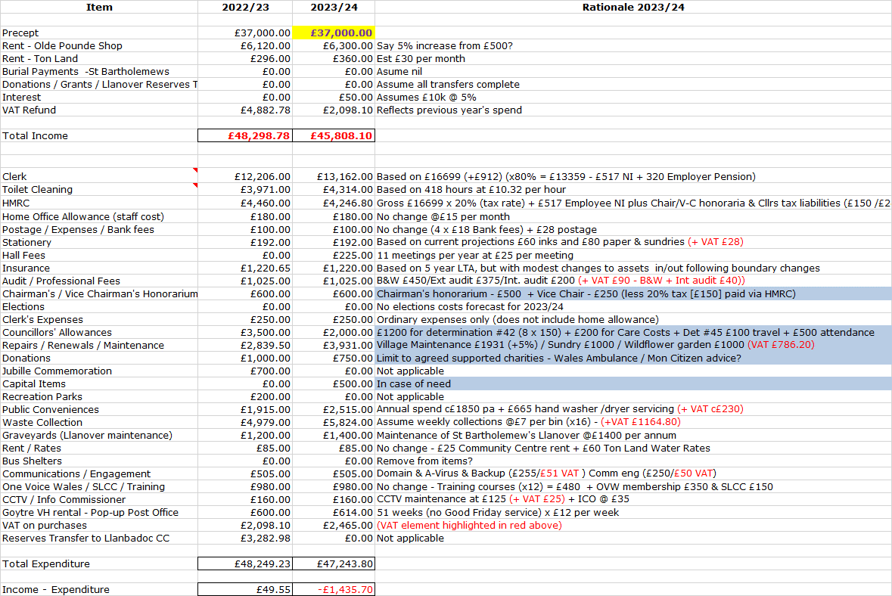  It was then proposed by Councillor Robins, seconded by Councillor Daniel (and carried unanimously), that the budget be presented to full Council on 17th October for further consideration. | Clerk/RFO
7 | Risk Review (inc Health & Safety schedule)  Following Councillor Morrey’s suggestion at the July meeting, the Clerk / RFO has added an additional column to record the previous risk classification and the date on which this was last recorded. This will enable the risk assessment scores to be tracked as they change over time. It was agreed at the last meeting that a full review of the assessment scores would probably be beneficial, and so the focus on this meeting is to review the appropriateness of these scores (rather than the risk comments which will be reviewed at our next meeting in January 2023). After careful consideration it was agreed that the following ‘scores’, (highlighted in yellow), should change as detailed below:  Item Potential Consequence Likelihood Severity New Classification  7. VAT Payment - Recovery of  a). Improper recording of input / output VAT 5 1 (was 2) 5 (was 10) Low (was Medium)  b) Improper Identification of Non-Business Activities 5 1 (was 2) 5 (was 10) Low (was Medium)  All other Risk assessments to stay the same.  Section 22 (Welsh Language Policy) comments updated to reflect that this item was completed some time ago.
 | The risk assessment updates agreed during the meeting were then formally proposed by Councillor Daniel, seconded by Councillor Chandler and carried unanimously. The Clerk / RFO will propose at next Full Council meeting for formal sign-off.  The Health & Safety Checklist update was then provided by the Clerk / RFO as follows:  - Ton Land  Dan Sainsbury, Tree Officer at MCC undertook a survey in June of the trees on Ton Land. His conclusions, with subsequent outcomes in bold are shown below.  - Tree 1 - Good vitality. Small old cavity at base typical of age and species. Has suffered from historic storm damage. Tolerable amount of deadwood throughout canopy. Two large limbs extend over adjacent property. Consider end weight reductions to these limbs and remove any damaged and dead branches contained within them. Action required and completed.  - Tree 2 - Good vitality. Typical features of age and species. Tolerable amount of deadwood throughout canopy. No further action required.  - Tree 3 - Good vitality. Typical features of age and species. Crown a little thin with a small amount of tip die back. Remove chicken wire from around stem. Action required and completed.  - Tree 4 – Good vitality - Typical features of age and species. Fruiting bodies present on deadwood from a historic wound. Tolerable amount of deadwood throughout canopy. No further action required.  - St Bartholomew’s Graveyard – headstone stability  The Clerk / RFO is arranging a headstone safety assessment – Cost £1100 + VAT which was approved by Full Council at their last meeting. The cost to secure any headstones which ‘fail will be £150 +VAT, although it’s not anticipated that many will fail.  The Health & Safety updates were accepted by the meeting and formally proposed by Councillor Robins, seconded by Councillor Chandler and carried unanimously. The Clerk / RFO will again propose at next Full Council meeting for sign-off. | Clerk/RFO  Clerk/RFO  Clerk/RFO
8 | Date of Next Meeting  Next meeting scheduled for Tuesday 10th January 2023, 6.30pm – with attendance by teleconference. | Clerk/RFO

Council member Date:

Clerk / RFO... Date:

