CYNGOR CYMUNED GOETRE FAWR COMMUNITY COUNCIL FINANCE COMMITTEE

MINUTES OF THE MEETING HELD BY TELE-CONFERENCE ON TUESDAY 8th OCTOBER 2024 @ 18.30

Present: Community Councillors Nigel Morrey, Janet Robins, Lewis Carter & Jonathan Lazenby as Clerk/RFO.
Apologies: None.
Absent without apology: Councillor Peter Daniel

 |  | ACTION
1 | Welcome and apologies for absence  The meeting commenced at 6.30pm with the Clerk/RFO welcoming everyone to the meeting.
2 | Approval of Minutes of the Previous Meeting  The minutes of the previous meeting held on Tuesday 10th July 2024 were reviewed. The minutes were proposed as a true and correct record by Councillor Carter and seconded by Councillor Morrey. The minutes were passed with all eligible Councillors voting in favour. (Councillor Robins did not vote, having been absent from the July meeting) | Clerk/  RFO
3 | Matters Arising  (Updates not covered as separate issues under the various agenda items below).  There were no matters arising.
4 | Cashflow as at 30th Sept 2024  The Clerk/RFO provided those present with a copy of the Sept 2024 cashflow position, together with the Unity Trust Bank (UTB) statements covering July, Aug & Sept 2024. The cashflow balances were verified to the closing balances in the UTB statements at the end of July/Aug/Sept, with Councillor Carter agreeing to sign to confirm their accuracy in accordance with section 2.2 of the Community Council Financial Regulations (Wales).  There was no further comment or observation. | Clerk/  RFO
5 | Audit 2023/24  The outcome of the audit is awaited (Wales Audit anticipate issuing audit opinions from 18th October). However, we have received the audit invoice (£200) – the same as last year, which suggests it has been completed. In the meantime, no further action is required on our behalf. | Clerk/  RFO
6 | Budget 2024/2025 – first review  The following (2nd^{t} draft) budget was submitted to the meeting for comment, prior to its submission to Full Council on 14th October. The Clerk made the following comments:  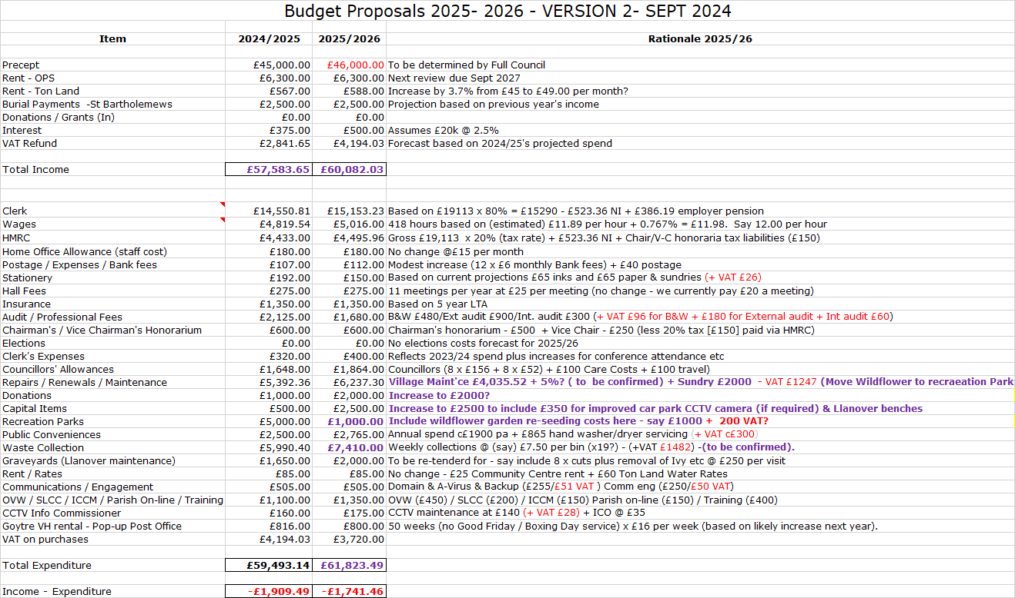  Although explanatory notes are provided against each of the budget lines (generally, most changes are just inflationary increases, or represent a minor adjustment), the Clerk felt the following points were worthy of further comment:  - Clerk’s salary. This is always difficult to estimate as the current year’s salary has not been finalised (no national agreement yet). The Clerk / RFO has, therefore, forecast a 3.5% increase on top of last year’s projected figure. Hopefully, this year’s national salary agreement will be finalised before we sign off on the budget. The final figure will also impact on the HMRC budget below (Tax & NI), but not to a great degree.  - Wages. Next year’s minimum wage is forecast (according to UK Govt.) to be between £11.65 and £12.18, with a central projection of £11.89, which, with our standard margin takes us to £11.98. For the moment the Clerk /RFO has rounded up to £12 per hour. This figure will need to be reviewed after the budget on 30th October when next year’s minimum wage will be confirmed.  - HMRC – see comments under Clerk’s salary.  - Audit Professional Fees – This has been reduced from £2125 to £1680. This reflects the removal of the £1000 which was to cover the legal costs of the new lease on the OPS. However, the Clerk / RFO has increased our audit fee to £900, as we have a full transactional audit next year (we paid £700 two years ago). Also there has been a slight increase this year in the fees we pay to Beverley & Williams, which is reflected in the figure.  - Repairs / Renewals / Maintenance – Clerk/RFO has asked for an exact price from MCC for the village maintenance. In the meantime, last year’s costs have been increased by (an estimated) 5%, and the general sundry repairs budget doubled to £2000. The wildflower seeding budget (of £1000) has been moved to the recreation parks budget line, where it sits better.  - Donations – Originally increased to £1500, this was further increased to £2000 on the previous suggestion of the Chair. This will give us more headroom to support good causes both locally and in the village.  - Capital Items – Increased to £2500 (from £500) to give us a little more leeway to purchase new equipment – potentially some benches for Llanover, dependent on what comes out of the proposed engagement survey.  - Recreation Parks – We included £5000 last year, which should all be spent once the new equipment is installed. £1000 has been added for re-seeding the wildflower bed(s). Clerk / RFO will see if the overgrown wildflower bed can be re-planted as part of the green corridor project.  - Waste Collection – We are still waiting for confirmation of next year’s costs from Merlin Environmental. In the meantime, the Clerk / RFO has budgeted for an increase from £7.20 per bin empty to £7.50, which is just under a 4.5% increase. The additional cost of three (potential) bins for Llanover has also been included in case of need.  The overall aim is to retain our reserves at circa 50% of the precept. An increase in the precept from £45k to £46K has been included, which would represent a 2.2% increase (to match current inflation). Two other proposals were considered:  - Increase the precept by £3000 (equivalent to 6.7%), which would leave a small surplus of c£258 (effectively a balanced budget).  - Increase the precept by £5000 (equivalent to11.1%). This would have us running a small budget surplus of £2258, and provide us with additional ‘wherewithal’ to fund additional initiatives.  For context, it was noted that an increase of £1000 is the equivalent of only 1.6p/week for each household based on a Band D property.  After discussion and further consideration, the committee agreed to increase the suggested precept by £3000 to £48000. The Clerk / RFO to update the current version (to v3) to reflect the change and to distribute this to Councillors for consideration at full council on 14th October. | Clerk / RFO
7 | Risk Review (inc Health & Safety schedule)  The following points were highlighted by the Clerk / RFO from the Risk Assessment  - Precept  - Second payment of 2024/25 precept received at the end of August. Clerk/RFO is currently preparing the annual budget for 2025/26, to be reviewed at Oct & Nov Full Council, with final sign off in December.  - Loss of Income from the Olde Pounde Shop  - Tenant has decided to renew the lease from Sept onwards. A new, 15- year lease has been drawn up, approved by full council at the September meeting and sent to tenant’s solicitors. Our business interruption insurance in place with Zurich has now been extended to 24 months (in line with new lease - max £12600 over 24-month period).  - Salaries / Wages  - National Clerk’s pay rise for the 2024/25 financial year, still to be agreed. This makes an accurate estimation of the 2025/26 salary date more difficult.  - Training of Clerk / Staff  - Councillor Carter to attend Code of Conduct course on 30h October. Training Plan reviewed and updated on 23rd September.  - Assets / maintenance  - Security of Buildings and Equipment: 2 x high quality 4k cameras purchased and trained on toilet doors to try to stop further vandalism. Hard drive now upgraded (enlarged) to provide sufficient capacity for extended recording.  - Maintenance Paul Lewis has now installed the new toilet door following the vandalism in the summer. The side door of the OPS also requires repair / replacement. Cost estimate still to be received but is the responsibility of the tenant under the shop lease terms.  - Health & Safety  - Lighting at the OPS now upgraded to LED, which has addressed the low level issue of a small length of ceiling light wiring not being enclosed by trunking.  - Code of Conduct  - Councillor Carter to attend training on 30th Oct.  - Community & Town Councils Duty under Section 6 of the Environment Wales Act  2016 (Bio-diversity plan)  - Existing initiatives include wildflower beds in  Goytre Park, together with pollinating and fruit  trees, although the wildflower beds require re-  seeding and addition of yellow rattle. Initiatives  to improve biodiversity are currently under  discussion with further public engagement  planned as part of the MCC green corridor  project initiative.  The Health & Safety Checklist update was then provided by the Clerk / RFO.  St Bartholomew’s Churchyard: – Llangybi blacksmiths have now completed their repairs on the handrail which now shows no sign of movement. The Clerk wanted it minuted that Llangybi blacksmiths had carried out the work free of charge.  There were no other Health & Safety issues to report.  The Risk Assessments & Health & Safety updates were accepted by the meeting and formally proposed by Councillor Morrey seconded by Councillor Carter, and carried unanimously. The Clerk / RFO will propose at next Full Council meeting for sign-off.
8 | Date of Next Meeting  Next meeting scheduled for Tuesday 7th January 2025, 6.30pm – with attendance by teleconference. All to diarise. | All

Council member Date:
Clerk / RFO............................. Date:

