CYNGOR CYMUNED GOETRE FAWR COMMUNITY COUNCIL FINANCE COMMITTEE

MINUTES OF THE MEETING HELD BY TELE-CONFERENCE ON TUESDAY 7th JANUARY 2025 @ 18.30

Present: Community Councillors Nigel Morrey, Janet Robins, Lewis Carter & Jonathan Lazenby as Clerk/RFO.
Apologies: None.
Absent without apology: Councillor Peter Daniel.

 |  | ACTION
1 | Welcome and apologies for absence  The meeting commenced at 6.30pm with the Clerk/RFO welcoming everyone to the meeting.
2 | Approval of Minutes of the Previous Meeting  The minutes of the previous meeting held on Tuesday 8th October 2024 were reviewed. The minutes were proposed as a true and correct record by Councillor Morrey, seconded by Councillor Robins and passed by all those present at the meeting. | Clerk/  RFO
3 | Matters Arising  (Updates not covered as separate issues under the various agenda items below).  - Item 5 – Audit 2023/24 – An unqualified audit was received from the Auditor General for Wales and accepted by full council at its meeting on 11th November
4 | Cashflow as at 31st December 2024  The Clerk/RFO provided those present with a copy of the Dec 2024 cashflow position, together with the Unity Trust Bank (UTB) statements covering October, November & December 2024. The cashflow balances were verified to the closing balances in the UTB statements at the end of Oct/Nov/Dec with Councillor Carter agreeing to sign to confirm their accuracy in accordance with section 2.6 of the Model Community Council Financial Regulations (Wales).  There was no further comment or observation. | Clerk/  RFO
5 | Budget 2025/2026 – Latest update  The following (6th draft) budget, was agreed at the December meeting of full council and reflects the following changes from version 5.  - The precept has been formally confirmed at £49,000.  - The Repairs / Renewals / Maintenance budget line has increased by £1000 (sundry maintenance has increased from £2000 to £3000 within this overall figure)  - The VAT budget line has increased by £200 to reflect the likelihood that the increased maintenance budget will attract £200 of VAT (£1000 x 20%)  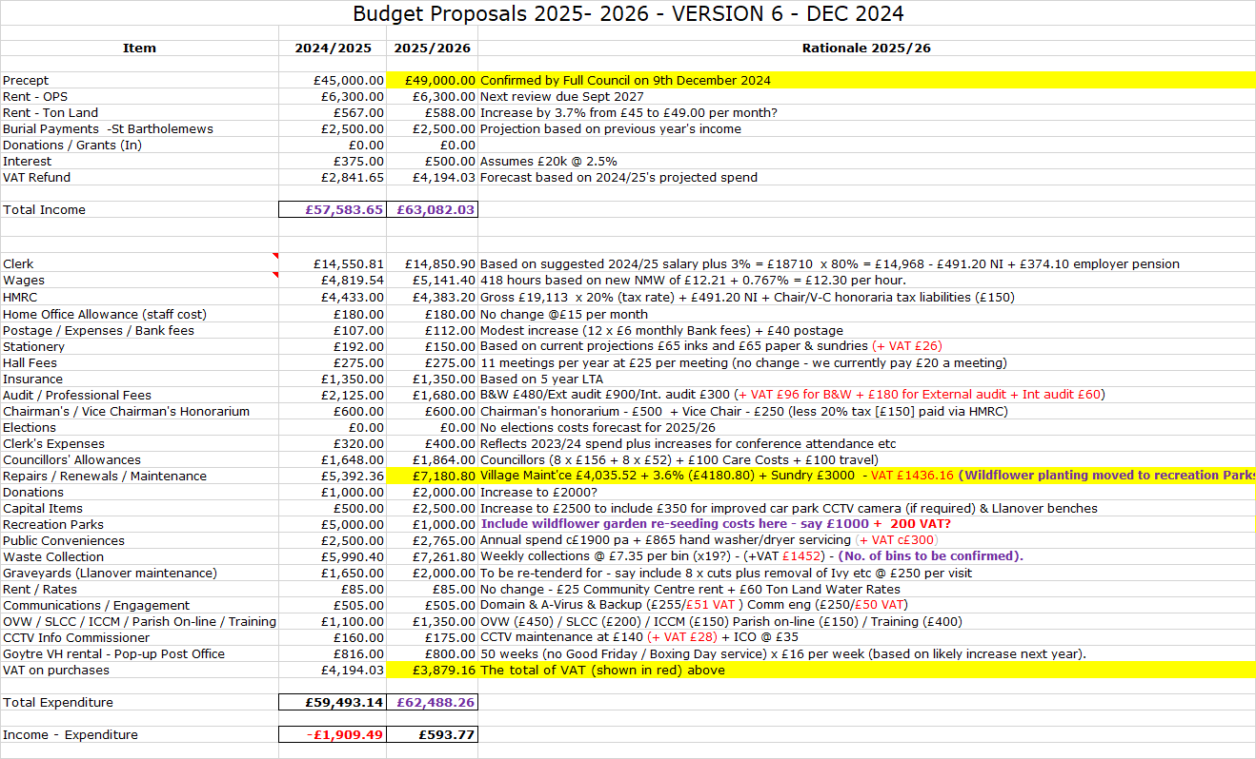  The (potential) additional VAT will reduce the previous projected ‘surplus’ from £793 to £593.  Councillor Morrey thought it would be prudent to incorporate a figure of £350 plus VAT (under professional fees), for Linnell’s to undertake a review of our property valuations for building insurance replacement purposes. This was last undertaken in February 2023, (when the fee was £300 plus VAT), and is due in early 2026 if councillors feel it prudent to maintain a three-year cycle of reviews. This would reduce the surplus by £420 to £173, (so more or less a balanced budget).  Version 6 of the budget will be presented to full council at its meeting on 13th January for Councillors to review and consider the additional budget item outlined above.  In the meantime, the Clerk confirmed that our precepts request has now been forwarded to MCC and receipt acknowledged. | Clerk/  RFO
6 | Risk Review (inc Health & Safety schedule)  The following points were highlighted by the Clerk / RFO from the latest Risk Assessment  - Precept  (a) Full Budget process in place. Clerk/RFO has prepared annual budget for 2025/26. Precept (£49000) was signed off at December 2024 full council. Advised to MCC and receipt confirmed. Final payment of 2024/25 precept received December.  (b) Loss of Income from the Olde Pounde Shop  New 15-year lease (from Sept 2024) still to be signed  - Reserves – Earmarked – ensure adequacy  - Previous earmarked funds of £1886 - representing remaining monies from Micro-Geography Fund, now allocated and will be spent on the adult exercise equipment for Goytre recreation park. Invoice awaited from MCC.  - Salaries / Wages – wrong rate applied  - Clerk’s salary increase for 2024/25 agreed at Nov 2024 Full Council and backdated to April 2024. B&W (payroll providers) advised. Projected 2025/26 salary now estimated based on this new figure to provide greater budget accuracy.  - Training of Councillors – ensure all Councillors have attended Code of Conduct Training  - Councillor Carter attended Code of Conduct course on 30th October. All Councillors have now attended.  - Training of Clerk / Staff – Ensure all staff receive appropriate training  - Email sent to S&A Fodden in January asking for confirmation of adequate safety supplies / materials safety guidance / training issues. Confirmation received 7th Jan 2025.  - Training Plan reviewed and updated on 16th December.  - Assets - Loss & Damage  - Review sums insured annually. Insurance renewal now received and to be reviewed by Full Council at January meeting and renewed on 2nd February 2025.  - Risk to third party properties or individuals - Employer’s liability cover notice to be posted in February following renewal of insurance. Clerk to place on stockroom door, notice boards and web site once received.  - Maintenance. The side door of the OPS also requires repair / replacement. Three cost estimates received based on uPVC/Softwood/hardwood. However, responsibility falls to tenant who is going to investigate a repair / replacement of storm guards at the base of each door and bottom of door frame.  - Disability Discrimination Issues  - Failure to identify and implement adaptations. Councillor Robins felt that this issue had now been addressed and hence the likelihood score should be reduced from 2 to 1 (which would reduce the classification from medium to low), following the installation of new play equipment in the park, much of which was disability inclusive. This was agreed by those at the meeting, with the comments amended to reflect this: “The previous lack of disability inclusive play facilities in Goytre Park has been addressed with the installation of new equipment”.  The Health & Safety Checklist update was then provided by the Clerk / RFO.  - Staff Health & Safety  Email confirmation required from Sarah & Andrew Fodden confirming adequacy of safety supplies / materials safety guidance / training issues has now been received. As stated above, the Employer’s liability cover notice will be posted on the stock room door, noticeboards and web site in February, following renewal of our insurance.  - St Bartholomew’s Churchyard. Non-compliant wiring has been discovered between the church and the footpath and lychgate lighting. Gwenlec electrics to replace as soon as possible with full armoured cabling throughout.  There were no other Health & Safety issues to report.  The Risk Assessments & Health & Safety updates were accepted by the meeting and formally proposed by Councillor Morrey seconded by Councillor Carter, and carried unanimously. The Clerk / RFO will propose at next Full Council meeting on 13th January for sign-off.
8 | Date of Next Meeting  Next meeting scheduled for Tuesday 8th April 2025, 6.30pm – with attendance by teleconference. Councillor Robins advised that she will be way and so gave her apologies. Clerk to check that Councillor Daniel is able to attend to ensure we will be quorate. The following two weeks cover the Easter holiday period, and so the scope for changing the date is, unfortunately, limited. | All  Clerk/  RFO

Council member Date:
Clerk / RFO....................................... Date:

