CYNGOR CYMUNED GOETRE FAWR COMMUNITY COUNCIL FINANCE COMMITTEE

MINUTES OF THE MEETING HELD BY TELE-CONFERENCE ON TUESDAY 7th OCTOBER 2025 @ 18.00

Present: Community Councillors Peter Daniel, Janet Robins, Lewis Carter & Jonathan Lazenby as Clerk/RFO.
Apologies: Community Councillor Nigel Morrey
Absent without apology: None

 |  | ACTION
1 | Welcome and apologies for absence  The meeting commenced at 6.00pm with the Clerk/RFO welcoming everyone to the meeting.  It was noted that Councillor Carter has a potential prejudicial interest in any funding / budgetary requests for the community centre (to be discussed under item 6)
2 | Approval of Minutes of the Previous Meeting  The minutes of the previous meeting held on Tuesday 8th July 2025 were reviewed. The minutes were proposed as a true and correct record by Councillor Robins and seconded by Councillor Carter and passed accordingly (Councillor Daniel did not vote being absent from the July meeting). | Clerk/  RFO
3 | Matters Arising  (Updates not covered as separate issues under the various agenda items below).  There were no matters arising.
4 | Cashflow as at 30th Sept 2025  The Clerk/RFO provided those present with a copy of the Sept 2025 cashflow position, together with the Unity Trust Bank (UTB) statements covering July, Aug & Sept 2025. The cashflow balances were verified to the closing balances in the UTB statements at the end of July/Aug/Sept, with Councillor Daniel agreeing to sign to confirm their accuracy in accordance with section 2.6 of the Community Council Financial Regulations (Wales).  There was no further comment or observation. | Clerk/  RFO

5 | Audit 2024/25  The Clerk/RFO was delighted to advise that we have received an unqualified audit opinion for 2024/25. Two points were identified for review and action, one being the need for any accompanying reports/papers to the agenda be published on the web site. This is covered in the 2013 Democracy Act, but does not appear to have been an issue in any of our audits since that time. However, the Clerk has already addressed the issue by uploading both the cashflow and first draft of the 2026/27 budget in support of this meeting (and will continue to publish documents as required).  The second note concerns the alleged use of an invalid VAT number. This appears to be related to a company which no longer trades under its own VAT number, having been taken over by a competitor in November 2024. The Clerk has checked all the invoices since 2020, and confirms that the same (presumably correct) VAT number was used throughout this period. The Clerk has checked with the new company, but they seem unable to help. There therefore appears little more that the Clerk can do to confirm the situation, but disappointingly, Wales Audit have declined to re-issue the report with an amendment.  The audit opinion has already been distributed to Councillors who will be asked to accept its outcome at full council on 13th October. | Clerk/  RFO
6 | Budget 2025/2026 – first review  The following (1stdraft) budget was submitted to the meeting for comment, prior to its submission to Full Council on 13th October. Although explanatory notes are provided against each of the budget lines (generally, most changes are just inflationary increases, or represent a minor adjustment), the Clerk felt the following points were worthy of further comment:  - Clerk’s salary This is based on a projected 3.2 % pay rise (although no ‘inside’ information is known). Given the rate of inflation in August / Sept, the Clerk queried whether it would it be sensible to increase this to 3.5% (although the difference is only £57 per annum). Whatever the final figure, it will also impact on the HMRC budget below (Tax), but not to a great degree.  - Wages The best projection for the 2026/27 minimum wages available at the moment is £12.71, which, with our standard margin, takes us to £12.81. This figure will need to be reviewed after the budget on 26th November when next year’s minimum wage will be confirmed.  - HMRC – Reflects tax applicable under Clerk’s salary and any taxable payments to Councillors (honoraria).  - Audit Professional Fees – This has been reduced from £2030 to £1130. This reflects the reduction in projected Wales Audit fees from £900 to £300 (due to reduction from triennial to standard audit), and the removal of the £350 cost of the revaluation of the OPS public conveniences (for insurance purposes).  - Elections – nothing has, as yet, been included to try and recoup and potential election fees from the summer (still no notification from MCC). The Clerk has been advised to take no action for the time being (as invoices are often slow at coming through) and to revisit towards the end of the year. At this point we could transfer an appropriate amount of money to an ear-marked reserve in our deposit account to cover. This could then be used to pay a late invoice, or in the case we are not billed, we could continue to leave it as ear-marked to cover any future election costs. However, that would ‘deplete’ our free reserves, so in this eventuality, should perhaps be covered by increasing the precept?  - Repairs / Renewals / Maintenance. – Village Maintenance (based on the proposed new ‘town Teams’ service £4,202.01 + 4% = £4370.09.  - Donations – Stay at £2000? A separate budget line has been added for the Community Centre. Should this be for capital expenditure only, rather than running costs (which seemed to be the indication)? Should we request from the trustees (as indicated by OVW), the purpose for which the funds will be used (together with latest accounts and a business plan for 2026/27?)  - Capital Items – Reduce back to £2500 (No need to include Llanover dog bins). Is this sufficient for the potential purchase of any benches for Llanover if needed, to replace the uncomfortable bins recently installed.  - Recreation Parks – Have included £1000 for re-seeding the wildflower bed(s) in case of need. Clerk is contacting Jayne Clerk to establish what (if any costs) might need to be accounted for to replicate this year’s planting as part of the green corridor project.  - Waste Collection – Budget figure reflects confirmed cost increase from £7.35 to £7.65 per bin.  - Graveyard – No change - contractor has confirmed the same process for 2026/27.  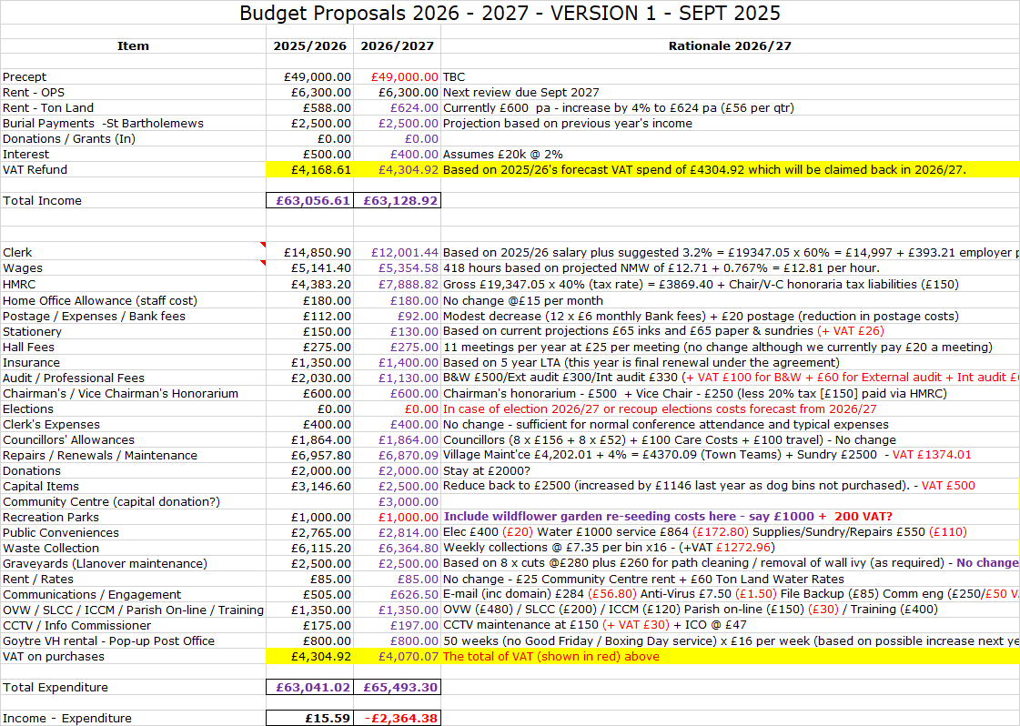  The overall aim is to retain our reserves at circa 50% of our annual spend. The figures above would suggest that, at this stage, an increase in the precept of somewhere between £2k and £3k would be required if we were to deliver a balance budget.  For context, it was noted that an increase of £1000 is the equivalent of only 1.6p per week / 83p per annum for each household based on a Band D property.  It was agreed that the first draft shown above will be distributed to Councillors for consideration at full council on 13th October. | Clerk / RFO

7 | Risk Review (inc Health & Safety schedule)  The following points were highlighted by the Clerk / RFO from the Risk Assessment  - Precept  Second payment of 2025/26 precept received at the end of August. Clerk/RFO is currently preparing the annual budget for 2026/27, to be reviewed at Oct & Nov Full Council, with final sign off in December.  - Legal Powers  With the election of Councillor Stevens in August 2025, the Council once again meets all three criteria for the adoption of the General Power of Competence. The Council therefore declared its eligibility and (re) adopted the power at the September 2025 meeting, meaning that in future it no longer has to rely on specific statutory powers and duties or s137.  - Salaries / Wages  Wrong Rates Applied - Clerk’s salary increase for 2025/26 agreed at Sept 2025 Full Council and backdated to April 2025. B&W (payroll providers) advised. 2026/27 salary forecast on this new figure  - Financial Assistance  Previously Clerk to contact OVW for advice in grey areas where section 137 is concerned. (Issue was highlighted in 2017/18 Audit report). However, compliance with section 137 has once again been superseded by the adoption of GPoC at the September 2025 full council.  - Councillor Allowances  ‘Claim’ process for 2025/26 financial year now underway.  - Code of Conduct  Councillor Stevens attended Code of Conduct course on 3rd September. All Councillors have now attended.  - Assets – Loss / Damage  Consider revaluation of properties prior to Feb 2026 insurance renewal  - Health & Safety  - Survey of Trees on Ton Land undertaken by MCC July 4th 2025. Report received 27th August 2025 confirming that all have good vitality and that no further action is necessary.  - The St Bartholomew’s Graveyard headstone risk assessment was completed March 2023, with headstones either secured or laid over where this was not possible. Next due March 2028.  - Register of Members Interest, Gifts and Hospitality  Interests received and recorded of newly appointed Councilor Martin Stevens, who replaced Councilor Grayland who ceased to become a Councillor on 10th June under s85 of the LGA 1972.  - Community & Town Councils Duty under Section 6 of the Environment Wales Act 2016 (Bio-diversity plan)  An updated plan is due at the end of this year and should reflect the Green Corridor initiatives which are taking place across the ward. These include wildflower beds and trees in Goytre Park (& Dog walking area), the green at Rhydymeirch and St Bartholomew’s graveyard, as well as other small selected sites. .  The Health & Safety Checklist update was then provided by the Clerk / RFO.  - Ton Land  A survey on the four oak trees at ton Land has confirmed that all show good vitality. Some have an element of deadwood, but this is tolerable for their age. No action needed. Re-diarised for July 2028  - St Bartholomew’s churchyard  The overhanging bough / large branch of a tree on an adjoining tree has now been removed.  There were no other Health & Safety issues to report.  The Risk Assessments & Health & Safety updates were the accepted by the meeting and formally proposed by Councillor Robins seconded by Councillor Carter and carried unanimously. The Clerk / RFO will propose at next Full Council meeting for sign-off. | Clerk / RFO
8 | Date of Next Meeting  Next meeting scheduled for Tuesday 6th January 2026, 6.30pm – with attendance by teleconference. All to diarise. | All

Council member Date:
Clerk / RFO............................. Date:

