CYNGOR CYMUNED

GOETRE FAWR

COMMUNITY COUNCIL
MINUTES OF THE MEETING HELD BY TELECONFERENCE ON MONDAY 18TH JANUARY 2021

Present: Community Councillors Owen Dodd, Andy Barnes, Jan Butler,
Colin Deakins, Janet Robins, Peter Daniel and Syd Welford
Apologies: Community Councillors Nigel Morrey, Nicola Awni and Rose Thayers
Absent without apology: Community Councillor Roger Howells and Lucyann Rands
In attendance: Jonathan Lazenby (Clerk)

 |  | ACTION
1 | Apologies for Absence  As above.
2 | Suspension of Standing Orders (7.35 pm)  Due to the delayed arrival of the Chair, the Vice-Chair opened the meeting and immediately suspended standing orders to allow Community Support Officer Sara Mason (a member of the North Monmouthshire Neighbourhood Policing Team), to address the meeting. Sara explained that she is now based at Usk having transferred from Abergavenny and works with fellow officers Rhydian Evans, Christopher Watkins and Stephen Cowles. The team work on a variety of issues, including crime prevention. Sara explained that rural burglaries, especially outbuildings and the theft of quad bikes, had seen an increase in recent months. They are also supporting the Covid-19 restrictions – advising and educating, rather than enforcing where possible. Sara then answered a number of questions, confirming that she and the team work with MCC on the problem of fly-tipping. Sara advised that the best way to contact here is via email, and it is hoped that she (or another member of the team) will join us on a regular basis going forward. Clerk to confirm our meeting link and meeting dates to Sara.  The Chair, having now joined the group reconvened the meeting at 7.43 pm. | Clerk
3 | Declarations of Interest  The Chair asked members whether they had any declarations of interest to make. The Chair referred to a recent complaint made to the Head of Legal at MCC regarding a possible conflict of interest in a decision made at a recent meeting. The Chair emphasised the need for all Councillors to ‘re-declare’ any potential conflicts on the agenda at the beginning of each meeting (even if previously declared and published), and where they are prejudicial to withdraw from any discussion / vote. At this point the clerk read a couple of key extracts from the Code, and the Chair said that he would also seek additional clarification from One Voice Wales. The Clerk will apply for the appropriate dispensation where an individual’s knowledge is considered essential to an informed debate. The Clerk is to request Matt Phillips (Head of Legal at MCC) to undertake a short training session, specifically on the issue of personal / prejudicial interests to provide further clarification on the subject. | Clerk
4 | Chairman’s Remarks  The Chair welcomed everyone to the meeting.
5 | Approval of the Minutes of the Council Meeting held on 14th Dec 2020  The minutes of the meeting were proposed as a true and correct record by Councillor Barnes and seconded by Councillor Daniel. | Clerk
6 | Matters Arising  - Item 5 (i) – Lapstone Road sign – The Clerk is now working with the destination marketing officer for MCC to see if a brown tourist sign would be appropriate for Lapstone Road canal car park.  - Item 5 (ii) - MCC have not responded to the Clerk’s second request to add Plough Road to the village gritting routes.  - Item 6 (ii) – There has been no update on the issue of water cascading from the drain cover on the pavement outside the village hall. However, Councillor Barnes advised that this has been an issue for many years.  - Item 13 (i) - No communication has been received from ‘Sparkle’ on the level of support they provide in the area.  - Item 13 (iii) – The pink bins have arrived and been collected by Mike Jones with two delivered to the school. | Clerk  Clerk
7 | Maintenance (inc. items reported but not addressed)  - Someone has removed the hand gel dispensers from the public conveniences, which have therefore had to be closed for the time being. The Clerk has identified replacement units (at a cost of c£12.50 per unit) whose design will make them more difficult to remove. It was agreed that these should be purchased, and this was formally proposed by Councillor Barnes and seconded by Councillor Butler.  - Little Mill Park requires clearing of moles and it was requested that James Price be contacted to attend. Proposed by Councillor Deakins and seconded by Councillor Welford.  - Litter picking in the village – two local residents have asked if MCC could provide a van with flashing warning light to shield them from traffic so they can clear the left-hand side of the carriageway of the A472 from LM towards the Beaufort Arms (as there is no footpath). Clerk to speak with Nigel Leaworthy to decide the best way forward.  - The WI are purchasing a new bench via MCC (Nigel Leaworthy).  - Clerk to enquire what is happening regarding the recently installed pedestrian crossing in Penperlleni, as people are still trying to use it.  - The public footpath that runs alongside the railway line from just over the railway bridge requires clearing – Clerk to contact MCC. | Clerk  Clerk  Clerk  Clerk  Clerk
8 | MUGA update  There is no update to report at the present time.
9 | Finance  - Review of accounts / cashflow.  The Clerk presented the meeting with a copy of the December 2020 cashflow position. This had been presented to the Finance committee last week, together with the Unity Trust Bank (UTB) statements covering Oct, Nov and Dec 2020. The cashflow balances were verified to the closing balances in the UTB statements at the end of Oct/Nov/Dec 2020, with Councillor Barnes signing to confirm in accordance with section 2.2 of the Community Council Financial Regulations (Wales).  The Clerk highlighted the following:  - The CC received the final instalment (£11,333) of this financial year’s precept, on 24th Dec.  - The payment to HMRC is higher this quarter as it includes the income tax due on Councillors’ payments and honoraria (£450).  There was no further comment or observation.  The costs of the wildflower / orchard project in the park, plus the wildflowers by the A4042 and Little Mill bus stops, will be charged by MCC before the year end at £2390 (as per the original agreement).  - Payments made since the Dec 14th meeting  £  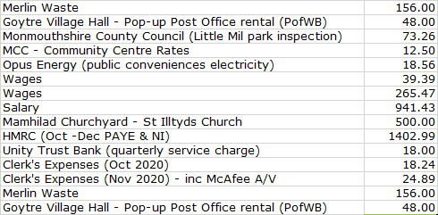  - Finance Committee report)  (1) Draft Budget for 2021/22 - The Clerk circulated the latest iteration (v 6) of the proposed 2021/22 budget.  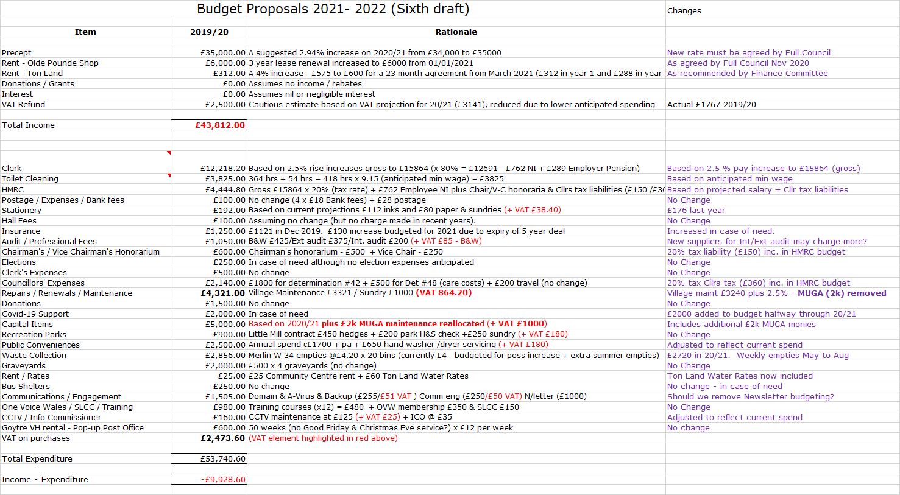  Clerk advised that £930 will need to be budgeted for the clearing and subsequent reseeding of the wildflower beds in Autumn 2021 / Spring 2022, (assuming Council wishes to continue with the scheme). The Finance Committee had considered whether this should be allocated from the existing ‘Sundry’ maintenance budget (currently £1000), or from the reallocation of monies from an existing budget line, and had recommended the reallocation of £1,000 from the Covid-19 donations budget as there are several central schemes which can provide emergency / Covid-19 resilience funding. This was accepted and proposed on behalf of Full Council by Councillor Butler and seconded by Councillor Robins. Clerk to adjust the 2021/22 budget accordingly.  (iv) Risk Assessment  The Clerk presented the following key elements from the risk assessment considered by the Finance Committee at their meeting on 12th Jan.  - Precept - Third (and final) 2020/21 payment now received from MCC.  - Loss of Money - Full Council has agreed to renew the current OPS lease at a monthly rate of £500 from 1st Jan. However only £495 was received in Jan. The Clerk is arranging for the £5 shortfall to be collected.  - Code of Conduct Training - All Councillors have now attended.  - Failure to comply with equalities and/or employment law - Potential Equality & Diversity Policy still under review. To be assessed again once OVW have run an online E&D course on behalf of all Councillors.  - Assets / Insurance – The CC’s insurance is due for renewal 1st February 2021 – See separate item below.  - Health & Safety - The damaged branch on an Oak Tree on Ton Land has still not been removed by MCC who are short staffed. Clerk / RFO has approached Joshua Tree Services (JTS), who have visited the site and quoted £200 (although only a small branch it is relatively inaccessible, requiring a significant amount of work to reach it safely). It is a clear potential hazard and requires removal asap, by a reputable and reliable tree surgeon. The acceptance of the quote and use of JTS has been proposed by the Finance Committee. This was accepted and proposed on behalf of Full Council by Councillor Barnes and seconded by Councillor Daniel.  - Electrical safety tests were undertaken at the public conveniences and Community Centre on 12th October – both were ‘satisfactory’.  - MCC will carry out a H&S inspection of Little Mill park in due course, and also make an assessment of the suitability of the equipment.  - Web page accessibility – Sight Cymru have awarded us ‘Sight Friendly Organisation’ status and will work with us to help maintain our standards.  - Duties under Section 6 of the Environment Wales Act 2016 (Bio diversity plan) - Following the marking out of the garden area and installation of the raised bed, the pollinating trees have now been planted with the orchard trees due shortly. Wild seeds have already been sown in the grass, with the beds to be seeded in the Spring  Acceptance of the Risk Assessment by Full Council was proposed by Councillor Butler and seconded by Councillor Welford.  - Ton Land Lease renewal  The lease is due for renewal on 1st March for a further period of 23 months. As per the proposed 2021/22 budget, the Clerk is suggesting a 4.35% increase (since 1st April 2019), to take the cost from £575 to £600 for the 23- month period. This will see payments of £312 in year 1 and £288 in year 2 (for the remaining 11 months). This was agreed and proposed by Councillor Deakins and seconded by Councillor Butler. Clerk to contact lease holder to progress.  - Insurance Renewal  Zurich (current insurers) are proposing the following  - A 1-year standard deal at £1288.22 pa.  - A 3-year LTA deal at £1232.77 pa.  - A 5-year LTA deal at £1177.60 pa.  Clerk / RFO has spoken to Came & Company (specialist local council insurance brokers) who were estimating their best deals to be in the £1400-£1600 range and they have therefore recommended acceptance of the Zurich five-year quote. This was recommended by the Finance Committee and proposed on behalf of Full Council by Councillor Daniel and seconded by Councillor Deakins.  - Internal Auditor  Our current auditor gave us notice last year that she intended to retire. The Clerk has therefore invited tenders from three alternative companies (based on the recommendations of other local Clerks)  - EH Accountancy – (Abergavenny) – they have promised to tender by 29th Jan  - Catherine A Williams – (Crickhowell) – they have promised to tender  - Dorrell Oliver (Abergavenny) – have advised us that they do not wish to increase their portfolio in the local authority sector.  Clerk will present the two tenders to Full Council at the February meeting  - Traditionally we have made payment to the VH by 4-weekly standing order to reduce admin. However, due to the increasing number of occasions when the PO is unable to operate due to their IT problems, the clerk queried whether in future we should request the VH to bill us for the exact number of sessions used. It was agreed that the Clerk should contact Idwal Sheen (VH Chair) to discuss the most efficient way forward.  - Web site renewal - The annual fee (£29.95) is due if we wish the site to be available without Google adverts. The payment was agreed and proposed by Councillor Barnes and seconded by Councillor Daniel. | Clerk  Clerk  Clerk  Clerk  Clerk  Clerk  Clerk  Clerk  Clerk
10 | Planning Committee – updates  Path Order at Springfield Cottage. Footpath No. 93  Following the CC’s submission, the MCC Rights of Way officer advised us that he has already informed the applicant that MCC would not be able to confirm the order if the new path alignment contains a stile. The applicant has therefore agreed to replace it with a gate. Councillor Barnes believes that the proposal to build the large new property may now have been abandoned in favour of updating the original bungalow on the site. Clerk to contact MCC to establish current situation. | Clerk
11 | Replacement MCC Local Development Plan (RDLP) – Growth and Spatial Options – update from 14th Jan to agree feedback for the T&CC event on 21st Jan.  Councillor Robins attended the meeting and reported that the two key options being considered are: Option 2 (New developments around existing areas of population) and option 5 - the growth option. Councillor Dodd expressed some concern that MCC population forecasts are often wrong, as many of the local children are not born in the area, so are excluded from projections. The development of the old Parke Davis site will also have a significant impact on local infrastructure. Councillor Robins advised that following the pandemic, MCC predict a much higher level of working from home and will be looking to include work / office space in future developments, as well as building more affordable housing to enable young people to stay in the area. It was agreed that more affordable housing (and a revisit of the qualifying salary thresholds) was required. Councillor Dodd encouraged as many people as possible to attend and to feed in the thoughts from our discussion today, as the new plan will run until 2034. | All
12 | Youth Representatives – next steps  The Clerk queried whether with the current climate (pandemic and lockdown), it was an appropriate time to advertise, as young people and parents had their minds on other issues. Councillor Butler agreed and Councillor Barnes added that it would be impossible to undertake any face-to-face interviews with prospective candidates. It was therefore proposed by Councillor Butler and seconded by Councillor Deakins that we postpone the initiative until the Autumn, by which time it is hoped circumstances will be more conducive to a successful campaign. Clerk to diarise for July review. | Clerk
13 | Reports – questions based on previously distributed update.  - Little Mill Village Hall  - No report submitted.  - Goytre Village Hall  - No report submitted.  - Goytre School Governors  - No report submitted.  - Goytre Community Centre  - Still actively trying to get grant funding for loss of income during COVID crisis.  - Trying to update trustees on Charity Commission website.  - GASC has new procedures in place to mitigate against any further closures. There are now two groups infants/juniors with designated staff and areas.  - Boiler maintenance has been carried out but there are still a few outstanding issues to resolve.  - Discussion took place regarding the vision for the future of the Centre/ Jack and Jill’s. Contacts at MCC have been provided by Councillor Jane Pratt. Cllrs Dodd and Butler are to start a conversation with Nick Keyes (Estates) and Sharon Randall-Smith (Education).  - Other Reports  - There were no other reports
14 | Donations  - Welsh Air Ambulance – It was felt by Councillors that this was a valuable service for the area, particularly with the high accident rate on the A4042 around the village, where the air ambulance had been used on more than one occasion. Given that the service is funded entirely by donations, Councillors again wished to support it, as in previous years, with a donation of £500 under section 137. This was proposed by Councillor Butler and seconded by Councillor Barnes.  - Urdd Committee - The Urdd National Eisteddfod committee have requested a donation to the national event in Denbighshire in May this year. However, given the location, Councillors did not feel it appropriate to support the event directly, but to consider supporting (if requested) local participation from the school or other organisation. | Clerk
15 | Communications  The Clerk is aware of problems with Councillors who operate Microsoft linked email accounts (Outlook & Hotmail) not receiving emails via the CC’s server – Microsoft appear to have ‘blacklisted; the server. The reason why is not clear but M/247 are working to resolve the issue as soon as possible. | Clerk
16 | Advertising - Usk and Raglan Diary contributions Mar / Apr 2021.  The closing date for submissions is this Friday 22nd It was agreed that CC articles should include the progress being made on the wildflower garden in the park and the decision to agree for MCC to build and maintain the MUGA.
17 | Date of next meeting & close – Monday 22nd February January 2021 at 19.30. (NB not 15th as originally planned) | All

Chairman: …………………………………….…………… Date:…………………….

