CYNGOR CYMUNED

GOETRE FAWR

COMMUNITY COUNCIL
MINUTES OF THE MEETING HELD BY TELECONFERENCE ON MONDAY 22nd MARCH 2021

Present: Community Councillors Owen Dodd, Andy Barnes, Jan Butler, Colin Deakins, Janet Robins, Nicola Awni, Nigel Morrey, Rose Thayers and Syd Welford
Apologies: Community Councillors Lucyann Rands and Peter Daniel
Absent without apology: Community Councillor Roger
Howells
In attendance: Jonathan Lazenby (Clerk), Sara Mason,
Community Support Officer from the
North Monmouthshire Neighbourhood
Policing Team, Jenny Carpenter –
Community Councillor, Llanbadoc
Community Council.

 |  | ACTION
1 | Apologies for Absence  As above.
2 | Declarations of Interest  The Chair asked members present whether they had any declarations of interest to make. None were forthcoming. The Chair reminded those present that they should notify the meeting of any additional interests which became apparent during the progress of the meeting.
3 | Chairman’s Remarks  The Chair welcomed everyone to the meeting, and in particular Sara Mason, Community Support Officer from the North Monmouthshire Neighbourhood Policing Team, and Jenny Carpenter, Community Councillor, Llanbadoc Community Council who was attending the meeting as an observer.
4 | Suspension of Standing Orders (7.32)  Sara Mason, Community Support Officer advised Councillors the following issues had been reported to the local police:  - Residents had reported a suspicious van parked by the Canal.  - A lorry had hit the bridge at Little Mill.  - People have been reported hunting with dogs at Llanover – this is still being investigated.  - Sara has visited Goytre Stores to let them have the dates of the monthly surgeries that she will be holding in the ward.  Councillors asked the following questions:  - Will Sara be visiting the school? Sara confirmed she would be visiting in future, the Covid outbreak having restricted this activity in recent months.  - Is hunting with only two dogs illegal? Sara is to check.  - There is a new Local Facebook page for people to report suspicious activity – was this felt to be a good idea? Sara said that it was possible that some things could be blown out of proportion and there was the potential for scaremongering.  The discussion ended with the Chair thanking Sara for her time in updating Councillors. The meeting was reconvened at 7.42 pm.
5 | Approval of the Minutes of the Council Meeting held on 22nd Feb 2021  - Main meeting minutes: Item 11 should read ‘…presentation from MCC at a One Voice Wales meeting…’. The minutes of the main meeting were then proposed as a true and correct record by Councillor Welford and seconded by Councillor Butler.  - Closed Session minutes: The minutes of the closed session were proposed as a true and correct record by Councillor Deakins and seconded by Councillor Welford. | Clerk  Clerk
6 | Matters Arising  - Item 8 (iv) – The change in wages has been advised to both members of staff and the Beverley & Williams payroll team advised.  - Item 8 (v) – EH Accountancy have been advised of their successful tender and the Clerk has sent the standard engagement letter for them to sign. The unsuccessful candidate has also been advised. | Clerk
7 | Maintenance (inc. items reported but not addressed)  - The ladies’ toilets have now been repaired by 24/7 Plumbing and Heating. The bill was £55 plus £11 VAT. Payment was authorised by Councillor Butler and seconded by Councillor Morrey.  - The defibrillator at Little Mill Village hall was recently needed in an emergency, but unfortunately the battery was flat. The Clerk has checked the other units and all are fine. However, the pads at the Star are out of date, and those at Goytre VH expire in June. Clerk has contacted Cariad to order some more. The management of defibrillators is now co-ordinated centrally by the British Heart Foundation under a system called ‘The Circuit’. The BHF recommend someone local (who can check their status at least monthly), registers the units and takes responsibility for checking them. Should this be someone on site or the Clerk? After discussion, it was agreed that the Community Council should take overall responsibility, with regular documented checks on the battery and pads. This was proposed by Councillor Barnes and seconded by Councillor Robins.  Clerk to liaise with Richard Bowie, who it is believed may already have registered the Capel Ed unit.  - Little Mill Recreation Ground – Seven moles have  been caught in the traps.  - Clerk to chase Highways regarding the drain on  Newtown Road.  - There remains a lot of leaf debris following the reported recent cleaning / sweeping of the Car Park. Clerk has emailed Nigel Leaworthy to query. | Clerk  Clerk  Clerk  Clerk  Clerk  Clerk
8 | Finance  - Review of accounts / cashflow.  The Clerk presented the meeting with a copy of the February 2021 cashflow.  There was no further comment or observation.  - Payments made since the Feb 22nd meeting  The following payments have been made.  £  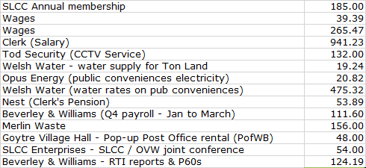  - Cemetery maintenance payments  In advance of this discussion Councillor Robins declared a potential interest as her husband is an elder and Treasurer of Capel Ed Church (although the Clerk advised the meeting that Capel Ed have not claimed this ‘allowance’ for the past couple of years). At present the CC has budgeted £2000 per annum (£500 per cemetery) for cemetery maintenance. However, a recent article in the Clerk’s magazine has highlighted that the legality of payments to church run cemeteries is currently disputed, with opinion being divided. The legal opinion is that we don’t have authority, whereas Govt. Ministers take a more relaxed view – but refuse to change the law to put it beyond all doubt. OVW are aware of a case being brought against a Council in South Wales so there may be future case law on this. However, in the meantime Councillors need to make a decision on whether to continue with this support, or to allocate the budget elsewhere. After much discussion, it was agreed to leave the budget line ‘as is’ for the time being, and to seek further clarification on what constitutes a closed churchyard.  - Dog Waste Bins  A number of dog waste bins are often filled to overflowing, and these have generated a number of complaints to the Clerk, and regularly feature on the village Facebook page. The bins are well used for their intended purpose, but a number, especially those by bridges 72 and 74 on the canal (plus a few others in the village) also attract a large amount of general litter – in particular paper cups and empty drinks cans, which causes them to overflow.  There is a sticker on the bin by bridge 72, advising people that the bin is for dog waste only, (unfortunately someone removed it from the other bin), but in any case, people seem to ignore it. Monmouthshire County Council are reluctant to install litter bins in remote locations, as they encourage fly tipping which causes an even bigger headache.  The Clerk therefore asked Councillors if the best solution is to arrange for the bins to be emptied weekly (at an additional cost of £2028 at current prices). Provision for weekly emptying for four months in 2021 has already been made in the budget, which would therefore leave a shortfall of £1304 for the remaining period (based on forecast prices). It was therefore agreed to transfer the £1k Covid 19 contingency support budget to this line, with the balance of £304 reflected in a larger projected budget deficit. This was proposed by Councillor Morrey and seconded by Councillor Welford.  - Confirmation of 2021/22 budget  The Clerk presented the current proposed budget and requested whether any further changes should be made. The following Changes were agreed:  - Reduce the projected VAT refund to £2,000.  - Transfer the Covid 19 budget (£1,000) to help cover some of the increased dog waste collections.  - Increase the dog waste budget to £4160 (based on £4 per bin).  - The projected budget deficit to be increased by £304.  This was proposed by Councillor Barnes and seconded by Councillor Welford. Clerk to make the adjustments and publish the final budget in the minutes.  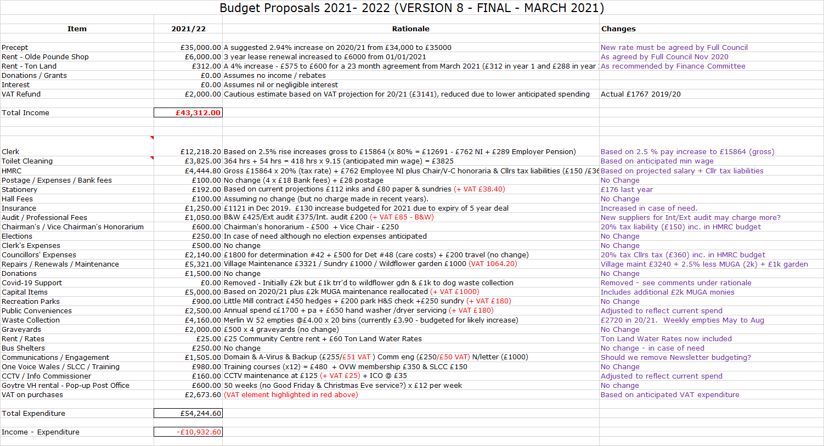 | Clerk  Clerk
10 | Planning Committee  The committee met on the 1st March to consider the following:  - A proposed single storey kitchen extension and  replacement workshop for a property in  Nantyderry.  - A proposed two storey rear extension creating a larger master bedroom and living/dining area for a property in Frondeg.  - On a general review basis only – the committee had looked at the proposed road scheme for traffic turning right into the Secret Garden. Unfortunately, the inclusion of the footpaths requested by the committee would require a wholesale re-design of the scheme, which can’t be accommodated. Neither is it possible to restrict exiting vehicles turning right across the southbound carriageway to travel north as ‘highways’ have no power to determine how vehicles exit private property.  Acceptance of the minutes of the planning meeting held on 1st March 2021 was proposed by Councillor Deakins and seconded by Councillor Dodd.  Councillor Barnes advised that the next planning committee meeting is to be arranged for next Monday or Tuesday.
11 | Allotments  A number of residents have expressed an interest in the CC providing allotments. The CC has a duty to provide allotments if at all possible, but currently has no suitable available land. The Clerk had identified a small patch of land in the village which may be suitable, but it appears that this is in private ownership. There are some old allotments along Penywern Lane, but these are very small and not considered suitable. Land forming part of Walnut Tree Farm (near the fields adjoining Frondeg), may also be a possibility. The Clerk will also investigate if Ton Land (currently leased to a local resident) would require planning permission for use as allotments. Councillors to continue to look out for possible opportunities and the Clerk to maintain on the agenda. In the meantime, the Clerk to email Mike Jones (who had raised the issue initially), with an update. | All  Clerk
12 | Litter and Fly-tipping prevention plan for Wales  To be carried forward to the meeting on 19th April. A response to the consultation is required by 22nd April. | Clerk
13 | Key provisions of the Local Government and Elections (Wales) Act 2021  An initial outline of the proposals includes the following:  - Changes to voting ages.  - County and County Boroughs to have a choice of election systems  - Election terms will increase from 4 to 5 years.  - The general power of competence - including the removal of the power of well-being plus the ability to trade.  - Access to meetings, inc., option for remote meetings to be made permanent.  - Community Council Annual Reports to be a requirement.  - Training of members and staff of Community Councils (with an associated plan) to be a requirement.  There will be an opportunity for the Clerk to receive a further update and to discuss the proposals at the joint SLCC / OVW conference on 13th May. | Clerk
14 | Network Rail – Trackside vegetation clearance  NR have sent a letter to advise local residents that they will be undertaking work to clear lineside vegetation during April. Councillors had expressed concern at the potential impact this will have on nesting birds and other wildlife. The Clerk has written to NR to raise these misgivings, and has received an assurance that a full and complete Preliminary Ecological Appraisal was undertaken in February 2021. Included in this was a search of local ecological data records.  Councillor Barnes still felt that it was unacceptable to be carrying out the work during the nesting season. (It was also noted that SWTRA are undertaking similar work along the A4042). After discussion it was proposed by Councillors Awni and Butler that the Council write to NR requesting that the work be delayed until after the nesting season (1st Sept). The vote was carried, with 8 votes for and 1 abstention. | Clerk
15 | Dog waste bins – misuse for general litter  With the agreement that we will now move to weekly collections, it was agreed that this agenda item was no longer required.
16 | Reports – questions based on previously distributed update.  - Little Mill Village Hall  - No report submitted (there has been no meeting).  - Goytre Village Hall  - No report submitted (there has been no meeting).  - Goytre School Governors  - No report submitted. (meeting due this Wednesday - 23rd).  - Goytre Community Centre  - No report submitted (meeting due tomorrow - 22nd).  - Other Reports  Councillor Awni has forwarded an update from the carbon literacy awareness and MCC Climate emergency working group, which has distributed a WWF website address to help people explore and calculate their carbon footprint. https://footprint.wwf.org.uk/#/
17 | Donations  Clerk has received an open request from Childline (based in Cardiff / Swansea). To help Councillors properly consider the request on behalf of local residents, he has asked for an outline of the work undertaken in the NP4 postal area. Response awaited.
18 | Communications.  - The annual fee (£29.99 + £6 VAT) for hosting the ‘goytre.gov.uk’ domain is due. Dissatisfaction was expressed by some Councillors at the problems they face with the non-receipt of emails. The Clerk is currently looking into this with the domain hosts, although it is not clear if the problem lies with M247 or individual email accounts, and whether moving to another provider would help. Payment was eventually proposed by Councillor Morrey and seconded by Councillor Barnes, with six votes for, two against and one abstention.  - The Health Board have advised that the surgery run by Drs Jarrett in Usk is to close, with some patients transferring to James House surgery. Councillor Deakins proposed, and Councillor Awni seconded that the Clerk write to the Health Board to ask how it is proposed that the service will be maintained. | Clerk  Clerk
19 | Advertising - Usk and Raglan Diary contributions May / June 2021.  Councillor Welford advised that the closing deadline for articles to be submitted for this edition is March 26th. The following articles were suggested:  - The CC is looking for allotment ground.  - The CC is querying the proposed tree and hedge cutting by Network Rail.  - The dog waste bins will be emptied weekly in future. | Cllr. Welford
20 | Date of next meeting & close – Monday 19th April 2021 at 19.30. | All

Chairman: ……………………………. Date:…………..…….

