CYNGOR CYMUNED

GOETRE FAWR

COMMUNITY COUNCIL
MINUTES OF THE MEETING HELD AT LLANOVER VILLAGE HALL & BY TELECONFERENCE ON MONDAY 12th DECEMBER 2022 @ 19.45

Present: Community Councillors, Andy Barnes, Janet Robins, Peter Daniel, and Morgan Chandler.

Guests None
In Attendance: Jonathan Lazenby (Clerk).
Apologies: Councillor Jan Butler, Nigel Morrey, Owen Dodd and Scott Grayland.
Absent without Apology: Youth Representative Chloe-Marie Tapper.
 |  | ACTION
1 | Apologies for Absence.  As above.
2 | Declarations of Interest.  In the absence of Councillor Dodd, the Vice-Chair, Councillor Andy Barnes, undertook the role of Chair. He commenced by asking the members present whether they had any declarations of ‘interest’ to make, which includes previous declarations already made. Councillor Barnes said that he had an interest in the MUGA as he was likely to vote against it on the grounds of potential noise affecting his property. Councillor Daniel, (as Chair of Goytre Village Hall), declared an interest in the Well-Being café which was run from the village hall. Councillor Barnes also reminded members that they should notify the meeting of any additional interests which became apparent during the progress of the meeting. No further interests from the other members were forthcoming. | All / Clerk
3 | Chairman’s Remarks.  Councillor Andy Barnes took the opportunity to welcome everyone to the meeting.
4 | Approval of minutes of the Council meeting held on 14th November 2022.  The minutes were proposed as a true and correct record by Councillor Barnes, seconded by Councillor Daniel, and carried unanimously.  No separate minutes were presented for the closed session held at the last meeting. | Clerk
5 | Matters Arising.  - Item 5 (iv) - Footpath between Longhouse Barn and Newtown Road. Councillor Butler asked if there had been any progress. The Clerk advised that Councillor Dodd was looking at this and he would send him a reminder by email.  - Item 5 (viii) - Councillor Grayland’s permission to publish his element of the training plan is still awaited.  - Item 10 – Council Plan for 2023/24. The Clerk is encouraging attendance on the OVW training Courses on ‘Introduction to Community Engagement’ (Module 8), and ‘Creating a Community Plan (Module 12), with Councillors Butler and Daniel already booked to attend (JB - 12 and PD 8 & 12). Additional courses will be run in the New Year, ideally in the evening, to increase opportunity for attendance, as the current courses are being run during the daytime.  - Item 11 – Our Biodiversity and Resilience Ecosystems report has now been posted on the web site and sent to Welsh Government.  - Item 12 – IRPW draft report – our feedback has been sent and acknowledged. | Cllr Grayland  All to review attendance
6 | Maintenance (including items previously reported but not yet addressed).  - A quote for the repair of the St Bartholomew’s Church Wall, (which appears to have been damaged by a vehicle collision), has now been received, being £847 (plus VAT), and a claim registered with Zurich Insurance. (It is not known if they will require further quotes for the work). The matter has also been reported to the police who have visited the site and logged the incident as a ‘fail to stop road traffic collision’. A crime number has been requested.  Approval to proceed with our insurance claim, based on the above, was proposed by Councillor Daniel and seconded by Councillor Morgan and carried unanimously. | Clerk
7 | Finance  - Payments made since the previous meeting.  £  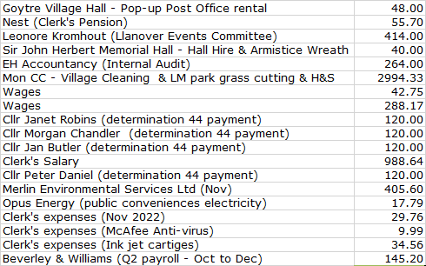  - Review of accounts / cashflow  The Clerk presented the meeting with a copy of the November 2022 cashflow, which included payments of annual allowances to four Councillors, as detailed above.  There was no further comment or observation.  - Contract with Merlin Environmental Services Ltd (MES Ltd)  It was agreed that the Council should sign a new contract with MES Ltd, (as supplied by MCC), to formally contract the dog waste collection service. The contract, based on a weekly collection, will run for 12 months at a cost of £7 per bin per week, (as already included in the proposed budget for next year). This was formally proposed by Councillor Barnes, seconded by Councillor Robins and passed unanimously. Clerk to sign and take forward with MES Ltd.  - Clerk’s salary Increase  The additional information referred to in the November minutes is contained in the closed session minutes from our February 2022 meeting. The hard copy of these minutes is still with Audit Wales. The Clerk found the electronic copy and shared this with the Councillors present. However, it was agreed that the item be deferred until January when Councillor Dodd, (who has been leading on this agenda item) was present.  - 2023/ 2024 budget – version 8 to agree 2023/24 Precept  The Clerk presented the updated version of the budget, to include the amendments requested at the November meeting. In addition, the Clerk had made the following changes which are highlighted in yellow.  - Increased the income for Ton Land from £360 pa to £960.  - Increased the hourly wage rate from £10.32 to £10.50 (the minimum wage increased to £10.42 in the recent budget, and traditionally the Council pays above this. Overall, this increases the wages bill by £75, (from £4314 to £4389).  - Amended the Clerk’s salary to include next year’s potential pay rise (say 5%?) NOT this year’s (under item (iv) above), which had been used in the previous calculation in error.  - Increase the annual cost of hiring the village hall for the post office from £12 to £16 per week – (£612 to £816 per annum)  - HMRC payments amended to £4685.35  - Councillor Allowances £1931.20 (Income tax adjustment – included in ‘e’ above)  Taken together, these create a small budget deficit of £478. However, it was likely that this deficit would be covered by the non-claiming of the ‘Attendance Allowance’ (£500), which, to date, has never been requested by any Councillor, and which would effectively balance the budget. Taking these changes into account, it was proposed that the final recommendation for the 2023/24 Precept should be £41,000. This was formally proposed by Councillor Daniel and seconded by Councillor Barnes and passed unanimously. Clerk to advise MCC.  A full copy of the budget is shown below.  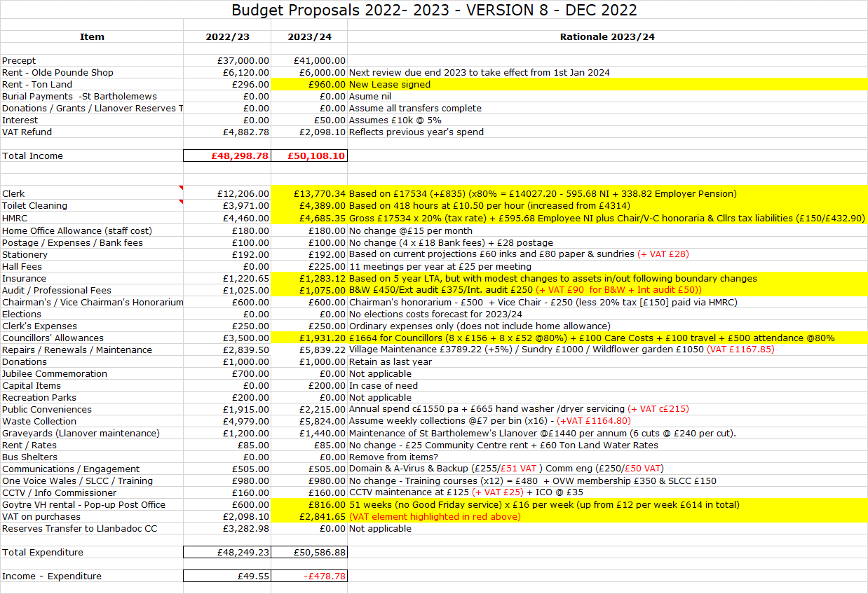  - Audit Update (if available)  At present there has been no further communication from Wales Audit. | Clerk  Clerk  Clerk
8 | Planning.  - To accept the responses of the Planning Committee meetings held on 15th November, to consider the following:  22/21488/FUL (BBNPA) - Application for new rooflights, chimney removal, new openings and windows including new glass screens within ancillary domestic attached barn.  Kiln Farm, Old Abergavenny Road, Pencroesoped Llanover NP7 9EL. There were no concerns or issues.  22/21420/FUL (BBNPA) - Single Storey Extensions & Alterations to the Existing Dwelling.  Sundew, Pentre Lane, Mamhilad, NP4 8RJ  There were no concerns or issues  Acceptance of the minutes (previously circulated), was proposed by Councillor Daniel and seconded by Councillor Robins and passed unanimously.  - Any other updates  A meeting is scheduled for Wednesday 14th to consider the following:  - DM/2022/01331 - Demolition of existing single-storey extension into a two-storey extension. 2 Newtown Road, Penperlleni.  - DM/2022/01621. Single storey extension to the side and rear of property, plus a small porch at the front of the property. 1 Rhyd Y Meirch, Llanover.  - DM/2022/01668. Conversion of Redundant Agricultural Buildings into residential use with new vehicle access from highway.  Llan Farm, Llanvair Road, Goytre.
9 | Annual Report 2021/22 - update.  There has been no further progress on the report. | Cllr Dodd
10 | MUGA – review of plans / options  Mike Moran from MCC has provided detailed architect drawings for a MUGA to be sited on both the top (previously discounted by the CC), and bottom sections of the recreation park. Following feedback from the Community Engagement undertaken in early 2019, the bottom design became the CC’s preferred option. However, none of the small number of members present wished to commit to the next stage. Therefore, the Clerk suggested that the item be deferred until the next meeting when more Councillors were present. This was agreed – the Clerk to schedule on the January 2023 agenda. | Clerk
11 | Training January / February 2023 – Councillors to commit to attendance to specific training as part of the Council’s Training Priorities  The Clerk had been hoping to circulate the OVW training programme for January and February 2023, in advance of today’s meeting. This was to obtain Councillors’ agreement to their attendance on relevant courses to reflect their training needs / interests, and the Community Council’s training priorities. However, the programme is not yet available, and so the Clerk will now circulate it in advance of the January meeting, when hopefully individual training commitments can be agreed. | Clerk
12 | Public Spaces Protections order – agreement to potential sites for implementation of relevant orders.  As highlighted at last month’s meeting, MCC are consulting on the potential creation of Public Spaces Protection Orders (PSPOs) in the County and have provided us with consultation papers. We are asked to give consideration to recommendations in the paper (particularly 2.2), as well as parts 3.12 (dog fouling) and 3.22 / 3.23 (Dogs on Leads Areas and Dog Exclusion Areas).  As previously stated, the orders can apply to any public space, so our opinions as to where orders should be imposed (for example Goytre park), are important. It must be borne in mind that these Orders should not be imposed lightly, as the breaking of a PSPO will potentially lead to an individual having a criminal record.  Following the opportunity to consider our responses, Councillors agreed to make the following requests to MCC:  - Under draft proposal 3.12, it was agreed that the PSPO should be made requiring people to clean up after their dogs which foul on any public space in the County (no exceptions were proposed).  - Under draft proposal 3.22 (Dogs on Leads Areas) – it was agreed that provisions should be made stipulating specific public spaces where dogs must be kept on a lead. In principle Councillors felt the following areas should be included within Goetre Fawr:  - Goytre Village (paved areas)  - Llanover Village (paved areas)  - The Community Garden area (only), of Capel Ed Church (subject to confirmation from the Church.  The Clerk to query if this would apply to anyone exercising their dog while using a mobility scooter.  - Under draft proposal 3.23 (Dog Exclusion Areas) – Again it was felt that provisions should be made in the draft PSPO, stipulating specific public spaces as dog exclusion areas. In particular, Councillors felt the following areas should be included within Goetre Fawr:  - Goytre Recreational Park  Items (i), (ii) and (iii) above were formally proposed by Councillor Robins and seconded by Councillor Daniel and passed unanimously. Clerk to advise MCC. | Clerk
13 | Proposed purchase of wide-angle teleconference camera  The current camera (which belongs to the Clerk) does not provide a satisfactory view of the whole meeting table of Councillors. The Clerk has therefore suggested the purchase of a new camera with a wide-angle lens for future meetings, at a cost of c£35.00, together with a small tripod on which to mount it, at c£17.00. The Clerk provided details of suggested items available on Amazon in advance to Councillors. The purchase of the units was then proposed by Councillor Barnes and seconded by Councillor Robins and passed unanimously. | Clerk
14 | Purchase of Spring Bulbs  Since the last meeting, the Clerk and Councillor Robins have been looking to improve the Village’s biodiversity by planting some spring bulbs on the small grassy area outside the public conveniences (opposite the chip shop), plus adding a few bulbs to the chip shop trough itself.  Unfortunately, MCC could not supply the bulbs, but Nantyderry Nurseries were able to provide a good mix of crocuses, daffs, bluebells and tulips. These were purchased in advance on the authority of the Vice Chair, under section 4.1 of the Financial Regulations. Similarly, the Vice Chair identified an on-line offer for 163 spring bulbs plus 5 packets of flower seeds, which the Clerk has purchased and will claim via expenses. The total outlay has been £42.99.  Formal approval was sought by the Clerk, and this was proposed by Councillor Daniel, seconded by Councillor Robins and passed unanimously.  The Nantyderry supplied bulbs have already been planted and the remaining bulbs will be despatched to us by the end of the month.
15 | Post -16 home-to-school transport – Chloe Tapper – Youth Representative.  At the request of Councillor Dodd, the Clerk had emailed our Youth Representative requesting details of the issues she wished to raise/have discussed concerning the home-to-school transport service provided by MCC. Nothing has been forthcoming. As the item has now appeared on the agenda on several occasions without discussion, it was agreed that it should be removed from future agendas for the time being. | Clerk
16 | Village Committee’s Reports – questions based on previously distributed updates  - Goytre Village Hall  - All going well with bookings into next year. Food hall and welcome coffee morning also going well. No other issues other than energy cost.  - Waiting on ‘Halls together’ to come up with help.  - Llanover Village Hall  - The most recent Village Hall meeting was held on 8th November  - Plans for the Llanover Christmas Cracker were the predominant event discussed, which took place on 27th. The event went very well with fine weather at the end of a wet week. It looks like this type of event will happen again in the future.  - The hall is maintaining bookings which is good during an uncertain time.  - Goytre School Governors  - Issues include prospective staff pay rise, energy costs and cut in money to MCC from WG, so there will be financial issues for the school next year (as there will be for schools across Wales).  - King Henry School - The new building is Eco friendly and is being built to suit 3 to 16 year olds. They are awaiting confirmation from the public about a new name for the school.  - Goytre Community Centre  - Goytre Community Centre committee has not met, but it is exploring the asset transfer with MCC. Cllr. Butler will be discussing options with Nicola Howells (Asset manager) on Thursday 8th to progress. Community Council may be needed to input on options as Custodian Trustees.  - The Community Ownership Fund is being progressed alongside this.  - Other Reports  - There were no other reports.
17 | Donation requests.  - Well Being café – Request for £75  The Well Being Café have approached the CC for a donation of another 20 mugs (@£1.50 per mug) due to the expansion of the cafe. A further £45 is requested to purchase a table cloth and decorations for the Christmas Party (scheduled for earlier today).  Strictly speaking only one donation is allowed per organisation within any 12 month period. However, given the small donaton of only £30 made earlier this year, Councilors did not feel that this restriction should be zealously applied. Similarly grants should not normally be made retrospectively. However, as the request was received before the scheduled date of the party, and was for a modest amount, Councillors agreed it would not be unreasonable to provide this funding. (In the meantime, the Well Being café has covered by requesting funds from the Village Hall).  It does not appear that they have their own bank account yet, and so payment will have to be made via the village hall. Councillors requested that Councillor Daniel check/confirm the café’s financial controls, as it was felt important that all transactions are recorded and could be accounted for in case of query.  A proposal to make a donation of £75 was made by Councillor Barnes , seconded by Councillor Robins and passed by the three ‘disinterested’ Councillors – (Councillor Daniel did not take part in the vote).  - Wales Air Ambulance  A request for a donation has been made from the service. The Air Ambulance has been called out to incidents in the village on a couple of occasions of late, and Councillors have traditionally been keen to support the service. A  donation of £500 was made in February 2022 (our previous financial year), and recognising the demands on our budgets, it was felt that a sum of £250 was more appropriate this financial year. However, in recogntion of the benefit provided to the Community, Councillors reserved the right to make a further donation before the end of the financial year, if budgets allowed.  A donation of £250 was the proposed by Councillor Daniel and seconded by Councillor Barnes and carried unanimously. | Clerk  Clerk
18 | Communications.  There have been no communications received.
19 | Advertising - Usk and Raglan Diary contributions Mar / Apr 2023.  The closing date for submissions for the Mar/Apr 2023 edition will be towards the end of next month. In the meantime, Councillor Daniel advised that a diary of events was maintained by the village hall, if we wished to include any forthcoming activities. | All
20 | Date of next meeting and close.  The next meeting to be held on Monday 16th January at 19.45.  The venue to be in Llanover Village Hall and by teleconference via: https://meet.jit.si/GoetreFawrCommunityCouncil | All/  Clerk

Chairman: …………………………………….…………… Date:…………………….

