CYNGOR CYMUNED

GOETRE FAWR

COMMUNITY COUNCIL
MINUTES OF THE MEETING HELD AT LLANOVER VILLAGE HALL & BY TELECONFERENCE ON MONDAY 14th NOVEMBER 2022

Present: Community Councillors Owen Dodd, Andy Barnes, Jan Butler,
Nigel Morrey, Janet Robins, Peter Daniel, Morgan Chandler and
Scott Grayland.

Guests None
In Attendance: Jonathan Lazenby (Clerk).
Apologies: None
Absent without Apology: Youth Representative Chloe-Marie Tapper.
 |  | ACTION
1 | Apologies for Absence.  As above.
2 | Declarations of Interest.  The Chair commenced by asking the members present whether they had any declarations of ‘interest’ to make, which includes previous declarations already made. The Chair, (Councillor Dodd), advised the meeting that he was now a member of the Goytre Social Club Committee. This has previously been notified to the Clerk who had added it to the list of members’ interests posted on line. The Chair reminded members that they should notify the meeting of any additional interests which became apparent during the progress of the meeting. No further interests from the other members were forthcoming. | All / Clerk
3 | Chairman’s Remarks.  The Chair welcomed everyone to the meeting.
4 | Approval of minutes of the Council meeting held on 17th October 2022.  The minutes were proposed as a true and correct record by Councillor Daniel and seconded by Councillor Barnes and carried unanimously. | Clerk
5 | Matters Arising.  - Item 5 (vi) - A cheque for £799.63, representing monies for Llanover ward following the May boundary changes, has now been received from Gobion Community Council, and credited to our current account.  - Item 6 (i) – Scout Hut footpath. Councillor Butler advised that MCC could not be certain who the footpath belonged to, and are having to resort to studying paper records to ascertain ownership. This may take several months. Councillor Morrey thought that the path was originally part of the Scout Hut plot, and the path was fenced off to stop dog walkers going through the Scout Hut grounds.  - Item 6 (ii) – The broken planters opposite the chip shop have now been removed.  - Item 6 (iii) – Over hanging tree on Longhouse Barn. Councillor Butler has not yet had an opportunity to speak to the resident (who is elderly), and may try to speak to her children instead when they next visit.  - Item 6 (iv) – Footpath between Longhouse Barn and Newtown Road. MCC have responded that this is not adopted. Councillor Butler is to log this again with MCC to see if progress can be made to repair a hazardous pothole, which can’t be seen in the dark.  - Item 6 (v) – MCC are investigating the removal of the traffic calming pad and are planning to replace it. Councillor Butler is to chase MCC for the work to be undertaken as soon as possible.  - Item 7(v) - Income – Correction – the Old Pounde Shop lease is not due for renewal until Sept 2024 (not 2023 as erroneously stated at the October meeting).  - Item 13 – The Council Training Plan for 2022/23 and 2023/24 has now been posted on the web site. It omits Councillor Grayland’s plan as the Clerk has not yet received his permission for it to be published. Clerk to re-send the note asking for permission. | Cllr Butler  Cllr Butler  Cllr Butler  Cllr Butler  Clerk
6 | Maintenance (including items previously reported but not yet addressed).  - Councillor Daniel mentioned that there is a large lime tree overhanging the Village Hall car park and footpath, which needs cutting back. However, a number of Councillors advised that the tree is in the grounds of the car park and as a result is the Hall’s responsibility.
7 | Finance  - Payments made since the previous meeting.  £  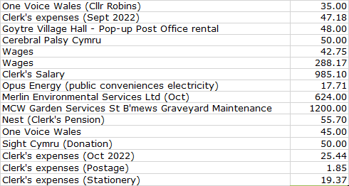  - Review of accounts / cashflow  The Clerk presented the meeting with a copy of the October 2022 cashflow.  There was no further comment or observation.  The Clerk advised that he had received notification of a payment due to MCC on 28th November of £2,495.27 (exc. VAT).  This was comprised of the following (all amounts exclude VAT)  - 2 x months of Little Mill Park maintenance contract £71.11  - 2 x months of Little Mill Park play inspection contract £26.68  - Full year cleaning contract for Goytre & 2 months Little Mill £2,397.48  The village cleaning element is some £558 over the annual budget of £1839.50. It transpires that the request for bi-monthly maintenance and to transfer the contract from Little Mill to Llanover was not actioned, and the invoice is therefore for the monthly cleaning for Little Mill (2 months) and the entire year for Goytre.  However, we do have another £1000 (unallocated) in the budget line for Repairs / Renewals / Maintenance, which we can use to cover the excess if Councillors wish to continue with monthly cleaning for the remainder of the financial year. Alternatively, we could look to claw some of the cost back by moving to cleaning every two months for the rest of the financial year. However, now is the peak time for the cleaning of leaf fall etc. so this would not be ideal. Councillors agreed that we should continue with the existing monthly cleaning, and this was formally proposed by Councillor Barnes and seconded by Councillor Morrey and carried unanimously. Cleaning for 2023/24 will be addressed under item (iv) below.  - Clerk’s salary Increase – Closed session  Councillors deferred making a decision until they had additional financial information. Clerk to add to the December agenda.  - 2023/ 2024 budget – fourth draft  The Clerk presented the updated version of the budget, to include the amendments requested at the October meeting.  During the draft budget discussion, the following changes were requested:  - Increase the village maintenance budget to £3789.22 (plus VAT), to cover the monthly cleaning of Goytre and Llanover (effectively just Rhyd Y Meirch) – this reflects a 5% cost increase advised by MCC.  - Increase the wildflower planting costs by 5% to £1050  - a + b above takes this budget line to £5839.22, and increases the recoverable VAT to £2831.65  The amendments recommended above, taken with the other planned expenditure, would lead to a projected budget deficit of c£4000. As a result, Councillors suggested at this stage an increase in the precept to £41,000 – the equivalent of 28p per month, per Band D household. The latest budget iteration (v5, to include a-c above) is shown below, with the suggested amendments from today’s meeting highlighted in yellow. A final recommendation will be taken at the December meeting and will include the updated figure for the Clerk’s salary.  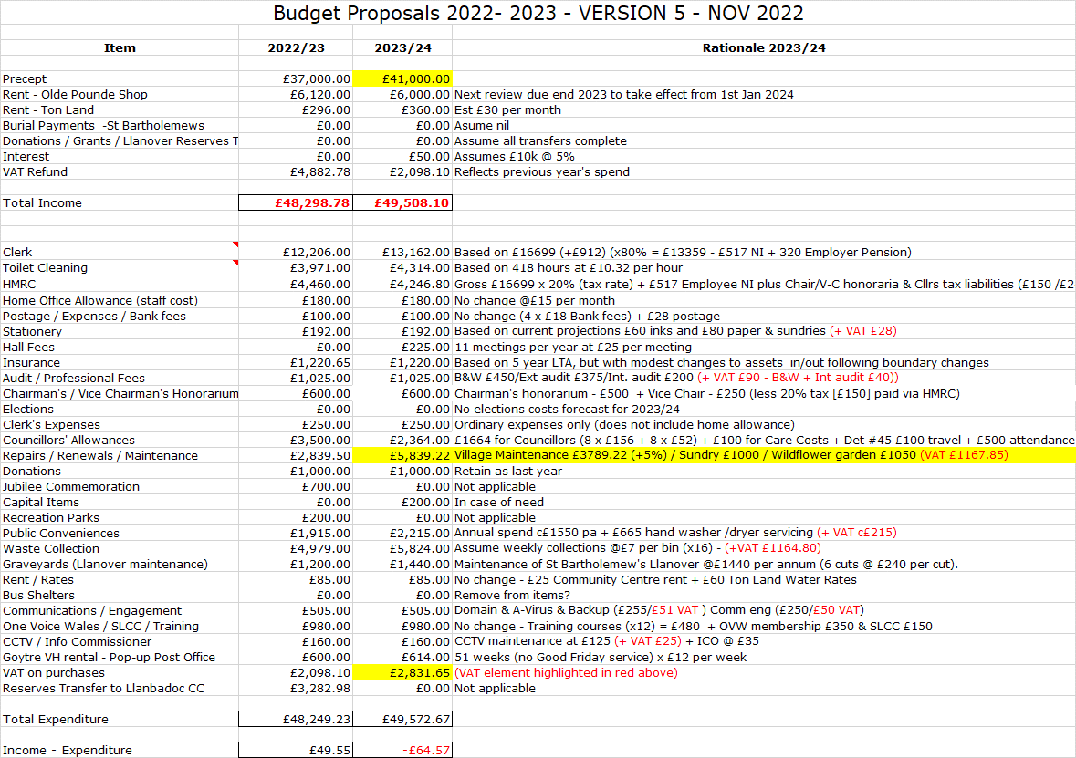  - Audit Update (if available)  At present there has been no further communication from Wales Audit. | Clerk  Clerk
8 | Planning.  - To accept the responses of the Planning Committee meetings held on 24th October, to consider the following:  - DM/2022/01419 - Glencoed Cottage, Croes Y Pant Lane, Mamhilad, Pontypool, Monmouthshire, NP4 0JD  - DM/2022/01450 - Rose Cottage, Star Road, Penperlleni, Goytre, Pontypool, Monmouthshire, NP4 0AJ  - DM/2022/01098 - Llan Farm, Llanvair Road, Goytre, Usk, NP15 1QD  Acceptance of the minutes (previously circulated), was proposed by Councillor Daniel and seconded by Councillor Morrey and passed unanimously.  - Any other updates  The Planning Committee is next due to meet on 15th November to discuss application 22/21488/FUL (BBNPA), for new rooflights, chimney removal, new openings and windows including new glass screens within an ancillary domestic attached barn - Kiln Farm, Old Abergavenny Road, Pencroesoped Llanover NP7 9EL. Plus 22/21420/FUL (also BBNPA), a proposed single storey extension & alterations to the existing dwelling, at Sundew, Pentre Lane, Mamhilad NP4 8RJ, together with any other applications received by this date.
9 | Annual Report Update.  Councillor Dodd advised that having reviewed the draft report for 2021/22, a few changes were needed and he is to send the proposed amendments to Councillor Daniel for final comment. | Cllr Dodd
10 | Council Plan for 2023/24.  It appeared that there has been no progress on this topic. The Clerk advised that Council plans were key to putting the annual budget together, and would form the basis of the Annual Report at the end of the year. To try and get some traction on this, the Clerk is to identify the opportunity for attendance at the following OVW courses:  - Module 8 - Introduction to Community Engagement  - Module 12 – Creating a Community Plan  In the absence of a report, Councillor Butler took the opportunity to update the meeting on the Replacement Local Development Plan (RLDP). As has already been published by MCC, the majority of the development will take place on the primary sites of Abergavenny, Caldicot and Chepstow.  In addition, a further 385 houses (some already built) have been agreed for the secondary sites of Penperlleni, Raglan and Usk. Councillor Butler shared print-outs of the candidate sites around Goytre, all of which were familiar to the Councillors present (and are available online at MCC). However, no sites have been approved as yet.  MCC are to shortly seek approval of the strategy, which will then move to a period of public consultation, running from 5th December 2022 to 30th January 2023. | Clerk
11 | Environment (Wales) Act 2016 Part 1 – Section 6  The Biodiversity and Resilience of Ecosystems Duty Report 2022  Our original Biodiversity and Resilience of Ecosystems Plan, prepared as part of our duties under the above Act, was published at the end of 2019, and is now due for its three-yearly review. An updated / revised document has been drawn up by the Clerk and Councillor Robins for review at this meeting, having been previously distributed to the members.  Councillors agreed that no alterations were required, and it should be published on our web site and sent to Welsh Government as it stands. This was proposed by Councillor Daniel and seconded by Councillor Chandler and passed unanimously. | Clerk
12 | Independent Remuneration Panel for Wales (IRPW) - Draft Report for consideration and feedback  The Clerk has previously circulated the following feedback to Councillors:  It is noted that there is now a new additional amount (The Set Payment) being made available to cover the cost of any consumables. The costs relating to these items were previously covered within the £150 Councillor allowance, and its unclear why they are now to be accounted for separately. It may be in preparation so that one or both of the payments can be made tax free? This of course would be welcomed. However, the approach being taken we feel rather over-complicates the administration of the payments, because Councillors now appear to have the following choices regarding the receipt of these payments:  - Basic Payment (Mandatory) – Options appear to be (as before):  - Accept in full or;  - Decline completely.  - Set Payment (Mandatory?) – Options for Councillors appear to be:  - Accept in full (payment paid annually up front / or by regular instalments).  - Decline completely.  - Receive in full, as and when, by submitting claims for specific costs incurred.  - Receive in part, as and when, by submitting claims for specific costs incurred.  - Make no particular decision either way, don’t bother claiming.  The Clerk felt that this will create the potential for numerous combinations of payments to / claims made by Councillors, all adding to an increased complexity of administration / audit recording / accounting etc. and queried if there was a more straightforward approach to achieve the same end?  No further comment was made by Councillors, and the feedback above was then proposed by Councillor Butler and seconded by Councillor Barnes and passed unanimously. | Clerk
13 | Public Spaces Protections order – consideration of MCC proposals and identification of potential sites.  MCC are consulting on the potential creation of Public Spaces Protection Orders (PSPOs) in the County and have provided us with consultation papers. We are asked to give consideration to recommendations in the paper (particularly 2.2), as well as parts 3.12 (dog fouling) and 3.22 / 3.23 (Dogs on Leads Areas and Dog Exclusion Areas).  The orders can apply to any public space, so our opinions as to where orders should be imposed (for example Goytre park), are important. It should be borne in mind that these Orders should not be imposed lightly, as the breaking of a PSPO will potentially lead to an individual having a criminal record.  Responses are not required until January, so the opportunity is being given for Councillors to consult more widely with residents, before making any final recommendations. MCC are to contact the Canal & Riverside Trust for their views on Goytre Wharf / The Towpath).  It was agreed that Goytre Park was a likely candidate (albeit owned by MCC), and Councillor Robins said that the Community Garden at Capel Ed may also be worthy for consideration. Clerk to put on the December agenda for final feedback. | Coun’llors  Clerk
14 | Post -16 home-to-school transport – Chloe Tapper – Youth Representative.  In the absence of our Youth Representative, the Chair asked if the Clerk would contact Chloe, asking her for details of the issues she wished to raise. | Clerk
15 | Village Committee’s Reports – questions based on previously distributed updates  - Goytre Village Hall  - Going well - lots of party bookings up to the end of the year.  - Welcome Cafe been successfully attended. All looking forward to their Xmas lunch 5th December.  - An audio / visual assessment is being undertaken in January. Grant been accepted.  - Food Hall also going well.  - Llanover Village Hall  - The most recent meeting was held on 9th November.  - Plans are continuing for the Llanover Christmas Cracker event to be held on 27th November. Events still to be decided but will have a light switch on as the finale. Posters have been printed to be put out around the village promoting the event.  - There is a midwinter meal in the planning stages to have people get together in January at the village hall. Currently pencilled in for Saturday 14th January.  - The next village hall meeting will be on 14th December at 18.30.  - Goytre School Governors  - No report as no meeting has taken place this term so far.  - Parents appear happy with the help so far.  - Goytre Community Centre  - No report submitted (are meeting this week).  - Other Reports  - There were no other reports.
16 | Donation requests.  - Llanover Event Committee have approached us for a donation of £584 to purchase the following items:  - Christmas Lights - £99  - Gazebo - £315  - Santa’s Grotto decorations - £100  - Tea Urn - £70  As a brand new committee, they currently have no funds of their own. Their aim is to organise community events in the village hall, to enable the rural communities of Upper and Lower Llanover to come together and develop a stronger sense of village cohesion. Their first event will be on 27th November (switching on of the Christmas Lights) with further events then ongoing throughout the calendar.  At the initial event, the Commitee will mark the moment of the Light Switch On with a Salvation Army Brass Band, and an hour of communal carol singing. Hopefully, a Craft Christmas Market with contributions from local residents is expected to generate approximately £700 to help pay for the costs of organising the occasion.  Although £584 would perhaps represent an overly large proportion of the £1000 donations budget, the Clerk advised that there was still funding unspent from the £700 Jubilee budget. This could perhaps be used to contribute to this request. However, concious that other similar applications may be forthcoming from elsewhere in the community, Councillors felt it appropriate to limit the funding to £414, to cover the costs of the Christmas lights and Gazebo (which we are advised are the priority items). This was proposed by Councillor Morrey and seconded by Councillor Grayland and passed unanimously. | Clerk
17 | Communications.  There have been no communications received.
18 | Advertising - Usk and Raglan Diary contributions Jan/ Feb 2023.  The closing date for submissions for the Jan/Feb 2023 edition of the Diary is at the end of this week. It was agreed that the following items should be included:  - The Donation to the Llanover Events Committee | Clerk
19 | Date of next meeting and close.  The next meeting to be held on Monday 12th December at 19.45.  The venue to be in Llanover Village Hall and by teleconference via: https://meet.jit.si/GoetreFawrCommunityCouncil | All/  Clerk

Chairman: …………………………………….…………… Date:…………………….

